UNITED STATES
SECURITIES AND EXCHANGE COMMISSION
Washington, D.C. 20549

FORM 8-K

CURRENT REPORT
PURSUANT TO SECTION 13 OR 15(d)
OF THE SECURITIES EXCHANGE ACT OF 1934
Date of Report (Date of earliest event reported): October 20, 2026

Alpha Teknova, Inc.
(Exact Name of Registrant as Specified in its Charter)

Delaware |  | 001-40538 |  | 94-3368109
(State or Other Jurisdiction  of Incorporation) |  | (Commission  File Number) |  | (IRS Employer  Identification No.)
2451 Bert Drive
Hollister, California 95023
(Address of Principal Executive Offices) (Zip Code)
(831) 637-1100
Registrant’s telephone number, including area code
N/A
(Former Name, or Former Address, if Changed Since Last Report)

Check the appropriate box below if the Form 8-K filing is intended to simultaneously satisfy the filing obligation of the registrant under any of the following provisions:

 | ☐ | Written communications pursuant to Rule 425 under the Securities Act (17 CFR 230.425)

 | ☐ | Soliciting material pursuant to Rule 14a-12 under the Exchange Act (17 CFR 240.14a-12)

 | ☐ | Pre-commencement communications pursuant to Rule 14d-2(b) under the Exchange Act (17 CFR 240.14d-2(b))

 | ☐ | Pre-commencement communications pursuant to Rule 13e-4(c) under the Exchange Act (17 CFR 240.13e-4(c))
Securities registered pursuant to Section 12(b) of the Exchange Act:

(Title of each class) |  | (Trading  Symbol) |  | (Name of exchange  on which registered)
Common Stock, par value $0.00001 per share |  | TKNO |  | The Nasdaq Stock Market LLC
Indicate by check mark whether the registrant is an emerging growth company as defined in Rule 405 of the Securities Act of 1933 (§230.405 of this chapter) or Rule 12b-2 of the Securities Exchange Act of 1934 (§240.12b-2 of this chapter).
Emerging growth company ☒
If an emerging growth company, indicate by check mark if the registrant has elected not to use the extended transition period for complying with any new or revised financial accounting standards provided pursuant to Section 13(a) of the Exchange Act. ☐

Item 1.01. | Entry into a Material Definitive Agreement.
On October 20, 2026, Alpha Teknova, Inc. (the “Company”) entered into an underwriting agreement (the “Underwriting Agreement”) with TD Securities (USA) LLC and William Blair & Company, L.L.C. as the representatives of the several underwriters named therein (the “Underwriters”), relating to an underwritten public offering (the “Offering”) of an aggregate of 8,000,000 shares of the Company’s common stock (“Common Stock”). The public offering price is $5.00 per share of Common Stock and the Underwriters have agreed to purchase the shares of Common Stock pursuant to the Underwriting Agreement at a price of $4.70 per share of Common Stock. Under the terms of the Underwriting Agreement, the Company also granted to the Underwriters an option, exercisable in whole or in part at any time for a period of 30 days from the date of the Underwriting Agreement, to purchase up to 1,200,000 additional shares of Common Stock.
The Offering is being made pursuant to the Company’s registration statement on Form S-3 (File No. 333-288613), previously filed with the Securities and Exchange Commission (the “SEC”) on July 10, 2025, and declared effective on July 16, 2025, a base prospectus dated July 16, 2025 and a prospectus supplement dated October 21, 2026.
Gross proceeds from the Offering will be $40 million, before deducting underwriting discounts and commissions and other offering expenses payable by the Company. The Company intends to use the net proceeds from the Offering for general corporate purposes, including potentially the repayment of outstanding debt obligations. The Company may use a portion of the net proceeds to acquire or invest in other businesses, products, and technologies that are complementary to its own, although the Company has no current commitments or arrangements to do so. The purchase and sale of the shares of Common Stock and the closing of the Offering, are expected to take place on or about October 22, 2026, subject to the satisfaction of customary closing conditions.
The Underwriting Agreement contains customary representations, warranties and covenants made by the Company. It also provides for customary indemnification by each of the Company and the Underwriters, severally and not jointly, for losses or damages arising out of or in connection with the Offering, including for liabilities under the Securities Act of 1933, as amended, other obligations of the parties and termination provisions. In addition, pursuant to the terms of the Underwriting Agreement, each of the Company’s directors and executive officers has entered into “lock-up” agreements with TD Securities (USA) LLC and William Blair & Company, L.L.C., which generally prohibit, without the prior written consent of TD Securities (USA) LLC and William Blair & Company, L.L.C. and subject to certain exceptions, the sale, transfer or other disposition of securities of the Company prior to January 19, 2027.
The representations, warranties and covenants contained in the Underwriting Agreement were made only for purposes of such agreement and as of specific dates, were solely for the benefit of the parties to the Underwriting Agreement and may be subject to limitations agreed upon by the contracting parties. Accordingly, the Underwriting Agreement is incorporated herein by reference only to provide investors with information regarding the terms of the Underwriting Agreement, and not to provide investors with any other factual information regarding the Company or its business, and should be read in conjunction with the disclosures in the Company’s periodic reports and other filings with the SEC.
The foregoing description of the Underwriting Agreement does not purport to be complete and is qualified in its entirety by reference to the copy of the Underwriting Agreement, which is filed as Exhibit 1.1 to this Current Report on Form 8-K. A copy of the opinion of Paul Hastings LLP, counsel to the Company, relating to the validity of the shares of Common Stock to be issued in the Offering is filed herewith as Exhibit 5.1.

Item 2.02 | Results of Operations and Financial Condition.
Financial Update
On October 20, 2026, the Company estimated that its revenue for the three months ended September 30, 2026 was between approximately $12.5 million and $12.7 million, with a gross margin of between 36.0% and 38.0%. The Company also estimated that as of September 30, 2026, it had $16.6 million in cash and short term investments. Further, the Company estimated that its Adjusted EBITDA for the three months ended September 30, 2026 was between negative $1.2 million and negative $1.0 million.
The Company’s financial statements for the three months ended September 30, 2026 are not yet available. Accordingly, the information presented above reflects the Company’s preliminary estimates subject to the completion of the Company’s financial closing procedures and any adjustments that may result from the completion of the quarterly review of the Company’s financial statements. As a result, these preliminary estimates may differ from the actual results that will be reflected in the Company’s financial statements for the quarter when they are completed and publicly disclosed. These preliminary estimates may change and those changes may be material.
The Company’s expectations with respect to its unaudited results for the period discussed above are based upon management estimates and are the responsibility of management. The Company’s independent registered public accounting firm has not audited, reviewed, or performed any procedures with respect to these preliminary results and, accordingly, does not express an opinion or any other form of assurance about them.
Reconciliation of Non-GAAP Financial Measures
Adjusted EBITDA is a non-GAAP financial measure that is not prepared in accordance with GAAP and that may be different from non-GAAP financial measures used by other companies. Our management believes that the use of this non-GAAP financial measure provides an additional tool for investors to use in evaluating ongoing operating results and trends of the Company. This non-GAAP financial measure should not be considered in isolation from, or as an alternative to, financial measures determined in accordance with GAAP. Adjusted EBITDA is a non-GAAP financial measure equal to net loss, the most directly comparable financial measure based on GAAP, excluding interest expense, income tax expense, depreciation and amortization, and stock-based compensation expense.
The following is a reconciliation of net income, the most directly comparable GAAP financial measure to Adjusted EBITDA:

($ in thousands) |  | Three Months Ended  September 30, 2026  (Estimated)
Net loss |  | $(3,694) - $(3,494)
Add back:
Interest expense, net |  | (259)
Provision for income taxes |  | 34
Depreciation expense |  | 1,302
Amortization of intangible assets |  | 287
EBITDA |  | $(1,812) - $(1,612)
Other and non-recurring expenses:
Stock-based compensation expense |  | 612
Adjusted EBITDA |  | $(1,200) - $(1,000)

Item 8.01. | Other Events.
On October 20, 2026, the Company issued a press release announcing the launch of the Offering. A copy of the press release is attached as Exhibit 99.1 to this Current Report on Form 8-K and is incorporated herein by reference.
On October 20, 2026, the Company issued a press release announcing the pricing of the Offering. A copy of the press release is attached as Exhibit 99.2 to this Current Report on Form 8-K and is incorporated herein by reference.
On October 21, 2026, the Company posted an updated company presentation to the investor section of the Company’s website. A copy of this presentation is attached as Exhibit 99.3 to this Current Report on Form 8-K and is incorporated herein by reference.

Item 9.01. | Financial Statements and Exhibits.
(d) Exhibits.

Exhibit  Number |  | Description
1.1 |  | Underwriting Agreement, dated as of October 20, 2026, by and among Alpha Teknova, Inc., TD Securities (USA) LLC and William Blair & Company, L.L.C.
5.1 |  | Opinion of Paul Hastings LLP.
23.1 |  | Consent of Paul Hastings LLP (included in Exhibit 5.1).
99.1 |  | Launch Press Release, dated October 20, 2026.
99.2 |  | Pricing Press Release, dated October 20, 2026.
99.3 |  | Company Presentation, dated October 14, 2026.
104 |  | Cover Page Interactive Data File, formatted in Inline Extensible Business Reporting Language (iXBRL).
Cautionary Statement Regarding Forward-Looking Statements
This Current Report on Form 8-K contains “forward-looking statements” within the meaning of the Private Securities Litigation Reform Act of 1955 that involve risks and uncertainties, such as statements related to the anticipated closing of the Offering and the anticipated use of proceeds from the Offering. The risks and uncertainties involved include the Company’s ability to satisfy certain conditions to closing the Offering on a timely basis or at all, market conditions and other risks detailed from time to time in the Company’s periodic reports and other filings with the SEC. Forward-looking statements can often be identified by words such as “will,” “intends,” “potentially,” “may,” “expect,” and similar expressions, and variations and negatives of these words. You are cautioned not to place undue reliance on forward-looking statements, which are based on the Company’s current expectations and assumptions and speak only as of the date of this Current Report on Form 8-K. Readers should not place undue reliance on any forward-looking statements, and are encouraged to review the Company’s other filings with the SEC for a more complete discussion of risks and other factors that could affect any forward looking statement. The Company does not intend to revise or update any forward-looking statement in this Current Report on Form 8-K as a result of new information, future events or otherwise, except as required by law.

SIGNATURES
Pursuant to the requirements of the Securities Exchange Act of 1934, the registrant has duly caused this report to be signed on its behalf by the undersigned hereunto duly authorized.

 |  |  |  | ALPHA TEKNOVA, INC.
Date: October 21, 2026 |  |  |  | By: |  | /s/ Stephen Gunstream
 |  |  |  | Name: |  | Stephen Gunstream
 |  |  |  | Title: |  | President and Chief Executive Officer
Exhibit 1.1
8,000,000 Shares
ALPHA TEKNOVA, INC.
Common Stock
UNDERWRITING AGREEMENT
October 20, 2026
TD SECURITIES (USA) LLC
WILLIAM BLAIR & COMPANY, L.L.C.
As Representatives of the several Underwriters
c/o TD Securities (USA) LLC
1 Vanderbilt Avenue
New York, New York 10017
c/o William Blair & Company, L.L.C.
150 North Riverside Plaza
Chicago, Illinois 60606
Dear Sirs and Madams:
1. INTRODUCTORY. Alpha Teknova, Inc., a Delaware corporation (the “Company”), proposes to sell, pursuant to the terms of this Agreement, to the several underwriters named in Schedule A hereto (the “Underwriters,” or, each, an “Underwriter”), an aggregate of 8,000,000 shares of common stock, $0.00001 par value per share (the “Common Stock”) of the Company. The aggregate of 8,000,000 shares so proposed to be sold is hereinafter referred to as the “Firm Stock”. The Company also proposes to sell to the Underwriters, upon the terms and conditions set forth in Section 3 hereof, up to an additional 1,200,000 shares of Common Stock (the “Optional Stock”). The Firm Stock and the Optional Stock are hereinafter collectively referred to as the “Stock”. TD Securities (USA) LLC and William Blair & Company, L.L.C. are acting as representatives of the several Underwriters and in such capacity are hereinafter referred to as the “Representatives.”
2. REPRESENTATIONS AND WARRANTIES OF THE COMPANY
The Company represents and warrants to the several Underwriters, as of the date hereof and as of each Closing Date (as defined below), and agrees with the several Underwriters, that:
(a) Registration Statement. A registration statement of the Company on Form S-3 (File No. 333-288613) (including all amendments thereto, the “Initial Registration Statement”) in respect of the Stock has been filed with the Securities and Exchange Commission (the “Commission”) pursuant to Rule 415 under the Securities Act of 1933, as amended (the “Securities Act”). The Company meets the requirements for use of Form S-3 under the Securities Act, and the rules and regulations of the Commission thereunder (the “Rules and Regulations”). The Initial Registration Statement and any post-effective amendment thereto, each in the form heretofore delivered to you, and, excluding exhibits thereto, to you for each of the other Underwriters, have been declared effective by the Commission in such form and meet the requirements of the Securities Act, and the Rules and Regulations. The proposed offering of the Stock may be made pursuant to General Instruction I.B.1 of Form S-3. Other than (i) the Initial Registration Statement, (ii) a registration statement, if any, increasing the size of the offering filed pursuant to Rule 462(b) under the Securities Act and the Rules and Regulations (a “Rule 462(b)

1

Registration Statement”), (iii) any Preliminary Prospectus (as defined below), (iv) the Prospectus (as defined below) contemplated by this Agreement to be filed pursuant to Rule 424(b) of the Rules and Regulations in accordance with Section 4(a) hereof and (v) any Issuer Free Writing Prospectus (as defined below), no other document with respect to the offer or sale of the Stock has heretofore been filed with the Commission. No stop order suspending the effectiveness of the Initial Registration Statement, any post-effective amendment thereto or the Rule 462(b) Registration Statement, if any, has been issued and no proceeding for that purpose or pursuant to Section 8A of the Securities Act has been initiated or, to the Company’s knowledge, threatened by the Commission (any preliminary prospectus included in the Initial Registration Statement or filed with the Commission pursuant to Rule 424 of the Rules and Regulations is hereinafter called a “Preliminary Prospectus”). The Initial Registration Statement including all exhibits thereto and including the information contained in the Prospectus filed with the Commission pursuant to Rule 424(b) of the Rules and Regulations and deemed by virtue of Rule 430A under the Securities Act to be part of the Initial Registration Statement at the time it became effective is hereinafter collectively called the “Registration Statement.” If the Company has filed a Rule 462(b) Registration Statement, then any reference herein to the term “Registration Statement” shall be deemed to include such Rule 462(b) Registration Statement. The base prospectus included in the Initial Registration Statement at the time of effectiveness thereof, as supplemented by the final prospectus supplement relating to the offer and sale of the Stock, in the form filed pursuant to and within the time limits described in Rule 424(b) under the Rules and Regulations, is hereinafter called the “Prospectus.”
Any reference herein to the Registration Statement, Preliminary Prospectus or the Prospectus shall be deemed to refer to and include the documents incorporated by reference therein. Any reference to any amendment or supplement to any Preliminary Prospectus or the Prospectus shall be deemed to refer to and include any documents filed after the date of such Preliminary Prospectus or the Prospectus under the Securities Exchange Act of 1934, as amended (the “Exchange Act”), and incorporated by reference in such Preliminary Prospectus or Prospectus, as the case may be. Any reference to (i) the Registration Statement shall be deemed to refer to and include the annual report of the last completed fiscal year of the Company on Form 10-K filed under Section 13(a) or 15(d) of the Exchange Act prior to the date hereof and (ii) the effective date of such Registration Statement shall be deemed to refer to and include the date such Registration Statement became effective and, if later, the date such Form 10-K was so filed. Any reference to any amendment to the Registration Statement shall be deemed to refer to and include any annual report of the Company filed pursuant to Section 13(a) or 15(d) of the Exchange Act after the date of this Agreement that is incorporated by reference in the Registration Statement.
(b) General Disclosure Package. As of the Applicable Time (as defined below) and as of the Closing Date or the Option Closing Date (as defined below), as the case may be, neither (i) the General Use Free Writing Prospectus(es) (as defined below) issued at or prior to the Applicable Time, the Pricing Prospectus (as defined below) and the information included on Schedule C hereto, all considered together (collectively, the “General Disclosure Package”), (ii) any individual Limited Use Free Writing Prospectus (as defined below), (iii) the bona fide electronic roadshow (as defined in Rule 433(h)(5) of the Rules and Regulations); nor (iv) any individual Written Testing-the-Waters Communication (as defined below), when considered together with the General Disclosure Package, included or will include any untrue statement of a material fact or omitted or will omit to state a material fact necessary in order to make the statements therein, in the light of the circumstances under which they were made, not misleading; provided, however, that the Company makes no representations or warranties as to information contained in or omitted from the Pricing Prospectus or any Issuer Free Writing Prospectus (as defined below), in reliance upon, and in conformity with, written information furnished to the Company through the Representatives by or on behalf of any Underwriter specifically for inclusion therein, which information the parties hereto agree is limited to the Underwriters’ Information (as defined in Section 18). As used in this paragraph (b) and elsewhere in this Agreement:

2

“Applicable Time” means 6:00 P.M., New York time, on the date of this Agreement or such other time as agreed to by the Company and the Representatives.
“Pricing Prospectus” means the Preliminary Prospectus relating to the Stock that is included in the Registration Statement immediately prior to the Applicable Time, including any document incorporated by reference therein.
“Issuer Free Writing Prospectus” means any “issuer free writing prospectus,” as defined in Rule 433 of the Rules and Regulations relating to the Stock in the form filed or required to be filed with the Commission or, if not required to be filed, in the form retained in the Company’s records pursuant to Rule 433(g) of the Rules and Regulations.
“General Use Free Writing Prospectus” means any Issuer Free Writing Prospectus that is identified on Schedule B to this Agreement.
“Limited Use Free Writing Prospectus” means any Issuer Free Writing Prospectus that is not a General Use Free Writing Prospectus.
“Written Testing-the-Waters Communication” means any Testing-the-Waters Communication (as defined below) that is a written communication within the meaning of Rule 405 of the Rules and Regulations.
(c) No Stop Orders; No Material Misstatements. No order preventing or suspending the use of any Preliminary Prospectus, any Issuer Free Writing Prospectus or the Prospectus relating to the proposed offering of the Stock has been issued by the Commission, and no proceeding for that purpose or pursuant to Section 8A of the Securities Act has been instituted or, to the Company’s knowledge, threatened by the Commission, and each Preliminary Prospectus, at the time of filing thereof, conformed in all material respects to the requirements of the Securities Act and the Rules and Regulations, and did not contain an untrue statement of a material fact or omit to state a material fact required to be stated therein or necessary to make the statements therein, in the light of the circumstances under which they were made, not misleading; provided, however, that the Company makes no representations or warranties as to information contained in or omitted from any Preliminary Prospectus, in reliance upon, and in conformity with, written information furnished to the Company through the Representatives by or on behalf of any Underwriter specifically for inclusion therein, which information the parties hereto agree is limited to the Underwriters’ Information.
(d) Registration Statement and Prospectus Contents. At the respective times, the Registration Statement and any amendments thereto became or become effective as to the Underwriters and at each Closing Date, the Registration Statement and any amendments thereto conformed and will conform in all material respects to the requirements of the Securities Act and the Rules and Regulations and did not and will not contain any untrue statement of a material fact or omit to state any material fact required to be stated therein or necessary to make the statements therein not misleading; and the Prospectus and any amendments or supplements thereto, at the time the Prospectus or any amendment or supplement thereto was issued and at each Closing Date, conformed and will conform in all material respects to the requirements of the Securities Act and the Rules and Regulations and did not and will not contain an untrue statement of a material fact or omit to state a material fact necessary in order to make the statements therein, in light of the circumstances under which they were made, not misleading; provided, however, that the foregoing representations and warranties in this paragraph (d) shall not apply to information contained in or omitted from the Registration Statement or the Prospectus, or any amendment or supplement thereto, in reliance upon, and in conformity with, written information furnished to the Company through the Representatives by or on behalf of any Underwriter specifically for inclusion therein, which information the parties hereto agree is limited to the Underwriters’ Information.

3

(e) Issuer Free Writing Prospectus. Each Issuer Free Writing Prospectus, as of its issue date and at all subsequent times through the completion of the public offer and sale of the Stock or until any earlier date that the Company notified or notifies the Representatives as described in Section 4(f), did not, does not and will not include any information that conflicted, conflicts or will conflict with the information contained in the Registration Statement, the Pricing Prospectus or the Prospectus, including any document incorporated by reference therein and any prospectus supplement deemed to be a part thereof, or included or would include an untrue statement of a material fact or omitted or would omit to state a material fact required to be stated therein or necessary in order to make the statements therein, in the light of the circumstances under which they were made, not misleading, provided, however, that the foregoing representations and warranties in this paragraph (e) shall not apply to information contained in or omitted from the Registration Statement or the Prospectus, or any amendment or supplement thereto, in reliance upon, and in conformity with, written information furnished to the Company through the Representatives by or on behalf of any Underwriter specifically for inclusion therein, which information the parties hereto agree is limited to the Underwriters’ Information.
(f) Documents Incorporated by Reference. The documents incorporated by reference in the Prospectus, when they were filed with the Commission conformed in all material respects to the requirements of the Securities Act or the Exchange Act, as applicable, and the rules and regulations of the Commission thereunder and none of such documents contained any untrue statement of a material fact or omitted to state any material fact required to be stated therein, or necessary to make the statements therein, in the light of the circumstances under which they were made, not misleading; and any further documents so filed and incorporated by reference in the Prospectus, when such documents are filed with the Commission will conform in all material respects to the requirements of the Securities Act or the Exchange Act, as applicable, and the rules and regulations of the Commission thereunder and will not contain any untrue statement of a material fact or omit to state any material fact required to be stated therein or necessary to make the statements therein, in the light of the circumstances under which they were made, not misleading.
(g) Distribution of Offering Materials. The Company has not, directly or indirectly, distributed and will not distribute any offering material in connection with the offering and sale of the Stock other than any Preliminary Prospectus, the Prospectus and other materials, if any, permitted under the Securities Act and consistent with Section 4(c) below. The Company will file with the Commission all Issuer Free Writing Prospectuses (other than a “road show” as described in Rule 433(d)(8) of the Rules and Regulations) in the time and manner required under Rules 163(b)(2) and 433(d) of the Rules and Regulations.
(h) Emerging Growth Company. From the first date on which the Company engaged directly or through any person authorized to act on its behalf in any communication in reliance on Section 5(d) of the Securities Act through the date hereof, the Company has been and is an “emerging growth company,” as defined in Section 2(a) of the Securities Act (an “Emerging Growth Company”).
(i) Not an Ineligible Issuer. At the time of filing the Initial Registration Statement, any Rule 462(b) Registration Statement and any post-effective amendments thereto, and at the date hereof, the Company was not, and the Company currently is not, an “ineligible issuer,” as defined in Rule 405 of the Rules and Regulations.

4

(j) Testing the Waters Communications. The Company (a) has not alone engaged in any Testing-the-Waters Communication other than Testing-the-Waters Communications with the consent of the Representatives with entities that are qualified institutional buyers within the meaning of Rule 144A under the Securities Act or institutions that are accredited investors within the meaning of Rule 501 under the Securities Act and (b) has not authorized anyone other than the Representatives to engage in Testing-the-Waters Communications. The Company reconfirms that the Representatives have been authorized to act on its behalf in undertaking Testing-the-Waters Communications. The Company has not distributed any Written Testing-the-Waters Communications other than those listed on Schedule D hereto.
(k) Organization and Good Standing. The Company and each of its subsidiaries (as defined in Section 16) have been duly organized and are validly existing as corporations or other legal entities in good standing (or the foreign equivalent thereof) under the laws of their respective jurisdictions of organization. The Company and each of its subsidiaries are duly qualified to do business and are in good standing as foreign corporations or other legal entities in each jurisdiction in which their respective ownership or lease of property or the conduct of their respective businesses requires such qualification and have all power and authority (corporate or other) necessary to own or hold their respective properties and to conduct the businesses in which they are engaged, except where the failure to so qualify or have such power or authority would not (i) have, singularly or in the aggregate, a material adverse effect on the business, properties, management, financial position, stockholders’ equity, results of operations or prospects of the Company and its subsidiaries taken as a whole, or (ii) impair in any material respect the ability of the Company to perform its obligations under this Agreement or to consummate any transactions contemplated by this Agreement, the General Disclosure Package or the Prospectus (any such effect as described in clauses (i) or (ii), a “Material Adverse Effect”). The Company has no subsidiaries.
(l) Underwriting Agreement. This Agreement has been duly authorized, executed and delivered by the Company.
(m) The Stock. The Stock to be issued and sold by the Company to the Underwriters hereunder has been duly and validly authorized and, when issued and delivered against payment therefor as provided herein, will be duly and validly issued, fully paid and non-assessable and will conform to the descriptions thereof in the Registration Statement, the General Disclosure Package and the Prospectus; and the issuance of the Stock is not subject to any preemptive or similar rights that have not been complied with or otherwise validly waived.
(n) Capitalization. The Company has an authorized capitalization as set forth in the Registration Statement, the Pricing Prospectus and the Prospectus, and all of the issued shares of capital stock of the Company, have been duly and validly authorized and issued, are fully paid and non-assessable, have been issued in compliance with federal and state securities laws, and conform in all material respects to the description thereof contained in the General Disclosure Package and the Prospectus. All of the Company’s options, warrants and other rights to purchase or exchange any securities for shares of the Company’s capital stock have been duly authorized and validly issued and were issued in compliance with federal and state securities laws. None of the outstanding shares of Common Stock were issued in violation of any preemptive rights, rights of first refusal or other similar rights to subscribe for or purchase securities of the Company. As of the date set forth in the General Disclosure Package, there were no authorized or outstanding shares of capital stock, options, warrants, preemptive rights, rights of first refusal or other rights to purchase, or equity or debt securities convertible into or exchangeable or exercisable for, any capital stock of the Company or any of its subsidiaries other than those described above or accurately described in the General Disclosure Package. Since such date, the Company has not issued any securities other than Common Stock issued pursuant to the exercise of warrants or

5

upon the exercise of stock options or other awards outstanding under the Company’s stock option plans, options or other securities granted or issued pursuant to the Company’s existing equity compensation plans or other plans, and the issuance of Common Stock pursuant to employee stock purchase plans. The description of the Company’s stock option, stock bonus and other stock plans or arrangements, and the options or other rights granted thereunder, as described in the General Disclosure Package and the Prospectus, accurately and fairly present in all material respects the information required to be shown with respect to such plans, arrangements, options and rights.
(o) No Conflicts. The execution, delivery and performance of this Agreement by the Company, the issue and sale of the Stock by the Company and the consummation of the transactions contemplated hereby will not (with or without notice or lapse of time or both) (i) conflict with or result in a breach or violation of any of the terms or provisions of, constitute a default or a Debt Repayment Triggering Event (as defined below) under, or result in the creation or imposition of any lien, encumbrance, security interest, claim or charge upon any property or assets of the Company or any subsidiary pursuant to, any indenture, mortgage, deed of trust, loan agreement or other agreement or instrument to which the Company or any of its subsidiaries is a party or by which the Company or any of its subsidiaries is bound or to which any of the property or assets of the Company or any of its subsidiaries is subject, (ii) result in any violation of the provisions of the charter or by-laws (or analogous governing instruments, as applicable) of the Company or any of its subsidiaries or (iii) result in the violation of any law, statute, rule, regulation, judgment, order or decree of any court or governmental or regulatory agency or body, domestic or foreign, having jurisdiction over the Company or any of its subsidiaries or any of their properties or assets except, in the case of clauses (i) and (iii) above, for any such conflict, breach, violation or default that would not, individually or in the aggregate, reasonably be expected to have a Material Adverse Effect. A “Debt Repayment Triggering Event” means any event or condition that gives, or with the giving of notice or lapse of time would give the holder of any note, debenture or other evidence of indebtedness (or any person acting on such holder’s behalf) the right to require the repurchase, redemption or repayment of all or a portion of such indebtedness by the Company or any of its subsidiaries.
(p) No Consents Required. Except for the registration of the Stock under the Securities Act and applicable state securities laws, and such consents, approvals, authorizations, orders and registrations or qualifications as may be required by the Financial Industry Regulatory Authority (“FINRA”) and the Nasdaq Global Market (the “Exchange”) in connection with the purchase and distribution of the Stock by the Underwriters and the listing of the Stock on the Exchange, no consent, approval, authorization or order of, or filing, qualification or registration (each an “Authorization”) with, any court, governmental or regulatory agency or body, foreign or domestic, which has not been made, obtained or taken and is not in full force and effect, is required for the execution, delivery and performance of this Agreement by the Company, the issuance and sale of the Stock or the consummation of the transactions contemplated hereby; and no event has occurred that allows or results in, or after notice or lapse of time or both would allow or result in, revocation, suspension, termination or invalidation of any such Authorization or any other impairment of the rights of the holder or maker of any such Authorization. All corporate approvals (including those of stockholders) necessary for the Company to consummate the transactions contemplated by this Agreement have been obtained and are in effect.
(q) Independent Auditors. Grant Thornton LLP, who have certified certain financial statements and related schedules of the Company and its subsidiaries included in the Registration Statement, the General Disclosure Package and the Prospectus, and have audited the Company’s internal control over financial reporting and management’s assessment thereof, is an independent registered public accounting firm with respect to the Company and its subsidiaries within the meaning of Article 2-01 of Regulation S-X and the Public Company Accounting Oversight Board (United States) (the “PCAOB”).

6

(r) Financial Statements. The financial statements, together with the related notes and schedules (if any), included in the General Disclosure Package, the Prospectus and in the Registration Statement fairly present, in all material respects, the financial position and the results of operations and changes in financial position of the Company at the respective dates or for the respective periods therein specified. Such statements and related notes and schedules have been prepared in accordance with the generally accepted accounting principles in the United States (“GAAP”) applied on a consistent basis throughout the periods involved except as may be set forth in the related notes included in the General Disclosure Package and provided that unaudited interim financial statements, which are subject to normal year-end adjustments, may not contain certain footnotes, as permitted by the rules of the Commission. The financial statements, together with the related notes and schedules, included in the General Disclosure Package and the Prospectus comply in all material respects with Regulation S-X. No other financial statements or supporting schedules or exhibits are required by Regulation S-X to be described, or included in the Registration Statement, the General Disclosure Package or the Prospectus. There is no pro forma or as adjusted financial information which is required to be included in the Registration Statement, the General Disclosure Package or the Prospectus in accordance with Regulation S-X which has not been included or incorporated as so required. The summary and selected financial data included in the General Disclosure Package, the Prospectus and the Registration Statement fairly present, in all material respects, the information shown therein as at the respective dates and for the respective periods specified and are derived from the consolidated financial statements set forth in the Registration Statement, the Pricing Prospectus and the Prospectus and other financial information. All information contained in the Registration Statement, the General Disclosure Package and the Prospectus regarding “non-GAAP financial measures” (as defined in Regulation G) complies with Regulation G and Item 10 of Regulation S-K, to the extent applicable.
(s) eXtensible Business Reporting Language. The interactive data in eXtensible Business Reporting Language included or incorporated by reference in the Registration Statement fairly presents the information called for in all material respects and has been prepared in accordance with the Commission’s rules and guidelines applicable thereto.
(t) No Material Adverse Change. Neither the Company nor any of its subsidiaries has sustained, since the date of the latest audited financial statements included in the General Disclosure Package, (i) any material loss or interference with its business from fire, explosion, flood or other calamity, whether or not covered by insurance, or from any labor dispute or action, order or decree of any court or governmental or regulatory authority, otherwise than as set forth or contemplated in the General Disclosure Package; (ii) any change in the capital stock (other than the issuance of shares of Common Stock upon exercise of stock options and warrants described as outstanding in, and the grant of options and awards under existing equity incentive plans described in, the Registration Statement, the General Disclosure Package and the Prospectus) or long-term debt of the Company or any of its subsidiaries, or any dividend or distribution of any kind declared, set aside for payment, paid or made by the Company on any class of capital stock, or any material adverse changes, or any development involving a prospective material adverse change, in or affecting the business, properties, assets, general affairs, management, financial position, prospects, stockholders’ equity or results of operations of the Company and its subsidiaries taken as a whole, otherwise than as set forth or contemplated in the General Disclosure Package.

7

(u) Legal Proceedings. Except as set forth in the General Disclosure Package, there is no legal or governmental proceeding to which the Company or any of its subsidiaries is a party or of which any property or assets of the Company or any of its subsidiaries is the subject, including any proceeding before the United States Food and Drug Administration of the U.S. Department of Health and Human Services (“FDA”) or comparable federal, state, local, supranational or foreign governmental bodies (it being understood that the interaction between the Company and the FDA and such comparable governmental bodies relating to the product development and manufacturing processes shall not be deemed proceedings for purposes of this representation), which is required to be described in the Registration Statement, the General Disclosure Package or the Prospectus and is not described therein, or which, singularly or in the aggregate, if determined adversely to the Company or any of its subsidiaries, would reasonably be expected to have a Material Adverse Effect; and no such proceedings are, to the Company’s knowledge, threatened by governmental or regulatory authorities or threatened by others. The Company is in compliance with all applicable federal, state, local, supranational and foreign laws, regulations, orders and decrees governing its business as prescribed by the FDA or any other federal, state or foreign agencies or bodies engaged in the regulation of pharmaceuticals, medical devices, equipment and supplies, or biohazardous substances or materials, except where noncompliance would not, singly or in the aggregate, have a Material Adverse Effect. All product development and manufacturing activities conducted by or on behalf of the Company have been conducted by the Company, or to the Company’s knowledge by third parties, in compliance with all applicable federal, state, supranational or foreign laws, rules, orders and regulations, except for such failure or failures to be in compliance as would not reasonably be expected to have, singly or in the aggregate, a Material Adverse Effect. Neither the Company nor any of its subsidiaries is a party to any corporate integrity agreements, monitoring agreements, deferred prosecution agreements, consent decrees, settlement orders, or similar agreements with or imposed by any governmental or regulatory authority. Additionally, neither the Company, any of its subsidiaries nor any of their respective employees, officers, directors, or agents has been excluded, suspended or debarred from participation in any U.S. health care program or human clinical research or, to the Company’s knowledge, is subject to a governmental inquiry, investigation, proceeding, or other similar action that could reasonably be expected to result in debarment, suspension, or exclusion.
(v) No Violation or Default. Neither the Company nor any of its subsidiaries is (i) in violation of its charter or by-laws (or analogous governing instrument, as applicable), (ii) in default in any respect, and no event has occurred which, with notice or lapse of time or both, would constitute such a default, in the due performance or observance of any term, covenant or condition contained in any indenture, mortgage, deed of trust, loan agreement, lease or other agreement or instrument to which it is a party or by which it is bound or to which any of its property or assets is subject or (iii) in violation in any respect of any law, ordinance, governmental rule, regulation or court order, decree or judgment to which it or its property or assets may be subject (including, without limitation, those administered by the FDA or by any foreign, federal, state, supranational or local governmental or regulatory authority performing functions similar to those performed by the FDA) except, in the case of clauses (ii) and (iii) above, for any such violation or default that would not, singularly or in the aggregate, have a Material Adverse Effect.
(w) Licenses or Permits. The Company and each of its subsidiaries possess all licenses, certificates, authorizations and permits issued by, and have made all declarations and filings with, the appropriate local, state, federal, supranational or foreign governmental or regulatory agencies or bodies (including, without limitation, those administered by the FDA or by any foreign, federal, state or local governmental or regulatory authority) that are necessary for the ownership or lease of their respective properties or the conduct of their respective businesses as described in the General Disclosure Package and the Prospectus (collectively, the “Governmental Permits”) except where any failures to possess or make the same would not, singularly or in the aggregate, reasonably be expected to have a Material Adverse Effect. The Company and its subsidiaries are in compliance with all such Governmental Permits, except where noncompliance

8

would not reasonably be expected to have a Material Adverse Effect, and all such Governmental Permits are valid and in full force and effect, except where the invalidity or failure to be in full force and effect would not, singularly or in the aggregate, reasonably be expected to have a Material Adverse Effect. Neither the Company nor any subsidiary has received written or, to the Company’s knowledge, oral notification of any revocation, modification, suspension, termination, limitation, restriction or invalidation (or proceedings related thereto) of any such Governmental Permit and the Company has no reason to believe that any such Governmental Permit will not be renewed, except for such revocations, modifications, suspensions, terminations, or invalidations which would not, singularly or in the aggregate, reasonably be expected to have a Material Adverse Effect.
(x) Regulatory Matters. The product development and manufacturing activities conducted by or on behalf of the Company that are described in the General Disclosure Package and the Prospectus (the “Company Product Development and Manufacturing”) were and, if still pending, are being, conducted in all material respects in accordance with protocols, procedures, specifications and controls pursuant to, where applicable, accepted professional scientific, manufacturing and quality standards; the descriptions of products resulting from the Company Product Development and Manufacturing contained in the General Disclosure Package and Prospectus are accurate in all material respects; the Company has no knowledge of any other products or manufacturing activities not described in the General Disclosure Package and the Prospectus, the results of which are inconsistent with or call in question the results described or referred to in the General Disclosure Package and the Prospectus; and the Company has not received any written notices or correspondence (or, to the Company’s knowledge, any oral communication) from the FDA or any supranational, foreign, state or local governmental body exercising comparable authority requiring the termination, suspension or material modification of any Company Product Development and Manufacturing, except for such termination, suspension or material modification which would not reasonably be expected to have a Material Adverse Effect and, to the Company’s knowledge, there are no reasonable grounds for the same. The manufacture of the Company’s products by or on behalf of the Company, to the knowledge of the Company, is being conducted in compliance with all applicable statutes, rules, regulations and policies of the FDA or by any supranational, foreign, federal, state or local governmental body exercising comparable regulatory authority, to which the Company is subject, except where the failure to so comply, whether individually or in the aggregate, would not reasonably be expected to have a Material Adverse Effect.
(y) Testing. The Company has not conducted any human clinical trials subject to certain regulatory requirements, including, but not limited to Investigational Device Exemption (“IDE”) or Good Clinical Practice (“GCP”) regulations as required by the FDA or by any supranational, foreign, federal, state or local governmental body exercising comparable regulatory authority.
(z) Regulatory Compliance. The Company has not received any unresolved FDA Form 483, notice of adverse filing, warning letter, untitled letter or other correspondence or notice from the FDA, or any other court or arbitrator or federal, state, local, or foreign governmental or regulatory authority, alleging or asserting material noncompliance with the Federal Food, Drug and Cosmetic Act (21 U.S.C § 301 et seq.) (the “FDCA”). The Company and its directors, officers, employees and agents are and have been in material compliance with applicable health care laws, including without limitation, the FDCA, the Federal Trade Commission Act and the regulation promulgated pursuant to such laws, and comparable state laws, and all other local, state, federal, national, supranational, and foreign laws, manual provisions, policies and administrative guidance relating to the regulation of the Company (collectively, “Health Care Laws”). The Company has not knowingly made an untrue statement of material fact or fraudulent statement to any governmental agent or authority, or knowingly committed an act, or knowingly made a

9

written submission that, at the time such disclosure or act, as applicable, was made, would reasonably be expected to be in violation of any Health Care Law. The Company has not, either voluntarily or involuntarily, initiated, conducted or issued or caused to be initiated, conducted or issued, any recall, correction, market withdrawal or replacement, safety alert, post-sale warning, or other notice or action relating to the alleged lack of safety or quality of any product or any alleged product defect or violation and, to the Company’s knowledge, no third-party has initiated or conducted any such notice or action. Neither the Company nor any of its officers, directors, employees, or agents has been or is currently excluded from participation in any federal or state healthcare program. Neither the Company nor, to the Company’s knowledge, any of its officers, directors, employees, or agents has been or is currently “suspended” or “debarred” from selling products to the U.S. government or its agencies pursuant to the Federal Acquisition Regulation relating to debarment and suspension applicable to federal government agencies under 48 C.F.R. Subpart 9.4.
(aa) Healthcare Product Manufacturing. The manufacture of the Company’s and its subsidiaries’ products and product candidates by or on behalf of the Company and its subsidiaries is being conducted in compliance in all material respects with all applicable Health Care Laws. Neither the Company nor any of its subsidiaries has had any manufacturing site (whether Company-owned, subsidiary-owned or that of a third party manufacturer for the Company’s or its subsidiaries’ product candidates) subject to a governmental authority (including FDA or the European Medicines Agency (“EMA”)) shutdown or import or export prohibition, nor received any FDA, EMA or other governmental authority “warning letters,” or “untitled letters” alleging or asserting material noncompliance with any applicable Health Care Laws, requests to make material changes to the Company’s or its subsidiaries’ product candidates, processes or operations, or similar correspondence or notice from the FDA, EMA or other governmental authority alleging or asserting material noncompliance with any applicable Health Care Laws. To the knowledge of the Company, neither the FDA, EMA or any other governmental authority is considering such action.
(bb) Investment Company Act. Neither the Company nor any of its subsidiaries is or, after giving effect to the offering of the Stock and the application of the proceeds thereof as described in the General Disclosure Package and the Prospectus, will be required to register as an “investment company” or an entity “controlled” by an “investment company” within the meaning of the Investment Company Act of 1940, as amended, and the rules and regulations of the Commission thereunder.
(cc) No Stabilization. Neither the Company nor, to the Company’s knowledge, any of its officers, directors or affiliates has taken or will take, directly or indirectly, any action designed or intended to stabilize or manipulate the price of any security of the Company, or which caused or resulted in, or which might in the future reasonably be expected to cause or result in, stabilization or manipulation of the price of any security of the Company.
(dd) Intellectual Property. The Company and its subsidiaries own or possess the valid right to use all (i) valid and enforceable patents, patent applications, trademarks, trademark registrations, service marks, service mark registrations, Internet domain name registrations, copyrights, copyright registrations, licenses, trade secret rights (“Intellectual Property Rights”) and (ii) inventions, software, works of authorships, trademarks, service marks, trade names, databases, formulae, know how, Internet domain names and other intellectual property (including trade secrets and other unpatented and/or unpatentable proprietary confidential information, systems, or procedures) (collectively, “Intellectual Property Assets”) necessary to conduct their respective businesses as currently conducted, and as proposed to be conducted and described in the General Disclosure Package and the Prospectus. The Company and its subsidiaries have not received any opinion from their legal counsel concluding that any activities of their respective businesses

10

infringe, misappropriate, or otherwise violate, valid and enforceable Intellectual Property Rights of any other person, and have not received written notice of any challenge, which is to their knowledge still pending, by any other person to the rights of the Company and its subsidiaries with respect to any Intellectual Property Rights or Intellectual Property Assets owned or used by the Company or its subsidiaries. To the Company’s knowledge, the Company and its subsidiaries’ respective businesses as now conducted do not give rise to any infringement of, any misappropriation of, or other violation of, any valid and enforceable Intellectual Property Rights of any other person. All licenses for the use of the Intellectual Property Rights described in the General Disclosure Package and the Prospectus are valid, binding upon, and enforceable by or against the parties thereto in accordance to its terms. The Company has complied in all material respects with, and is not in breach nor has received any asserted or threatened claim of breach of any Intellectual Property license, and the Company has no knowledge of any breach or anticipated breach by any other person to any Intellectual Property license. Except as described in the General Disclosure Package, no claim has been made against the Company alleging the infringement by the Company of any patent, trademark, service mark, trade name, copyright, trade secret, license in or other intellectual property right or franchise right of any person. The Company has taken all reasonable steps to protect, maintain and safeguard its Intellectual Property Rights, including the execution of appropriate nondisclosure and confidentiality agreements. The consummation of the transactions contemplated by this Agreement will not result in the loss or impairment of or payment of any additional amounts with respect to, nor require the consent of any other person in respect of, the Company’s right to own, use, or hold for use any of the Intellectual Property Rights as owned, used or held for use in the conduct of the business as currently conducted. With respect to the use of the software in the Company’s business as it is currently conducted, the Company has not experienced any material defects in such software including any material error or omission in the processing of any transactions other than defects which have been corrected, and to the Company’s knowledge, no such software contains any device or feature designed to disrupt, disable, or otherwise impair the functioning of any software or is subject to the terms of any “open source” or other similar license that provides for the source code of the software to be publicly distributed or dedicated to the public.
(ee) Privacy Laws. The Company is, and at all times has been, in material compliance with all (i) applicable data privacy and security laws and regulations (including laws and regulations relating to the collection, storage, use, access, disclosure, processing, security, and transfer of Personal Data (as defined below), and data breach notification), and any rules or regulations implemented thereunder, including, without limitation, as applicable, the European Union General Data Protection Regulation (EU 2016/679) (“GDPR”); the GDPR as transposed into United Kingdom national law by operation of section 3 of the European Union (Withdrawal) Act 2018 and as amended by the Data Protection, Privacy and Electronic Communications (Addendums etc.) (EU Exit) Regulations 2019, together with the Data Protection Act 2018, the Data Protection, Privacy and Electronic Communications (Addendums etc.) (EU Exit) Regulations 2019; the California Consumer Privacy Act of 2018; and laws and regulations relating to e-commerce, sales, marketing, and electronic communications, including, without limitation, the U.S. CAN-SPAM Act, the U.S. Telephone Consumer Protection Act, and the U.S. Telemarketing Sales Rule; (ii) all applicable industry guidelines and self-regulatory programs, including to the extent applicable, the PCI Security Standards Council’s Payment Card Industry Data Security Standard (PCI-DSS) and all other applicable security rules and requirements as promulgated by the PCI Security Standards Council, by any member thereof, or by any entity that functions as a card brand, card association, card network, payment processor, acquiring bank, merchant bank or issuing bank ((i)-(ii) collectively, “Privacy Laws”); and (iii) all contracts (or portions thereof) to which the Company or a subsidiary is a party that are applicable to the Company’s or its subsidiaries’ data processing activities (“Privacy Agreements”). The Company

11

and its subsidiaries have in place, materially comply with, and take appropriate steps to ensure compliance in all material respects with, their policies and procedures relating to data privacy and security and the processing, collection, storage, use, disclosure, transfer, handling and analysis of Personal Data and other information in the Company’s, its subsidiaries’ and its and their service providers’ possession or control (the “Policies”). The Company provides materially accurate notice of its Policies to its customers, employees, third party vendors and representatives. The Policies provide materially accurate and sufficient notice of the Company’s then current privacy practices related to its subject matter and such Policies comply with applicable Privacy Laws in all material respects, do not contain any material omissions of the Company’s then-current privacy practices, and do not contain any inaccurate, misleading, or deceptive disclosures. “Personal Data” means (i) a natural person’s name, street address, telephone number, email address, photograph, social security number, bank information, or customer or account number; (ii) any information that would qualify as “personally identifying information” under the Federal Trade Commission Act, as amended; (iii) “personal data” as defined by GDPR; (iv) any other data defined as “personal data”, “personal information” or similar term under applicable Privacy Laws; and (v) any other piece of information that allows the identification of a natural person, or his or her family, or permits the collection or analysis of any data related to an identified person’s health or sexual orientation. None of such disclosures made or contained in any of the Policies have been inaccurate, misleading, deceptive or in violation of any Privacy Laws or Policies in any material respect. The execution, delivery and performance of this Agreement or any other agreement referred to in this Agreement will not result in a breach of any Privacy Laws, Privacy Agreements or Policies. Neither the Company nor any of its subsidiaries, (A) has received notice of any actual or potential violation of, any Privacy Laws, or complaint related to the Company’s or its subsidiaries’ use of Personal Data, and has no knowledge of any event or condition that would reasonably be expected to result in any such notice or complaint; (B) is currently conducting or paying for, in whole or in part, any investigation, remediation or other corrective action pursuant to any Privacy Law; or (C) is a party to any order, decree, or agreement that imposed any obligation or liability under any Privacy Law as a result of any violation or alleged violation of any Privacy Law.
(ff) IT Systems. (i)(x) There has been no security breach, or compromise, unauthorized acquisition, use, modification, disclosure or other misuse of, or damage, loss, or unauthorized access to, any of the Company’s or its subsidiaries’ information technology and computer systems, networks, hardware, software, data (including Personal Data, intellectual property, confidential information, the data of the Company’s and its subsidiaries’ respective customers, employees, suppliers, vendors, and any third party data maintained by or on behalf of the foregoing persons), equipment or technology (“IT Systems and Data”) or any IT Systems and Data in the possession or control of a Company or subsidiary service provider (each, a “Security Incident”), except for those that have been remedied without material cost or liability, and (y) the Company and its subsidiaries have not been notified of, and have no knowledge of any event or condition that would reasonably be expected to result in a Security Incident; (ii) the Company and its subsidiaries have materially complied, and are presently in material compliance with, all applicable laws, statutes or any judgment, order, rule or regulation of any court or arbitrator or governmental or regulatory authority and all industry guidelines, standards, internal policies and contractual obligations relating to the privacy and security of IT Systems and Data and to the protection of such IT Systems and Data; and (iii) the Company and its subsidiaries have implemented reasonable measures to protect the IT Systems and Data from damage, loss, and unauthorized access, acquisition, use, modification, disclosure or other misuse, including backup and disaster recovery technology consistent with industry standards and practice.

12

(gg) Title to Real and Personal Property. The Company does not own any real property and the Company and each of its subsidiaries have valid and marketable rights to lease or otherwise use, all items of real or personal property which are material to the business of the Company and its subsidiaries taken as a whole, in each case free and clear of all liens, encumbrances, security interests, claims and defects that (i) do not, singularly or in the aggregate, materially affect the value of such property and do not materially interfere with the use made and proposed to be made of such property by the Company or any of its subsidiaries or (ii) would not reasonably be expected, singularly or in the aggregate, to have a Material Adverse Effect.
(hh) No Labor Dispute. There is (A) no significant unfair labor practice complaint pending against the Company, or any of its subsidiaries, nor to the Company’s knowledge, threatened against it or any of its subsidiaries, before the National Labor Relations Board, any state or local labor relation board or any foreign labor relations board, and no significant grievance or significant arbitration proceeding arising out of or under any collective bargaining agreement is so pending against the Company or any of its subsidiaries, or, to the Company’s knowledge, threatened against it and (B) no labor disturbance by or dispute with, employees of the Company or any of its subsidiaries exists or, to the Company’s knowledge, is threatened, and the Company is not aware of any existing or imminent labor disturbance by the employees of any of its or its subsidiaries’ principal suppliers, manufacturers, customers or contractors, that would reasonably be expected, singularly or in the aggregate, to have a Material Adverse Effect. The Company is not aware that any key employee or significant group of employees of the Company or any subsidiary plans to terminate employment with the Company or any such subsidiary.
(ii) Compliance with ERISA. No “prohibited transaction” (as defined in Section 406 of the Employee Retirement Income Security Act of 1974, as amended, including the regulations and published interpretations thereunder (“ERISA”), or Section 4975 of the Internal Revenue Code of 1986, as amended from time to time (the “Code”)) or “accumulated funding deficiency” (as defined in Section 302 of ERISA) or any of the events set forth in Section 4043(b) of ERISA (other than events with respect to which the thirty (30)-day notice requirement under Section 4043 of ERISA has been waived) has occurred or could reasonably be expected to occur with respect to any employee benefit plan of the Company or any of its subsidiaries which would, singularly or in the aggregate, have a Material Adverse Effect. Each employee benefit plan of the Company or any of its subsidiaries is in compliance in all material respects with applicable law, including ERISA and the Code. The Company and its subsidiaries have not incurred and could not reasonably be expected to incur liability under Title IV of ERISA with respect to the termination of, or withdrawal from, any pension plan (as defined in ERISA). Each pension plan for which the Company or any of its subsidiaries would have any liability that is intended to be qualified under Section 401(a) of the Code is so qualified, and, to the Company’s knowledge, nothing has occurred, whether by action or by failure to act, which could, singularly or in the aggregate, cause the loss of such qualification.
(jj) Environmental Laws and Hazardous Materials. The Company and its subsidiaries are in compliance, in all material respects, with all foreign, federal, state and local rules, laws and regulations relating to the use, treatment, storage and disposal of hazardous or toxic substances or waste and protection of health and safety or the environment which are applicable to their businesses (“Environmental Laws”). There has been no storage, generation, transportation, handling, treatment, disposal, discharge, emission, or other release of any kind of toxic or other wastes or other hazardous substances by, due to, or caused by the Company or any of its subsidiaries (or, to the Company’s knowledge, any other entity for whose acts or omissions the Company or any of its subsidiaries is or may otherwise be liable) upon any of the property now or previously owned or leased by the Company or any of its subsidiaries, or upon any other property, in violation of any law, statute, ordinance, rule, regulation, order, judgment, decree or permit or which would, under any law, statute, ordinance, rule (including rule of common law), regulation, order, judgment, decree or permit, give rise to any liability that would, singularly or in the aggregate, reasonably be expected to have a Material Adverse Effect; and there has been no disposal, discharge, emission or other release of any kind onto such property or into the environment surrounding such property of any toxic or other wastes or other hazardous substances with respect to which the Company or any of its subsidiaries has knowledge.

13

(kk) Taxes. The Company and its subsidiaries each (i) have timely filed all necessary federal, state, local and foreign tax returns, and all such returns were true, complete and correct, (ii) have paid all federal, state, local and foreign taxes, for which it is liable, including, without limitation, all sales and use taxes and all taxes which the Company or any of its subsidiaries is obligated to withhold from amounts owing to employees, creditors and third parties, and (iii) do not have any tax deficiency or claims outstanding or assessed or, to the Company’s knowledge, proposed against any of them, except those, in each of the cases described in clauses (i), (ii) and (iii) above, that would not, singularly or in the aggregate, have a Material Adverse Effect.
(ll) Insurance. The Company and each of its subsidiaries carry, or are covered by, insurance in such amounts and covering such risks as the Company reasonably believes is adequate for the conduct of their respective businesses and the value of their respective properties. Neither the Company nor any of its subsidiaries has any reason to believe that it will not be able to renew its existing insurance coverage as and when such coverage expires or to obtain similar coverage from similar insurers as may be necessary to continue its business at a cost that would not have a Material Adverse Effect. Neither the Company nor any of its subsidiaries has received written notice from any insurer, agent of such insurer or the broker of the Company or any of its subsidiaries that any material capital improvements or any other material expenditures (other than premium payments) are required or necessary to be made in order to continue such insurance.
(mm) Accounting Controls. The Company and each of its subsidiaries maintain a system of “internal control over financial reporting” (as such term is defined in Rule 13a-15(f) of the General Rules and Regulations under the Exchange Act (the “Exchange Act Rules”)) that complies with the requirements of the Exchange Act and has been designed by their respective principal executive and principal financial officers, or under their supervision, to provide reasonable assurances that (i) transactions are executed in accordance with management’s general or specific authorizations; (ii) transactions are recorded as necessary to permit preparation of financial statements in conformity with GAAP and to maintain accountability for assets; (iii) access to assets is permitted only in accordance with management’s general or specific authorization; (iv) the recorded accountability for assets is compared with existing assets at reasonable intervals and appropriate action is taken with respect to any differences and (v) interactive data in eXtensible Business Reporting Language included or incorporated by reference in the Registration Statement fairly presents in all material respects and has been prepared in accordance with the Commission’s rules and guidelines applicable thereto. The Company’s internal control over financial reporting is effective. Except as described in the General Disclosure Package, since the end of the Company’s most recent audited fiscal year, there has been (A) no material weakness in the Company’s internal control over financial reporting (whether or not remediated) and (B) no change in the Company’s internal control over financial reporting that has materially affected, or is reasonably likely to materially affect, the Company’s internal control over financial reporting.
(nn) Disclosure Controls. The Company and its subsidiaries maintain disclosure controls and procedures (as such is defined in Rule 13a-15(e) of the Exchange Act Rules) that comply with the requirements of the Exchange Act; such disclosure controls and procedures have been designed to ensure that information required to be disclosed by the Company and its subsidiaries in reports that they file or submit under the Exchange Act is recorded, processed, summarized and reported within the time periods specified in the Commission’s rules and forms, including controls and procedures designed to ensure that such information is accumulated and communicated to the Company’s management to allow timely decisions regarding disclosures. The Company and its subsidiaries have conducted evaluations of the effectiveness of their disclosure controls as required by Rule 13a-15 of the Exchange Act.

14

(oo) Minute Books. The minute books of the Company have been made available to the Underwriters and counsel for the Underwriters, and such books (i) contain a complete summary of all meetings and actions of the board of directors (including each board committee) and stockholders of the Company (or analogous governing bodies and interest holders, as applicable), since the time of its incorporation through the date of the latest meeting and action, and (ii) accurately in all material respects reflect all transactions referred to in such minutes.
(pp) No Undisclosed Relationships. No relationship, direct or indirect, exists between or among the Company or any of its subsidiaries on the one hand, and the directors, officers, stockholders (or analogous interest holders), customers or suppliers of the Company or any of its affiliates on the other hand, which is required to be described in the General Disclosure Package and the Prospectus and which is not so described.
(qq) No Registration Rights. No person or entity has the right to require registration of shares of Common Stock or other securities of the Company or any of its subsidiaries because of the filing or effectiveness of the Registration Statement or otherwise, except for persons and entities who have expressly waived such right in writing or who have been given timely and proper written notice and have failed to exercise such right within the time or times required under the terms and conditions of such right. Except as described in the General Disclosure Package, there are no persons with registration rights or similar rights to have any securities registered by the Company or any of its subsidiaries under the Securities Act.
(rr) Margin Rules. The application of the proceeds received by the Company from the issuance, sale and delivery of the Stock as described in the General Disclosure Package and the Prospectus will not violate Regulation T, U or X of the Board of Governors of the Federal Reserve system or any other regulation of such Board of Governors.
(ss) No Broker’s Fees. Neither the Company nor any of its subsidiaries is a party to any contract, agreement or understanding with any person (other than this Agreement) that would give rise to a valid claim against the Company or any of its subsidiaries or the Underwriters for a brokerage commission, finder’s fee or like payment in connection with the offering and sale of the Stock or any transaction contemplated by this Agreement, the Registration Statement, the General Disclosure Package or the Prospectus.
(tt) No Restrictions on Subsidiaries. Except as described in the General Disclosure Package and the Prospectus, no subsidiary of the Company is currently prohibited, directly or indirectly, under any agreement or other instrument to which it is a party or is subject, from paying any dividends to the Company, from making any other distribution on such subsidiary’s capital stock, from repaying to the Company any loans or advances to such subsidiary from the Company or from transferring any of such subsidiary’s properties or assets to the Company or any other subsidiary of the Company.
(uu) PFIC. The Company is not a Passive Foreign Investment Company (“PFIC”) within the meaning of Section 1296 of the Code, and the Company is not likely to become a PFIC.
(vv) Forward-Looking Statements. No forward-looking statement (within the meaning of Section 27A of the Securities Act and Section 21E of the Exchange Act) contained in either the General Disclosure Package or the Prospectus has been made or reaffirmed without a reasonable basis or has been disclosed other than in good faith.

15

(ww) Listing. The Company is subject to and in compliance in all material respects with the reporting requirements of Section 13 or Section 15(d) of the Exchange Act. The Common Stock is registered pursuant to Section 12(b) or 12(g) of the Exchange Act and is listed on the Exchange, and the Company has taken no action designed to, or reasonably likely to have the effect of, terminating the registration of the Common Stock under the Exchange Act or delisting the Common Stock from the Exchange, nor has the Company received any notification that the Commission or FINRA is contemplating terminating such registration or listing.
(xx) Sarbanes-Oxley Act. There is and has been no failure on the part of the Company or, to the Company’s knowledge, any of the Company’s officers or directors, in their capacities as such, to comply with any provision of the Sarbanes-Oxley Act of 2002 and the rules and regulations promulgated in connection therewith applicable to the Company or such officers or directors as of the date hereof (the “Sarbanes-Oxley Act”), including Section 402 related to loans and Sections 302 and 906 related to certifications.
(yy) No Unlawful Payments. Neither the Company nor any of its subsidiaries nor, to the Company’s knowledge, any director, officer, employee, agent, affiliate or other person acting on behalf of the Company or any subsidiary, has (i) used any corporate funds for unlawful contributions, gifts, entertainment or other unlawful expenses relating to political activity, (ii) made any direct or indirect unlawful payment to foreign or domestic government officials or employees, political parties or campaigns, political party officials, or candidates for political office from corporate funds, (iii) violated or is in violation of any provision of the U.S. Foreign Corrupt Practices Act of 1977, as amended, or any applicable anti-corruption laws, rules, or regulation of any other jurisdiction in which the Company or any subsidiary conducts business, or (iv) made any other unlawful bribe, rebate, payoff, influence payment, kickback, or other unlawful payment to any person.
(zz) Statistical and Market Data. The statistical and market related data included in the Registration Statement, the General Disclosure Package and the Prospectus are based on or derived from sources that the Company believes to be reliable and accurate, and such data agree with the sources from which they are derived.
(aaa) Compliance with Anti-Money Laundering Laws. The operations of the Company and its subsidiaries are and have been conducted at all times in compliance with all applicable financial recordkeeping and reporting requirements, including those of the U.S. Bank Secrecy Act, as amended by Title III of the Uniting and Strengthening America by Providing Appropriate Tools Required to Intercept and Obstruct Terrorism Act of 2001 (USA PATRIOT Act), and the applicable anti-money laundering statutes of jurisdictions where the Company and its subsidiaries conduct business, the rules and regulations thereunder and any related or similar rules, regulations or guidelines, issued, administered or enforced by any governmental agency (collectively, the “Anti-Money Laundering Laws”), and no action, suit or proceeding by or before any court or governmental agency, authority or body or any arbitrator involving the Company or any of its subsidiaries with respect to the Anti-Money Laundering Laws is pending or, to the Company’s knowledge, threatened.
(bbb) Compliance with OFAC.

 | (A) | Neither the Company nor any of its subsidiaries, nor any director, officer or employee thereof, nor, to the Company’s knowledge, any agent, affiliate, representative or other person acting on behalf of the Company or any of its subsidiaries, is an individual or entity (“Person”) that is, or is owned or controlled by a Person that is: (i) the subject of any economic, financial or trade sanctions administered or enforced by the U.S. Department of Treasury’s Office of Foreign Assets Control (“OFAC”), the United Nations Security Council (“UNSC”), the European Union (“EU”), His Majesty’s

16

Treasury (“HMT”), the Swiss Secretariat of Economic Affairs, or other relevant sanctions authority (collectively, “Sanctions”), nor (ii) located, organized or resident in a country or territory that is the subject of a U.S. government embargo (including, without limitation, the so-called Donetsk People’s Republic, the so-called Luhansk People’s Republic, the Crimea Region of Ukraine, the non-government controlled areas of the Zaporizhzhia and Kherson Regions, Cuba, Iran, North Korea and Syria).

 | (B) | The Company will not, directly or indirectly, use the proceeds of the offering, or lend, contribute or otherwise make available such proceeds to any subsidiary, joint venture partner or other Person: (i) to fund or facilitate any activities or business of or with any Person that, at the time of such funding or facilitation, is the subject of Sanctions, or in any country or territory that, at the time of such funding or facilitation, is the subject of a U.S. government embargo; or (ii) in any other manner that will result in a violation of Sanctions by any Person (including any Person participating in the offering, whether as underwriter, advisor, investor or otherwise).

 | (C) | Since April 24, 2019, the Company and its subsidiaries have not knowingly engaged in, are not now knowingly engaged in, and will not engage in, any direct or indirect dealings or transactions with any Person that at the time of the dealing or transaction is or was the subject of Sanctions or any country or territory that, at the time of the dealing or transaction is or was the subject of a U.S. government embargo.
(ccc) No Associated Persons; FINRA Matters. Neither the Company nor any of its affiliates (within the meaning of FINRA Rule 5121(f)(1)) directly or indirectly controls, is controlled by, or is under common control with, or is an associated person (within the meaning of Article I, Section 1(ee) of the By-laws of FINRA) of, any member firm of FINRA.
(ddd) Certification Regarding Beneficial Owners. The Company has delivered to the Representatives a properly completed and executed Certification Regarding Beneficial Owners of Legal Entity Customers, and, if required, copies of identifying documentation.
(eee) No Acquisitions or Dispositions. Except as are described in the Registration Statement, the General Disclosure Package and the Prospectus, there are no contracts, letters of intent, term sheets, agreements, arrangements or understandings with respect to the direct or indirect acquisition or disposition by the Company of material interests in real or personal property.
(fff) Outbound Investment Security Program. Neither the Company nor any of its subsidiaries is a “covered foreign person”, as that term is defined in 31 C.F.R. § 850.209. Neither the Company nor any of its subsidiaries currently engages, or has plans to engage, directly or indirectly, in a “covered activity”, as that term is defined in 31 C.F.R. § 850.208 (“Covered Activity”). The Company does not have any joint ventures that engage in or plans to engage in any Covered Activity. The Company also does not, directly or indirectly, hold a board seat on, have a voting or equity interest in, or have any contractual power to direct or cause the direction of the management or policies of any person or persons that engages or plans to engage in any Covered Activity.
Any certificate signed by or on behalf of the Company and delivered to the Representatives or to counsel for the Underwriters shall be deemed to be a representation and warranty by the Company to each Underwriter as to the matters covered thereby.
3. PURCHASE, SALE AND DELIVERY OF OFFERED SECURITIES. On the basis of the representations, warranties and agreements herein contained, but subject to the terms and conditions herein set forth, the Company agrees to sell to the Underwriters, and the Underwriters agree, severally and not jointly, to purchase from the Company the respective numbers of shares of Firm Stock set forth opposite the names of the Underwriters in Schedule A hereto.

17

The purchase price per share to be paid by the Underwriters to the Company for the Stock will be $4.70 per share (the “Purchase Price”).
The Company will deliver the Firm Stock to the Representatives for the respective accounts of the several Underwriters, through the facilities of The Depository Trust Company, in each such case, issued in such names and in such denominations as the Representatives may direct by notice in writing to the Company given at or prior to 12:00 Noon, New York time, on the second (2nd) full business day preceding the Closing Date against payment of the aggregate Purchase Price therefor by wire transfer in federal (same day) funds to an account at a bank specified by the Company payable to the order of the Company for the Firm Stock sold by them all at the offices of DLA Piper LLP (US), 701 5th Ave #6900, Seattle, WA 98104. Time shall be of the essence, and delivery at the time and place specified pursuant to this Agreement is a further condition of the obligations of each Underwriter hereunder. The time and date of the delivery and closing shall be at 10:00 A.M., New York time, on October 22, 2026, in accordance with Rule 15c6-1 of the Exchange Act. The time and date of such payment and delivery are herein referred to as the “Closing Date”. The Closing Date and the location of delivery of, and the form of payment for, the Firm Stock may be varied by agreement between the Company and the Representatives.
The Underwriters may purchase all or less than all of the Optional Stock. The price per share to be paid for the Optional Stock shall be the Purchase Price. The Company agrees to sell to the Underwriters the number of shares of Optional Stock specified in the written notice delivered by the Representatives to the Company described below and the Underwriters agree, severally and not jointly, to purchase such shares of Optional Stock. Such shares of Optional Stock shall be purchased from the Company for the account of each Underwriter in the same proportion as the number of shares of Firm Stock set forth opposite such Underwriter’s name on Schedule A bears to the total number of shares of Firm Stock (subject to adjustment by the Representatives to eliminate fractions). The option granted hereby may be exercised as to all or any part of the Optional Stock at any time, and from time to time, provided however, that notice of such exercise must be delivered not more than thirty (30) days subsequent to the date of this Agreement. No Optional Stock shall be sold and delivered unless the Firm Stock previously has been, or simultaneously is, sold and delivered. The right to purchase the Optional Stock or any portion thereof may be surrendered and terminated at any time upon notice by Representatives to the Company.
The option granted hereby shall be exercised by written notice being given to the Company by Representatives setting forth the number of shares of the Optional Stock to be purchased by the Underwriters and the date and time for delivery of and payment for the Optional Stock. Each date and time for delivery of and payment for the Optional Stock (which may be the Closing Date, but not earlier) is herein called the “Option Closing Date” and shall in no event be earlier than two (2) business days nor later than five (5) business days after written notice is given. The Option Closing Date and the Closing Date are herein called the “Closing Dates.”
The Company will deliver the Optional Stock to the Representatives for the respective accounts of the several Underwriters through the facilities of The Depository Trust Company issued in such names and in such denominations as the Representatives may direct by notice in writing to the Company given at or prior to 12:00 Noon, New York time, on the second (2nd) full business day preceding the Option Closing Date against payment of the aggregate Purchase Price therefor by wire transfer in federal (same day) funds to an account at a bank acceptable to the Representatives payable to the order of the Company all at the offices of DLA Piper LLP (US), 701 5th Ave #6900, Seattle, WA 98104. Time shall be of the essence, and delivery at the time and place specified pursuant to this Agreement is a further condition of the obligations of each Underwriter hereunder. The Option Closing Date and the location of delivery of, and the form of payment for, the Optional Stock may be varied by agreement between the Company and the Representatives.

18

The several Underwriters propose to offer the Stock for sale upon the terms and conditions set forth in the Prospectus. The Company acknowledges and agrees that the Underwriters may offer and sell Stock to or through any affiliate of an Underwriter.
4. FURTHER AGREEMENTS
The Company agrees with the several Underwriters:
(a) Required Filings; Amendments or Supplements; Notice to the Representative. To prepare the Rule 462(b) Registration Statement, if necessary, in a form approved by the Representatives and file such Rule 462(b) Registration Statement with the Commission by 10:00 P.M., New York time, on the date hereof, and the Company shall at the time of filing either pay to the Commission the filing fee for the Rule 462(b) Registration Statement or give irrevocable instructions for the payment of such fee pursuant to Rule 111(b) under the Rules and Regulations; to prepare the Prospectus in a form approved by the Representatives containing information previously omitted at the time of effectiveness of the Registration Statement in reliance on Rules 430A, 430B or 430C of the Rules and Regulations and to file such Prospectus pursuant to Rule 424(b) of the Rules and Regulations not later than the second (2nd) business day following the execution and delivery of this Agreement or, if applicable, such earlier time as may be required by the Securities Act; to notify the Representatives immediately of the Company’s intention to file or prepare any supplement or amendment to the Registration Statement or to the Prospectus and to make no amendment or supplement to the Registration Statement, the General Disclosure Package or to the Prospectus to which the Representatives shall reasonably object by notice to the Company after a reasonable period to review; to advise the Representatives, promptly after it receives notice thereof, of the time when any amendment to the Registration Statement has been filed or becomes effective or any supplement to the General Disclosure Package or the Prospectus or any amended Prospectus or any Issuer Free Writing Prospectus or any Written Testing-the-Waters Communication has been filed and to furnish the Underwriters with copies thereof; to file promptly all material required to be filed by the Company with the Commission pursuant to Rules 433(d) or 163(b)(2) of the Rules and Regulations, as the case may be; to file promptly all reports and any definitive proxy or information statements required to be filed by the Company with the Commission pursuant to Section 13(a), 13(c), 14 or 15(d) of the Exchange Act subsequent to the date of the Prospectus and for so long as the delivery of a prospectus (or in lieu thereof, the notice referred to in Rule 173(a) of the Rules and Regulations) is required in connection with the offering or sale of the Stock; to advise the Representatives, promptly after it receives notice thereof, of the issuance by the Commission of any stop order or of any order preventing or suspending the use of any Preliminary Prospectus, any Issuer Free Writing Prospectus, the Prospectus or any Written Testing-the-Waters Communication, of the suspension of the qualification of the Stock for offering or sale in any jurisdiction, of the initiation or, to the Company’s knowledge, threatening of any proceeding for any such purpose, or of any request by the Commission for the amending or supplementing of the Registration Statement, the General Disclosure Package or the Prospectus or for additional information including, but not limited to, any request for information concerning any Testing-the-Waters Communication; and, in the event of the issuance of any stop order or of any order preventing or suspending the use of any Preliminary Prospectus, any Issuer Free Writing Prospectus or the Prospectus or suspending any such qualification, and promptly to use its best efforts to obtain the withdrawal of such order.
(b) Emerging Growth Company. The Company will promptly notify the Representatives if the Company ceases to be an Emerging Growth Company at any time prior to the later of (a) the completion of the distribution of the Firm Stock within the meaning of the Securities Act and (b) December 31, 2026.

19

If at any time following the distribution of any Written Testing-the-Waters Communication there occurred or occurs an event or development as a result of which such Written Testing-the-Waters Communication included or would include an untrue statement of a material fact or omitted or would omit to state a material fact required to be stated therein necessary in order to make the statements therein, in the light of the circumstances existing at that subsequent time, not misleading, the Company will promptly notify the Representatives and will promptly amend or supplement, at its own expense, such Written Testing-the-Waters Communication to eliminate or correct such untrue statement or omission.
(c) Permitted Free Writing Prospectus. The Company represents and agrees that, unless it obtains the prior consent of the Representatives, and each Underwriter represents and agrees that, unless it obtains the prior consent of the Company and the Representatives, it has not made and will not, make any offer relating to the Stock that would constitute a “free writing prospectus” as defined in Rule 405 of the Rules and Regulations unless the prior written consent of the Representatives has been received (each, a “Permitted Free Writing Prospectus”); provided that the prior written consent of the Representatives hereto shall be deemed to have been given in respect of the Issuer Free Writing Prospectuses included in Schedule B hereto. The Company represents that it has treated and agrees that it will treat each Permitted Free Writing Prospectus as an Issuer Free Writing Prospectus, comply with the requirements of Rules 164 and 433 of the Rules and Regulations applicable to any Issuer Free Writing Prospectus, including the requirements relating to timely filing with the Commission, legending and record keeping and will not take any action that would result in an Underwriter or the Company being required to file with the Commission pursuant to Rule 433(d) of the Rules and Regulations a free writing prospectus prepared by or on behalf of such Underwriter that such Underwriter otherwise would not have been required to file thereunder.
(d) Ongoing Compliance. If at any time prior to the date when a prospectus relating to the Stock is required to be delivered (or in lieu thereof, the notice referred to in Rule 173(a) under the Securities Act) any event occurs or condition exists as a result of which the Prospectus as then amended or supplemented would include any untrue statement of a material fact, or omit to state any material fact necessary to make the statements therein, in light of the circumstances under which they were made when the Prospectus is delivered (or in lieu thereof, the notice referred to in Rule 173(a) of the Rules and Regulations), not misleading, or if it is necessary at any time to amend or supplement the Registration Statement or the Prospectus or to file under the Exchange Act any document incorporated by reference in the Prospectus to comply with the Securities Act or the Exchange Act, that the Company will promptly notify the Representatives thereof and upon their request will prepare an appropriate amendment or supplement in form and substance satisfactory to the Representatives which will correct such statement or omission or effect such compliance and will use its reasonable best efforts to have any amendment to the Registration Statement declared effective as soon as possible. The Company will furnish without charge to each Underwriter and to any dealer in securities as many copies as the Representatives may from time to time reasonably request of such amendment or supplement. In case any Underwriter is required to deliver a prospectus (or in lieu thereof, the notice referred to in Rule 173(a) of the Rules and Regulations) relating to the Stock, the Company upon the request of the Representatives will prepare promptly an amended or supplemented Prospectus as may be necessary to permit compliance with the requirements of Section 10(a)(3) of the Securities Act and deliver to such Underwriter as many copies as such Underwriter may reasonably request of such amended or supplemented Prospectus complying with Section 10(a)(3) of the Securities Act.

20

(e) Amendment to General Disclosure Package. If the General Disclosure Package is being used to solicit offers to buy the Stock at a time when the Prospectus is not yet available to prospective purchasers and any event shall occur as a result of which, in the judgment of the Company or in the reasonable opinion of the Underwriters, it becomes necessary to amend or supplement the General Disclosure Package in order to make the statements therein, in the light of the circumstances then prevailing, not misleading, or to make the statements therein not conflict with the information contained in the Registration Statement then on file and not superseded or modified, or if it is necessary at any time to amend or supplement the General Disclosure Package to comply with any law, the Company promptly will prepare, file with the Commission (if required) and furnish to the Underwriters and any dealers an appropriate amendment or supplement to the General Disclosure Package.
(f) Amendment to Issuer Free Writing Prospectus. If at any time following issuance of an Issuer Free Writing Prospectus there occurred or occurs an event or development as a result of which such Issuer Free Writing Prospectus conflicted or will conflict with the information contained in the Registration Statement, Pricing Prospectus or Prospectus and not superseded or modified or included or would include an untrue statement of a material fact or omitted or would omit to state a material fact required to be stated therein or necessary in order to make the statements therein, in the light of the circumstances prevailing at the subsequent time, not misleading, the Company has promptly notified or will promptly notify the Representatives so that any use of the Issuer Free Writing Prospectus may cease until it is amended or supplemented and has promptly amended or will promptly amend or supplement, at its own expense, such Issuer Free Writing Prospectus to eliminate or correct such conflict, untrue statement or omission. The foregoing sentence does not apply to statements in or omissions from any Issuer Free Writing Prospectus in reliance upon, and in conformity with, written information furnished to the Company through the Representatives by or on behalf of any Underwriter specifically for inclusion therein, which information the parties hereto agree is limited to the Underwriters’ Information.
(g) Delivery of Registration Statement. To the extent not available on the Commission’s Electronic Data Gathering, Analysis and Retrieval system or any successor system (“EDGAR”), upon the request of the Representatives, to furnish promptly to the Representatives and to counsel for the Underwriters a signed copy of the Registration Statement as originally filed with the Commission, and of each amendment thereto filed with the Commission, including all consents and exhibits filed therewith.
(h) Delivery of Copies. Upon request of the Representatives, to the extent not available on EDGAR, to deliver promptly to the Representatives in New York City such number of the following documents as the Representatives shall reasonably request: (i) conformed copies of the Registration Statement as originally filed with the Commission (in each case excluding exhibits), (ii) each Preliminary Prospectus, (iii) any Issuer Free Writing Prospectus, (iv) the Prospectus (the delivery of the documents referred to in clauses (i), (ii), (iii) and (iv) of this paragraph (h) to be made not later than 10:00 A.M., New York time, on the business day following the execution and delivery of this Agreement), (v) conformed copies of any amendment to the Registration Statement (excluding exhibits), (vi) any amendment or supplement to the General Disclosure Package or the Prospectus (the delivery of the documents referred to in clauses (v) and (vi) of this paragraph (h) to be made not later than 10:00 A.M., New York time, on the business day following the date of such amendment or supplement) and (vii) any document incorporated by reference in the General Disclosure Package or the Prospectus (excluding exhibits thereto) (the delivery of the documents referred to in clause (vii) of this paragraph (h) to be made not later than 10:00 A.M., New York time, on the business day following the date of such document).

21

(i) Earnings Statement. To make generally available to its stockholders as soon as practicable, but in any event not later than sixteen (16) months after the effective date of the Registration Statement (as defined in Rule 158(c) of the Rules and Regulations), an earnings statement of the Company and its subsidiaries (which need not be audited) complying with Section 11(a) of the Securities Act (including, at the option of the Company, Rule 158). However, so long as the Company is subject to the reporting requirements of either Section 13 or Section 15(d) of the Exchange Act and is timely filing reports with the Commission on its EDGAR system, it is not required to furnish such annual reports or quarterly financial statements to its stockholders.
(j) Blue Sky Compliance. To take promptly from time to time such actions as the Representatives may reasonably request to qualify the Stock for offering and sale under the securities or Blue Sky laws of such jurisdictions (domestic or foreign) as the Representatives may reasonably designate and to continue such qualifications in effect, and to comply with such laws, for so long as required to permit the offer and sale of Stock in such jurisdictions; provided that the Company and its subsidiaries shall not be obligated to (i) qualify as foreign corporations in any jurisdiction in which they are not so qualified, (ii) file a general consent to service of process in any jurisdiction or (iii) subject itself to taxation in any such jurisdiction if it is not otherwise so subject.
(k) Reports. Upon request, during the period of three (3) years from the date hereof, to deliver to each of the Underwriters, (i) as soon as they are available, copies of all reports or other communications (financial or other) furnished to stockholders of the Company, and (ii) as soon as they are available, copies of any reports and financial statements furnished or filed with the Commission or any national securities exchange on which the Stock is listed. However, so long as the Company is subject to the reporting requirements of either Section 13 or Section 15(d) of the Exchange Act and is timely filing reports with the Commission on its EDGAR system , it is not required to furnish such reports or statements to the Underwriters.
(l) Lock-Up. During the period commencing on and including the date hereof and ending on and including the 90th day following the date of this Agreement (the “Lock-Up Period”), the Company will not, without the prior written consent of the Representatives (which consent may be withheld at the sole discretion of the Representatives), directly or indirectly offer, sell (including, without limitation, any short sale), assign, transfer, pledge, contract to sell, establish an open “put equivalent position” within the meaning of Rule 16a-1(h) under the Exchange Act, or otherwise dispose of, or announce the offering of, or submit or file any registration statement under the Securities Act in respect of, any Common Stock, options, rights or warrants to acquire Common Stock or securities exchangeable or exercisable for or convertible into Common Stock (other than is contemplated by this Agreement with respect to the Stock) or publicly announce any intention to do any of the foregoing; provided, however, that the Company may (i) issue Common Stock and options to purchase Common Stock, shares of Common Stock underlying options granted and other securities, each pursuant to any director or employee stock option plan, stock ownership plan or dividend reinvestment plan of the Company in effect on the date hereof and described in the General Disclosure Package; (ii) issue Common Stock pursuant to the conversion of securities or the exercise of options or warrants, which securities, options or warrants are outstanding on the date hereof and described in the General Disclosure Package; (iii) issue Common Stock or other securities to a third party in connection with a bona fide commercial relationship (including strategic partnerships, joint ventures, marketing or distribution arrangements, collaboration agreements or acquisition or license of any business products, technology or intellectual property) or any bona fide acquisition of assets of not less than a majority or controlling portion of the equity of another entity, provided that the aggregate number of shares of Common Stock that the Company may sell or issue or agree to sell or issue shall not exceed 10% of the total number of shares of Common Stock issued and outstanding immediately subsequent to the completion of the transactions contemplated by this Agreement, and provided further that it shall be a condition to the sale, issuance or transfer of shares of any such securities that the transferee executes and delivers to the Representatives, acting on behalf

22

of the Underwriters, not later than one business day prior to such transfer, a written agreement, in substantially the form of Exhibit I hereto, and otherwise satisfactory in form and substance to the Representatives, and provided further that such shares of Common Stock are issued as “restricted securities” (as defined in Rule 144) and carry no registration rights that require or permit the filing of any registration statement in connection therewith during the Lock-Up Period; and (iv) adopt a new equity incentive plan, and file a registration statement on Form S-8 under the Securities Act to register the offer and sale of securities to be issued pursuant to such new equity incentive plan, and issue securities pursuant to such new equity incentive plan (including, without limitation, the issuance of shares of Common Stock upon the exercise of options or other securities issued pursuant to such new equity incentive plan), provided that (1) such new equity incentive plan satisfies the transaction requirements of General Instruction A.1 of Form S-8 under the Securities Act and (2) this clause (iv) shall not be available unless each recipient of shares of Common Stock, or securities exchangeable or exercisable for or convertible into Common Stock, pursuant to such new equity incentive plan shall be contractually prohibited from selling, offering, disposing of or otherwise transferring any such shares or securities during the remainder of the Lock-Up Period. The Company will cause each officer, director and certain other securityholders of the Company to furnish to the Representative, prior to the Closing Date, a “lock-up” agreement, substantially in the form of Exhibit I hereto. In addition, the Company will direct the transfer agent to place stop transfer restrictions upon any such securities of the Company that are bound by such “lock-up” agreements.
(m) Delivery of SEC Correspondence. To supply the Underwriters with copies of all correspondence to and from, and all documents issued to and by, the Commission in connection with the registration of the Stock under the Securities Act or any of the Registration Statement, any Preliminary Prospectus or the Prospectus, or any amendment or supplement thereto or document incorporated by reference therein.
(n) Press Releases. Prior to the Closing Date, not to issue any press release or other communication directly or indirectly or hold any press conference with respect to the Company, its condition, financial or otherwise, or earnings, business affairs or business prospects (except for routine oral marketing communications in the ordinary course of business and consistent with the past practices of the Company and of which the Representatives are notified), without the prior consent of the Representatives, unless in the judgment of the Company and its counsel, and after notification to the Representatives, such press release or communication is required by law.
(o) Compliance with Regulation M. Until the Underwriters shall have notified the Company of the completion of the resale of the Stock, that the Company will not, and will use its reasonable best efforts to cause its affiliated purchasers (as defined in Regulation M under the Exchange Act) not to, either alone or with one or more other persons, bid for or purchase, for any account in which it or any of its affiliated purchasers has a beneficial interest, any Stock, or attempt to induce any person to purchase any Stock; and not to, and to use its reasonable best efforts to cause its affiliated purchasers not to, make bids or purchase for the purpose of creating actual, or apparent, active trading in or of raising the price of the Stock.
(p) Registrar and Transfer Agent. To maintain, at its expense, a registrar and transfer agent for the Stock.
(q) Use of Proceeds. To apply the net proceeds from the sale of the Stock as set forth in the Registration Statement, the General Disclosure Package and the Prospectus under the heading “Use of Proceeds,” and except as disclosed in the General Disclosure Package, the Company does not intend to use any of the proceeds from the sale of the Stock hereunder to repay any outstanding debt owed to any affiliate of any Underwriter.

23

(r) Exchange Listing. To use its reasonable best efforts to list, subject to notice of issuance, the Stock on the Exchange.
(s) Performance of Covenants and Satisfaction of Conditions. To use its reasonable best efforts to do and perform all things required to be done or performed under this Agreement by the Company prior to each Closing Date and to satisfy all conditions precedent to the delivery of the Firm Stock and the Optional Stock.
5. PAYMENT OF EXPENSES. The Company agrees to pay, or reimburse if paid by any Underwriter, whether or not the transactions contemplated hereby are consummated or this Agreement is terminated: (a) the costs incident to the authorization, issuance, sale, preparation and delivery of the Stock and any taxes payable in that connection; (b) the costs incident to the registration of the Stock under the Securities Act; (c) the costs incident to the preparation, printing and distribution of the Registration Statement, any Preliminary Prospectus, any Issuer Free Writing Prospectus, the General Disclosure Package, the Prospectus, any amendments, supplements and exhibits thereto or any document incorporated by reference therein and the costs of printing, reproducing and distributing the Underwriters’ Questionnaire, this Agreement and any closing documents by mail or other means of communications; (d) the actual, reasonable and documented fees and expenses (including related fees and expenses of counsel for the Underwriters) incurred in connection with securing any required review by FINRA of the terms of the sale of the Stock and any filings made with FINRA; (e) any applicable listing or other fees; (f) the actual, reasonable and documented fees and expenses (including related fees and expenses of counsel to the Underwriters) of qualifying the Stock under the securities laws of the several jurisdictions as provided in Section 4(j) and of preparing, printing and distributing wrappers, Blue Sky Memoranda and Legal Investment Surveys; (g) the cost of preparing and printing stock certificates; (h) all fees and expenses of the registrar and transfer agent of the Stock; (i) the costs and expenses of the Company relating to investor presentations on any “road show” undertaken in connection with the marketing of the offering of the Stock, including, without limitation, expenses associated with the preparation or dissemination of any electronic road show, expenses associated with the production of road show slides and graphics, fees and expenses of any consultants engaged in connection with the road show presentations with the prior approval of the Company, travel and lodging expenses of the officers of the Company and such consultants, and fifty percent (50%) of the cost of any aircraft chartered in connection with the road show with the prior consent of the Company (and the Underwriters shall pay 50% of the cost of any such aircraft), and (j) all other costs and expenses incident to the offering of the Stock or the performance of the obligations of the Company under this Agreement (including, without limitation, the fees and expenses of the Company’s counsel and the Company’s independent accountants); provided that, the amount payable by the Company in respect of the fees and expenses of counsel for the Underwriters pursuant to the foregoing clauses (d) and (f) shall not exceed $20,000 in the aggregate; provided, further that, except to the extent otherwise provided in this Section 5 and in Sections 9 and 10, the Underwriters shall pay their own costs and expenses, including the fees and expenses of their counsel not contemplated herein, any transfer taxes on the resale of any Stock by them and the expenses of advertising any offering of the Stock made by the Underwriters.
6. CONDITIONS OF UNDERWRITERS’ OBLIGATIONS. The respective obligations of the several Underwriters hereunder are subject to the accuracy, when made and as of the Applicable Time and on each Closing Date, of the representations and warranties of the Company contained herein, to the accuracy of the statements of the Company made in any certificates pursuant to the provisions hereof, to the performance by the Company of its obligations hereunder, and to each of the following additional terms and conditions:
(a) Registration Compliance; No Stop Orders. The Registration Statement has become effective under the Securities Act, and no stop order suspending the effectiveness of the Registration Statement or any part thereof, preventing or suspending the use of any Preliminary Prospectus,

24

the Prospectus or any Permitted Free Writing Prospectus or any part thereof shall have been issued and no proceedings for that purpose or pursuant to Section 8A under the Securities Act shall have been initiated or threatened by the Commission, and all requests for additional information on the part of the Commission (to be included in the Registration Statement or the Prospectus or otherwise) shall have been complied with to the reasonable satisfaction of the Representatives; the Rule 462(b) Registration Statement, if any, each Issuer Free Writing Prospectus and the Prospectus shall have been filed with, the Commission within the applicable time period prescribed for such filing by, and in compliance with, the Rules and Regulations and in accordance with Section 4(a), and the Rule 462(b) Registration Statement, if any, shall have become effective immediately upon its filing with the Commission; and FINRA shall have raised no unresolved objection to the fairness and reasonableness of the terms of this Agreement or the transactions contemplated hereby.
(b) No Material Misstatements. None of the Underwriters shall have discovered and disclosed to the Company on or prior to such Closing Date that the Registration Statement or any amendment or supplement thereto contains an untrue statement of a fact which, in the opinion of counsel for the Underwriters, is material or omits to state any fact which, in the opinion of such counsel, is material and is required to be stated therein or is necessary to make the statements therein not misleading, or that the General Disclosure Package, any Issuer Free Writing Prospectus or the Prospectus or any amendment or supplement thereto contains an untrue statement of fact which, in the opinion of such counsel, is material or omits to state any fact which, in the opinion of such counsel, is material and is necessary in order to make the statements, in the light of the circumstances in which they were made, not misleading.
(c) Corporate Proceedings. All corporate proceedings and other legal matters incident to the authorization, form and validity of each of this Agreement, the Stock, the Registration Statement, the General Disclosure Package, each Issuer Free Writing Prospectus and the Prospectus and all other legal matters relating to this Agreement and the transactions contemplated hereby shall be reasonably satisfactory in all material respects to counsel for the Underwriters, and the Company shall have furnished to such counsel all documents and information that they may reasonably request to enable them to pass upon such matters.
(d) Opinion and 10b-5 Statement of Counsel for the Company. Paul Hastings LLP shall have furnished to the Representatives such counsel’s written opinion and 10b-5 Statement, as counsel to the Company, addressed to the Underwriters and dated such Closing Date, in form and substance reasonably satisfactory to the Representatives.
(e) Opinion and 10b-5 Statement of Counsel for the Underwriters. The Representatives shall have received from DLA Piper LLP (US), counsel for the Underwriters, such opinion or opinions and 10b-5 Statement, dated such Closing Date, with respect to such matters as the Underwriters may reasonably require, and the Company shall have furnished to such counsel such documents as they request for enabling them to pass upon such matters.
(f) Comfort Letter. At the time of the execution of this Agreement, the Representatives shall have received from Grant Thornton LLP a letter, addressed to the Underwriters, executed and dated such date, in form and substance satisfactory to the Representatives (i) confirming that they are an independent registered accounting firm with respect to the Company and its subsidiaries within the meaning of the Securities Act and the Rules and Regulations and PCAOB and (ii) stating the conclusions and findings of such firm, of the type ordinarily included in accountants’ “comfort letters” to underwriters, with respect to the financial statements and certain financial information contained in the Registration Statement, the General Disclosure Package and the Prospectus.

25

(g) Bring Down Comfort. On the effective date of any post-effective amendment to the Registration Statement and on such Closing Date, the Representatives shall have received a letter (the “bring-down letter”) from Grant Thornton LLP addressed to the Underwriters and dated such Closing Date confirming, as of the date of the bring-down letter (or, with respect to matters involving changes or developments since the respective dates as of which specified financial information is given in the General Disclosure Package and the Prospectus, as the case may be, as of a date not more than three (3) business days prior to the date of the bring-down letter), the conclusions and findings of such firm, of the type ordinarily included in accountants’ “comfort letters” to underwriters, with respect to the financial information and other matters covered by its letter delivered to the Representatives concurrently with the execution of this Agreement pursuant to paragraph (f) of this Section 6.
(h) Officer’s Certificate. The Company shall have furnished to the Representatives a certificate, dated such Closing Date, of its Chief Executive Officer or President and its Chief Financial Officer stating in their respective capacities as officers of the Company on behalf of the Company that (i) no stop order suspending the effectiveness of the Registration Statement (including, for avoidance of doubt, any Rule 462(b) Registration Statement), or any post-effective amendment thereto, shall be in effect and no proceedings for such purpose shall have been instituted or, to their knowledge, threatened by the Commission, (ii) for the period from and including the date of this Agreement through and including such Closing Date, there has not occurred any Material Adverse Effect, (iii) to their knowledge, after reasonable investigation, as of such Closing Date, the representations and warranties of the Company in this Agreement are true and correct and the Company has complied with all agreements and satisfied all conditions on its part to be performed or satisfied hereunder at or prior to such Closing Date, and (iv) there has not been, subsequent to the date of the most recent audited financial statements included or incorporated by reference in the General Disclosure Package, any Material Adverse Effect in the financial position or results of operations of the Company, or any change or development that, singularly or in the aggregate, would reasonably be expected to involve a Material Adverse Effect, except as set forth in the General Disclosure Package and the Prospectus.
(i) No Material Adverse Effect. Since the date of the latest audited financial statements included in the General Disclosure Package, (i) neither the Company nor any of its subsidiaries shall have sustained any loss or interference with its business from fire, explosion, flood or other calamity, whether or not covered by insurance, or from any labor dispute or court or governmental action, order or decree, otherwise than as set forth in the General Disclosure Package, and (ii) there shall not have been any change in the capital stock or long-term debt of the Company or any of its subsidiaries (other than as a result of the exercise of stock options or the award of equity in the ordinary course of business pursuant to the Company’s equity plans that are described in the General Disclosure Package), or any change, or any development involving a prospective change, in or affecting the business, general affairs, management, financial position, stockholders’ equity or results of operations of the Company and its subsidiaries, otherwise than as set forth in the General Disclosure Package, the effect of which, in any such case described in clause (i) or (ii) of this paragraph (i), is, in the judgment of the Representatives, so material and adverse as to make it impracticable or inadvisable to proceed with the sale or delivery of the Stock on the terms and in the manner contemplated in the General Disclosure Package.
(j) No Legal Impediment to Issuance. No action shall have been taken and no law, statute, rule, regulation or order shall have been enacted, adopted or issued by any governmental or regulatory agency or body which would prevent the issuance or sale of the Stock; and no injunction, restraining order or order of any other nature by any federal or state court of competent jurisdiction shall have been issued which would prevent the issuance or sale of the Stock or materially and adversely affect or potentially materially and adversely affect the business or operations of the Company.

26

(k) No Downgrade. Subsequent to the execution and delivery of this Agreement (i) no downgrading shall have occurred in the Company’s corporate credit rating or the rating accorded the Company’s debt securities by any “nationally recognized statistical rating organization,” as that term is defined by the Commission for purposes of Rule 436(g)(2) of the Rules and Regulations and (ii) no such organization shall have publicly announced that it has under surveillance or review (other than an announcement with positive implications of a possible upgrading), the Company’s corporate credit rating or the rating of any of the Company’s debt securities.
(l) Market Conditions. Subsequent to the execution and delivery of this Agreement there shall not have occurred any of the following: (i) trading in any of the Company’s securities shall have been suspended or materially limited by the Commission or the Exchange, or trading in securities generally on the New York Stock Exchange, Nasdaq Global Select Market, the Exchange, Nasdaq Capital Market or the NYSE MKT LLC or in the over-the-counter market, or trading in any securities of the Company on any exchange or in the over-the-counter market, shall have been suspended or materially limited, or minimum or maximum prices or maximum range for prices shall have been established on any such exchange or such market by the Commission, by such exchange or market or by any other regulatory body or governmental authority having jurisdiction, (ii) a banking moratorium shall have been declared by Federal or state authorities or a material disruption has occurred in commercial banking or securities settlement or clearance services in the United States, (iii) the United States shall have become engaged in hostilities, or the subject of an act of terrorism, or there shall have been an outbreak of or escalation in hostilities involving the United States, or there shall have been a declaration of a national emergency or war by the United States or (iv) there shall have occurred such a material adverse change in general economic, political or financial conditions (or the effect of international conditions on the financial markets in the United States shall be such) as to make it, in the judgment of the Representatives, impracticable or inadvisable to proceed with the sale or delivery of the Stock on the terms and in the manner contemplated in the General Disclosure Package and the Prospectus.
(m) Exchange Listing. The Company shall have filed a Listing of Additional Shares Notification Form with the Exchange and shall have received no objection thereto from the Exchange.
(n) Good Standing. The Representatives shall have received on and as of such Closing Date satisfactory evidence of the good standing of the Company in its jurisdiction of organization and its good standing as a foreign entity in such other jurisdictions as the Representatives may reasonably request, in each case in writing or any standard form of telecommunication from the appropriate governmental authorities of such jurisdictions.
(o) Lock Up Agreements. The Representatives shall have received the written agreements, substantially in the form of Exhibit I hereto, of the officers, directors and certain other securityholders of the Company.
(p) Secretary’s Certificate. The Company shall have furnished to the Representatives a Secretary’s Certificate of the Company, in form and substance reasonably satisfactory to counsel for the Underwriters and customary for the type of offering contemplated by this Agreement.
(q) Chief Financial Officer Certificate. The Company shall have furnished to the Representatives a certificate, dated as of such Closing Date, of its Chief Financial Officer, in form and substance reasonably satisfactory to counsel for the Underwriters and customary for the type of offering contemplated by this Agreement.

27

(r) Additional Document. On or prior to such Closing Date, the Company shall have furnished to the Representatives such further certificates and documents as the Representatives may reasonably request.
All opinions, letters, evidence and certificates mentioned above or elsewhere in this Agreement shall be deemed to be in compliance with the provisions hereof only if they are in form and substance reasonably satisfactory to counsel for the Underwriters.
7. INDEMNIFICATION AND CONTRIBUTION.
(a) Indemnification of Underwriters by the Company. The Company shall indemnify and hold harmless:
each Underwriter, its affiliates, directors, officers, managers, members, employees, representatives and agents and each person, if any, who controls any Underwriter within the meaning of Section 15 of the Securities Act or Section 20 of the Exchange Act (collectively the “Underwriter Indemnified Parties,” and each an “Underwriter Indemnified Party”) against any loss, claim, damage, expense or liability whatsoever (or any action, investigation or proceeding in respect thereof), joint or several, to which such Underwriter Indemnified Party may become subject, under the Securities Act or otherwise, insofar as such loss, claim, damage, expense, liability, action, investigation or proceeding arises out of or is based upon (A) any untrue statement or alleged untrue statement of a material fact contained in any Written Testing-the-Waters Communication, any Preliminary Prospectus, any Issuer Free Writing Prospectus, any “issuer information” filed or required to be filed pursuant to Rule 433(d) of the Rules and Regulations, the Registration Statement, the Prospectus, or in any amendment or supplement thereto or document incorporated by reference therein or in any materials or information provided to investors by, or with the approval of, the Company in connection with the marketing of the offering of the Common Stock, including any roadshow or investor presentations made to investors by the Company (whether in person or electronically) (“Marketing Materials”) or (B) the omission or alleged omission to state in any Written Testing-the-Waters Communication, any Preliminary Prospectus, any Issuer Free Writing Prospectus, any “issuer information” filed or required to be filed pursuant to Rule 433(d) of the Rules and Regulations, the Registration Statement or the Prospectus, or in any amendment or supplement thereto or document incorporated by reference therein or in any Marketing Materials, a material fact required to be stated therein or necessary to make the statements therein not misleading, and shall reimburse each Underwriter Indemnified Party promptly upon demand for any reasonable and documented legal fees or other expenses reasonably incurred by that Underwriter Indemnified Party in connection with investigating, or preparing to defend, or defending against, or appearing as a third party witness in respect of, or otherwise incurred in connection with, any such loss, claim, damage, expense, liability, action, investigation or proceeding, as such fees and expenses are incurred; provided, however, that the Company shall not be liable in any such case to the extent that any such loss, claim, damage, expense or liability arises out of or is based upon an untrue statement or alleged untrue statement in, or omission or alleged omission from any Preliminary Prospectus, the Registration Statement or the Prospectus, or any such amendment or supplement thereto, any Issuer Free Writing Prospectus or any Marketing Materials made in reliance upon and in conformity with written information furnished to the Company through the Representatives by or on behalf of any Underwriter specifically for use therein, which information the parties hereto agree is limited to the Underwriters’ Information.

28

The indemnity agreement in this Section 7(a) is not exclusive and is in addition to each other liability which the Company might have under this Agreement or otherwise, and shall not limit any rights or remedies which may otherwise be available under this Agreement, at law or in equity to any Underwriter Indemnified Party.
(b) Indemnification of Company by the Underwriters. Each Underwriter, severally and not jointly, shall indemnify and hold harmless the Company and its directors, its officers who signed the Registration Statement and each person, if any, who controls the Company within the meaning of Section 15 of the Securities Act or Section 20 of the Exchange Act (collectively the “Company Indemnified Parties” and each a “Company Indemnified Party”) against any loss, claim, damage, expense or liability whatsoever (or any action, investigation or proceeding in respect thereof), joint or several, to which such Company Indemnified Party may become subject, under the Securities Act or otherwise, insofar as such loss, claim, damage, expense, liability, action, investigation or proceeding arises out of or is based upon (i) any untrue statement or alleged untrue statement of a material fact contained in any Preliminary Prospectus, any Issuer Free Writing Prospectus, any “issuer information” filed or required to be filed pursuant to Rule 433(d) of the Rules and Regulations, the Registration Statement or the Prospectus, or in any amendment or supplement thereto, or (ii) the omission or alleged omission to state in any Preliminary Prospectus, any Issuer Free Writing Prospectus, any “issuer information” filed or required to be filed pursuant to Rule 433(d) of the Rules and Regulations, the Registration Statement or the Prospectus, or in any amendment or supplement thereto, a material fact required to be stated therein or necessary to make the statements therein not misleading, but in each case only to the extent that the untrue statement or alleged untrue statement or omission or alleged omission was made in reliance upon and in conformity with written information furnished to the Company through the Representatives by or on behalf of that Underwriter specifically for use therein, which information the parties hereto agree is limited to the Underwriters’ Information, and shall reimburse the Company Indemnified Parties for any legal or other expenses reasonably incurred by such party in connection with investigating or preparing to defend or defending against or appearing as third party witness in connection with any such loss, claim, damage, liability, action, investigation or proceeding, as such fees and expenses are incurred. This indemnity agreement is not exclusive and will be in addition to any liability which the Underwriters might otherwise have and shall not limit any rights or remedies which may otherwise be available under this Agreement, at law or in equity to the Company Indemnified Parties.
(c) Promptly after receipt by an indemnified party under this Section 7 of notice of the commencement of any action, the indemnified party shall, if a claim in respect thereof is to be made against an indemnifying party under this Section 7, notify such indemnifying party in writing of the commencement of that action; provided, however, that the failure to notify the indemnifying party shall not relieve it from any liability which it may have under this Section 7 except to the extent it has been materially prejudiced by such failure; and, provided, further, that the failure to notify an indemnifying party shall not relieve it from any liability which it may have to an indemnified party otherwise than under this Section 7. If any such action shall be brought against an indemnified party, and it shall notify the indemnifying party thereof, the indemnifying party shall be entitled to participate therein and, to the extent that it wishes, jointly with any other similarly notified indemnifying party, to assume the defense of such action with counsel reasonably satisfactory to the indemnified party (which counsel shall not, except with the written consent of the indemnified party, be counsel to the indemnifying party). After notice from the indemnifying party to the indemnified party of its election to assume the defense of such action, except as provided herein, the indemnifying party shall not be liable to the indemnified party under Section 7 for any legal or other expenses subsequently incurred by the indemnified party in connection with the defense of such action other than reasonable costs of investigation;

29

provided, however, that any indemnified party shall have the right to employ separate counsel in any such action and to participate in the defense of such action but the fees and expenses of such counsel (other than reasonable costs of investigation) shall be at the expense of such indemnified party unless (i) the employment thereof has been specifically authorized in writing by the Company in the case of a claim for indemnification under Section 7(a) or the Representatives in the case of a claim for indemnification under Section 7(b), (ii) such indemnified party shall have been advised by its counsel that there may be one or more legal defenses available to it which are different from or additional to those available to the indemnifying party, or (iii) the indemnifying party has failed to assume the defense of such action and employ counsel reasonably satisfactory to the indemnified party within a reasonable period of time after notice of the commencement of the action or the indemnifying party does not diligently defend the action after assumption of the defense, in which case, if such indemnified party notifies the indemnifying party in writing that it elects to employ separate counsel at the expense of the indemnifying party, the indemnifying party shall not have the right to assume the defense of (or, in the case of a failure to diligently defend the action after assumption of the defense, to continue to defend) such action on behalf of such indemnified party and the indemnifying party shall be responsible for legal or other expenses subsequently incurred by such indemnified party in connection with the defense of such action; provided, however, the indemnifying party shall not, in connection with any one such action or separate but substantially similar or related actions in the same jurisdiction arising out of the same general allegations or circumstances, be liable for the reasonable fees and expenses of more than one separate firm of attorneys at any time for all such indemnified parties (in addition to any local counsel), which firm shall be designated in writing by the Representatives if the indemnified parties under this Section 7 consist of any Underwriter Indemnified Party or by the Company if the indemnified parties under this Section 7 consist of any Company Indemnified Parties. Subject to this Section 7(c), the amount payable by an indemnifying party under Section 7 shall include, but not be limited to, (x) reasonable legal fees and expenses of counsel to the indemnified party and any other expenses in investigating, or preparing to defend or defending against, or appearing as a third party witness in respect of, or otherwise incurred in connection with, any action, investigation, proceeding or claim, and (y) all amounts paid in settlement of any of the foregoing. No indemnifying party shall, without the prior written consent of the indemnified parties, settle or compromise or consent to the entry of judgment with respect to any pending or threatened action or any claim whatsoever, in respect of which indemnification or contribution could be sought under this Section 7 (whether or not the indemnified parties are actual or potential parties thereto), unless such settlement, compromise or consent (i) includes an unconditional release of each indemnified party in form and substance reasonably satisfactory to such indemnified party from all liability arising out of such action or claim and (ii) does not include a statement as to or an admission of fault, culpability or a failure to act by or on behalf of any indemnified party. Subject to the provisions of the following sentence, no indemnifying party shall be liable for settlement of any pending or threatened action or any claim whatsoever that is effected without its written consent (which consent shall not be unreasonably withheld or delayed), but if settled with its written consent, if its consent has been unreasonably withheld or delayed or if there be a judgment for the plaintiff in any such matter, the indemnifying party agrees to indemnify and hold harmless any indemnified party from and against any loss or liability by reason of such settlement or judgment. In addition, if at any time an indemnified party shall have requested that an indemnifying party reimburse the indemnified party for fees and expenses of counsel, such indemnifying party agrees that it shall be liable for any settlement of the nature contemplated by Section 7(a) effected without its written consent if (i) such settlement is entered into more than forty-five (45) days after receipt by such indemnifying party of the request for reimbursement, (ii) such indemnifying party shall have received notice of the terms of such settlement at least thirty (30) days prior to such settlement being entered into and (iii) such indemnifying party shall not have reimbursed such indemnified party in accordance with such request prior to the date of such settlement.

30

(d) If the indemnification provided for in this Section 7 is unavailable or insufficient to hold harmless an indemnified party under Section 7(a) or 7(b), then each indemnifying party shall, in lieu of indemnifying such indemnified party, contribute to the amount paid, payable or otherwise incurred by such indemnified party as a result of such loss, claim, damage, expense or liability (or any action, investigation or proceeding in respect thereof), as incurred, (i) in such proportion as shall be appropriate to reflect the relative benefits received by the Company on the one hand and the Underwriters on the other from the offering of the Stock, or (ii) if the allocation provided by clause (i) of this Section 7(d) is not permitted by applicable law, in such proportion as is appropriate to reflect not only the relative benefits referred to in clause (i) of this Section 7(d) but also the relative fault of the Company on the one hand and the Underwriters on the other with respect to the statements, omissions, acts or failures to act which resulted in such loss, claim, damage, expense or liability (or any action, investigation or proceeding in respect thereof) as well as any other relevant equitable considerations. The relative benefits received by the Company on the one hand and the Underwriters on the other with respect to such offering shall be deemed to be in the same proportion as the total net proceeds from the offering of the Stock purchased under this Agreement (before deducting expenses) received by the Company bear to the total underwriting discounts and commissions received by the Underwriters with respect to the Stock purchased under this Agreement, in each case as set forth in the table on the cover page of the Prospectus. The relative fault of the Company on the one hand and the Underwriters on the other shall be determined by reference to, among other things, whether the untrue or alleged untrue statement of a material fact or the omission or alleged omission to state a material fact relates to information supplied by the Company on the one hand or the Underwriters on the other, the intent of the parties and their relative knowledge, access to information and opportunity to correct or prevent such untrue statement, omission, act or failure to act; provided that the parties hereto agree that the written information furnished to the Company through the Representatives by or on behalf of the Underwriters for use in the Preliminary Prospectus, the Registration Statement or the Prospectus, or in any amendment or supplement thereto, consists solely of the Underwriters’ Information.
(e) The Company and the Underwriters agree that it would not be just and equitable if contributions pursuant to Section 7(d) above were to be determined by pro rata allocation or by any other method of allocation which does not take into account the equitable considerations referred to in Section 7(d) above. The amount paid or payable by an indemnified party as a result of the loss, claim, damage, expense, liability, action, investigation or proceeding referred to in Section 7(d) above shall be deemed to include, subject to the limitations set forth above, any legal or other expenses reasonably incurred by such indemnified party in connection with investigating, preparing to defend or defending against or appearing as a third party witness in respect of, or otherwise incurred in connection with, any such loss, claim, damage, expense, liability, action, investigation or proceeding. Notwithstanding the provisions of this Section 7, no Underwriters shall be required to contribute any amount in excess of the amount by which the total underwriting discounts and commissions received by such Underwriter with respect to the offering of the Stock exceeds the amount of any damages which the Underwriter has otherwise paid or become liable to pay by reason of any untrue or alleged untrue statement, omission or alleged omission, act or alleged act or failure to act or alleged failure to act. No person guilty of fraudulent misrepresentation (within the meaning of Section 11(f) of the Securities Act) shall be entitled to contribution from any person who was not guilty of such fraudulent misrepresentation. The Underwriters’ obligations to contribute as provided in this Section 7 are several in proportion to their respective underwriting obligations and not joint.

31

8. TERMINATION. The obligations of the Underwriters hereunder may be terminated by the Representatives, in their absolute discretion by notice given to the Company prior to delivery of and payment for the Firm Stock if, prior to that time, any of the events described in Sections 6(i), 6(k) or 6(l) have occurred or if the Underwriters shall decline to purchase the Stock for any reason permitted under this Agreement.
9. REIMBURSEMENT OF UNDERWRITERS’ EXPENSES. Notwithstanding anything to the contrary in this Agreement, if (a) this Agreement shall have been terminated pursuant to Section 8 or 10, (b) the Company shall fail to tender the Stock for delivery to the Underwriters for any reason not permitted under this Agreement, (c) the Underwriters shall decline to purchase the Stock for any reason permitted under this Agreement or (d) the sale of the Stock is not consummated because any condition to the obligations of the Underwriters set forth herein is not satisfied or because of the refusal, inability or failure on the part of the Company to perform any agreement herein or to satisfy any condition or to comply with the provisions hereof, then in addition to the payment of amounts in accordance with Section 5, the Company shall reimburse the Underwriters for the reasonable and documented fees and expenses of Underwriters’ counsel and for such other out-of-pocket expenses as shall have been reasonably incurred by them in connection with this Agreement and the proposed purchase of the Stock, including, without limitation, travel and lodging expenses of the Underwriters, and upon demand the Company shall pay the full amount thereof to the Representatives; provided that if this Agreement is terminated pursuant to Section 10 by reason of the default of one or more Underwriters, the Company shall not be obligated to reimburse any defaulting Underwriter on account of expenses to the extent incurred by such defaulting Underwriter, provided further that the foregoing shall not limit any reimbursement obligation of the Company to any non-defaulting Underwriter under this Section 9.
10. SUBSTITUTION OF UNDERWRITERS. If any Underwriter or Underwriters shall default in its or their obligations to purchase shares of Stock hereunder on any Closing Date and the aggregate number of shares which such defaulting Underwriter or Underwriters agreed but failed to purchase does not exceed ten percent (10%) of the total number of shares to be purchased by all Underwriters on such Closing Date, the other Underwriters shall be obligated severally, in proportion to their respective commitments hereunder, to purchase the shares which such defaulting Underwriter or Underwriters agreed but failed to purchase on such Closing Date. If any Underwriter or Underwriters shall so default and the aggregate number of shares with respect to which such default or defaults occur is more than ten percent (10%) of the total number of shares to be purchased by all Underwriters on such Closing Date and arrangements satisfactory to the Representatives and the Company for the purchase of such shares by other persons are not made within forty-eight (48) hours after such default, this Agreement shall terminate.
If the remaining Underwriters or substituted Underwriters are required hereby or agree to take up all or part of the shares of Stock of a defaulting Underwriter or Underwriters on such Closing Date as provided in this Section 10, (i) the Company shall have the right to postpone such Closing Date for a period of not more than five (5) full business days in order that the Company may effect whatever changes may thereby be made necessary in the Registration Statement or the Prospectus, or in any other documents or arrangements, and the Company agrees promptly to file any amendments to the Registration Statement or supplements to the Prospectus which may thereby be made necessary, and (ii) the respective numbers of shares to be purchased by the remaining Underwriters or substituted Underwriters shall be taken as the basis of their underwriting obligation for all purposes of this Agreement. Nothing herein contained shall relieve any defaulting Underwriter of its liability to the Company or the other Underwriters for damages occasioned by its default hereunder. Any termination of this Agreement pursuant to this Section 10 shall be without liability on the part of any non-defaulting Underwriter or the Company, except that the representations, warranties, covenants, indemnities, agreements and other statements set forth in Section 2, the obligations with respect to expenses to be paid or reimbursed pursuant to Sections 5 and 9 and the provisions of Section 7 and Sections 11 through 21, inclusive, shall not terminate and shall remain in full force and effect.

32

11. ABSENCE OF FIDUCIARY RELATIONSHIP. The Company acknowledges and agrees that:
(a) each Underwriter’s responsibility to the Company is solely contractual in nature, the Representatives have been retained solely to act as underwriters in connection with the sale of the Stock and no fiduciary, advisory or agency relationship between the Company and the Representatives has been created in respect of any of the transactions contemplated by this Agreement, irrespective of whether any of the Representatives has advised or is advising the Company on other matters;
(b) the price of the Stock set forth in this Agreement was established by the Company following discussions and arms-length negotiations with the Representatives, and the Company is capable of evaluating and understanding, and understands and accepts, the terms, risks and conditions of the transactions contemplated by this Agreement;
(c) it has been advised that the Representatives and their affiliates are engaged in a broad range of transactions which may involve interests that differ from those of the Company and that the Representatives have no obligation to disclose such interests and transactions to the Company by virtue of any fiduciary, advisory or agency relationship; and
(d) it waives, to the fullest extent permitted by law, any claims it may have against the Representatives for breach of fiduciary duty or alleged breach of fiduciary duty and agrees that the Representatives shall have no liability (whether direct or indirect) to the Company in respect of such a fiduciary duty claim or to any person asserting a fiduciary duty claim on behalf of or in right of the Company, including stockholders, employees or creditors of the Company.
12. SUCCESSORS; PERSONS ENTITLED TO BENEFIT OF AGREEMENT. This Agreement shall inure to the benefit of and be binding upon the several Underwriters, the Company and their respective successors and assigns. Nothing expressed or mentioned in this Agreement is intended or shall be construed to give any person, other than the persons mentioned in the preceding sentence, any legal or equitable right, remedy or claim under or in respect of this Agreement, or any provisions herein contained, this Agreement and all conditions and provisions hereof being intended to be and being for the sole and exclusive benefit of such persons and for the benefit of no other person; except that the representations, warranties, covenants, agreements and indemnities of the Company contained in this Agreement shall also be for the benefit of the Underwriter Indemnified Parties, and the indemnities of the several Underwriters shall be for the benefit of the Company Indemnified Parties. It is understood that each Underwriter’s responsibility to the Company is solely contractual in nature and the Underwriters do not owe the Company, or any other party, any fiduciary duty as a result of this Agreement. No purchaser of any of the Stock from any Underwriter shall be deemed to be a successor or assign by reason merely of such purchase.
13. SURVIVAL OF INDEMNITIES, REPRESENTATIONS, WARRANTIES, ETC. The respective indemnities, covenants, agreements, representations, warranties and other statements of the Company and the several Underwriters, as set forth in this Agreement or made by them respectively, pursuant to this Agreement, shall remain in full force and effect, regardless of any investigation made by or on behalf of any Underwriter, the Company or any person controlling any of them and shall survive delivery of and payment for the Stock. Notwithstanding any termination of this Agreement, including without limitation any termination pursuant to Section 8 or Section 10, the indemnities, covenants, agreements, representations, warranties and other statements set forth in Sections 2, 5, 7 and 9 and Sections 11 through 21, inclusive, of this Agreement shall not terminate and shall remain in full force and effect at all times.
14. RECOGNITION OF THE U.S. SPECIAL RESOLUTION REGIMES
(a) In the event that any Underwriter that is a Covered Entity becomes subject to a proceeding under a U.S. Special Resolution Regime, the transfer from such Underwriter of this Agreement, and any interest and obligation in or under this Agreement, will be effective to the same extent as the transfer would be effective under the U.S. Special Resolution Regime if this Agreement, and any such interest and obligation, were governed by the laws of the United States or a state of the United States.

33

(b) In the event that any Underwriter that is a Covered Entity or a BHC Act Affiliate of such Underwriter becomes subject to a proceeding under a U.S. Special Resolution Regime, Default Rights under this Agreement that may be exercised against such Underwriter are permitted to be exercised to no greater extent than such Default Rights could be exercised under the U.S. Special Resolution Regime if this Agreement were governed by the laws of the United States or a state of the United States.
15. NOTICES. All statements, requests, notices and agreements hereunder shall be in writing, and:
(a) if to the Underwriters, shall be delivered or sent by mail or email to (i) TD Securities (USA) LLC, 1 Vanderbilt Avenue, New York, New York 10017, Attention: Head of Equity Capital Markets, with a copy to CIBLegal@tdsecurities.com; and (ii) William Blair & Company, L.L.C., 150 North Riverside Plaza, Chicago, IL 60606, Attention: General Counsel, Facsimile: (312) 551-4646;
(b) if to the Company shall be delivered or sent by mail or email to Alpha Teknova, Inc. Attention: General Counsel, email damon.terrill@teknova.com;
provided, however, that any notice to an Underwriter pursuant to Section 7 shall be delivered or sent by mail to such Underwriter at its address set forth in its acceptance email to the Representatives, which address will be supplied to any other party hereto by the Representatives upon request. Any such statements, requests, notices or agreements shall take effect at the time of receipt thereof.
16. DEFINITION OF CERTAIN TERMS. For purposes of this Agreement, (a) “affiliate” has the meaning set forth in Rule 405 under the Securities Act, (b) “business day” means any day on which the New York Stock Exchange, Inc. is open for trading (c) “subsidiary” has the meaning set forth in Rule 405 of the Rules and Regulations, (d) “BHC Act Affiliate” has the meaning assigned to the term “affiliate” in, and shall be interpreted in accordance with, 12 U.S.C. § 1841(k), (e) “Covered Entity” means any of the following: (i) a “covered entity” as that term is defined in, and interpreted in accordance with, 12 C.F.R. § 252.82(b); (ii) a “covered bank” as that term is defined in, and interpreted in accordance with, 12 C.F.R. § 47.3(b); or (iii) a “covered FSI” as that term is defined in, and interpreted in accordance with, 12 C.F.R. § 382.2(b), (f) “Default Right” has the meaning assigned to that term in, and shall be interpreted in accordance with, 12 C.F.R. §§ 252.81, 47.2 or 382.1, as applicable, (g) “U.S. Special Resolution Regime” means each of (i) the Federal Deposit Insurance Act and the regulations promulgated thereunder and (ii) Title II of the Dodd-Frank Wall Street Reform and Consumer Protection Act and the regulations promulgated thereunder.
17. GOVERNING LAW, JURISDICTION, WAIVER OF JURY TRIAL. This Agreement shall be governed by and construed in accordance with the laws of the State of New York, including without limitation Section 5-1401 of the New York General Obligations. The Company irrevocably (a) submits to the exclusive jurisdiction of the Federal and state courts in the Borough of Manhattan in The City of New York for the purpose of any suit, action or other proceeding arising out of this Agreement or the transactions contemplated by this Agreement, the Registration Statement and any Preliminary Prospectus or the Prospectus, (b) agrees that all claims in respect of any such suit, action or proceeding may be heard and determined by any such court, (c) waives to the fullest extent permitted by applicable law, any immunity from the jurisdiction of any such court or from any legal process, (d) agrees not to commence any such suit, action or proceeding other than in such courts, and (e) waives, to the fullest extent permitted by applicable law, any claim that any such suit, action or proceeding is brought in an inconvenient forum. Each of the parties to this Agreement hereby waives any right to trial by jury in any suit or proceeding arising out of or relating to this Agreement.

34

18. UNDERWRITERS’ INFORMATION. The parties hereto acknowledge and agree that, for all purposes of this Agreement, the Underwriters’ Information consists solely of the following information in the Prospectus: the statements concerning the Underwriters contained in the second sentence of the eighth paragraph, ninth paragraph and first sentence of the eleventh paragraph under the heading “Underwriting.”
19. AUTHORITY OF THE REPRESENTATIVES. In connection with this Agreement, the Representatives will act for and on behalf of the several Underwriters, and any action taken under this Agreement by the Representatives, will be binding on all the Underwriters.
20. PARTIAL UNENFORCEABILITY. The invalidity or unenforceability of any section, paragraph, clause or provision of this Agreement shall not affect the validity or enforceability of any other section, paragraph, clause or provision hereof. If any section, paragraph, clause or provision of this Agreement is for any reason determined to be invalid or unenforceable, there shall be deemed to be made such minor changes (and only such minor changes) as are necessary to make it valid and enforceable.
21. GENERAL. This Agreement constitutes the entire agreement of the parties to this Agreement and supersedes all prior written or oral and all contemporaneous oral agreements, understandings and negotiations with respect to the subject matter hereof. In this Agreement, the masculine, feminine and neuter genders and the singular and the plural include one another. The section headings in this Agreement are for the convenience of the parties only and will not affect the construction or interpretation of this Agreement. This Agreement may be amended or modified, and the observance of any term of this Agreement may be waived, only by a writing signed by the Company and the Representatives.
22. COUNTERPARTS. This Agreement may be signed in any number of counterparts, each of which shall be an original, with the same effect as if the signatures thereto and hereto were upon the same instrument. Counterparts to this Agreement may be delivered via facsimile, electronic mail (including pdf or any electronic signature complying with the U.S. federal ESIGN Act of 2000, Uniform Electronic Transactions Act, the Electronic Signatures and Records Act or other applicable law, e.g., www.docusign.com or www.echosign.com) or other transmission method and any counterpart so delivered shall be deemed to have been duly and validly delivered and be valid and effective for all purposes.

35

If the foregoing is in accordance with your understanding please indicate your acceptance of this Agreement by signing in the space provided for that purpose below.

Very truly yours,
ALPHA TEKNOVA, INC.
By: |  | /s/ Stephen Gunstream
 |  | Name: Stephen Gunstream
 |  | Title: President and Chief Executive Officer

Accepted as of
the date first above written:
TD SECURITIES (USA) LLC
WILLIAM BLAIR & COMPANY, L.L.C.
Acting on their own behalf
and as Representatives of several
Underwriters listed on Schedule A to this
Agreement.
By: TD SECURITIES (USA) LLC

By: |  | /s/ Peter Callas
 |  | Name: Peter Callas
 |  | Title: Managing Director
By: WILLIAM BLAIR & COMPANY, L.L.C.
By: |  | /s/ Rakhee Bhagat
 |  | Name: Rakhee Bhagat
 |  | Title: Managing Director

36

Exhibit 5.1

October 21, 2026 |  | 47198.00011
Alpha Teknova, Inc.
2451 Bert Drive
Hollister, CA 95023
Ladies and Gentlemen:
We have acted as counsel to Alpha Teknova, Inc., a Delaware corporation (the “Company”), in connection with the preparation and filing with the Securities and Exchange Commission (the “Commission”) pursuant to Rule 424(b) of the rules and regulations of the Securities Act of 1933, as amended (the “Act”), of a prospectus supplement, dated October 21, 2026 (the “Prospectus Supplement”), to the Company’s Registration Statement on Form S-3 (File No. 333-288613) filed with the Commission under the Act on July 10, 2025 (the “Registration Statement”), and the related prospectus, dated July 16, 2025, included in the Registration Statement at the time it originally became effective (the “Base Prospectus” and, together with the Prospectus Supplement, the “Prospectus”), relating to the offering by the Company of (i) 8,000,000 shares (the “Firm Shares”) of the Company’s common stock, par value $0.00001 per share (the “Common Stock”) and (ii) up to 1,200,000 shares of Common Stock that may be sold pursuant to the exercise of an option to purchase additional shares (the “Option Shares” and, together with the Firm Shares, the “Shares”) granted to the Underwriters (as defined below). The Shares are being sold to the Underwriters pursuant to an underwriting agreement, dated October 20, 2026 (the “Underwriting Agreement”), by and among the Company, TD Securities (USA) LLC and William Blair & Company, L.L.C. (collectively, the “Underwriters”).
In connection with this opinion, we have examined and relied upon the Registration Statement, the Prospectus, the Underwriting Agreement, the Company’s Amended and Restated Certificate of Incorporation and the Company’s Amended and Restated Bylaws, each as currently in effect, and the originals or copies certified to our satisfaction of such records, documents, certificates, memoranda and other instruments as in our judgment are necessary or appropriate to enable us to render the opinion expressed below. As to certain factual matters, we have relied upon a certificate of an officer of the Company and have not independently verified such matters. We have assumed the genuineness and authenticity of all documents submitted to us as originals, and the conformity to originals of all documents submitted to us as copies thereof.
Our opinion is limited to the matters stated herein and no opinion is implied or may be inferred beyond the matters expressly stated. Our opinion herein is expressed solely with respect to the General Corporation Law of the State of Delaware. We are not rendering any opinion as to compliance with any federal or state antifraud law, rule or regulation relating to securities, or to the sale or issuance thereof. Our opinion is based on these laws as in effect on the date hereof, and we disclaim any obligation to advise you of facts, circumstances, events or developments which hereafter may be brought to our attention and which may alter, affect or modify the opinion expressed herein. We express no opinion as to whether the laws of any particular jurisdiction other than those identified above are applicable to the subject matter hereof.
On the basis of the foregoing, and in reliance thereon, we are of the opinion that the Shares, when issued and sold against payment therefor in accordance with the Underwriting Agreement, will be validly issued, fully paid and nonassessable.


October 21, 2026
Page 2

We consent to the reference to our firm under the caption “Legal Matters” in the Prospectus Supplement and to the filing of this opinion as an exhibit to a Current Report on Form 8-K of the Company. In giving such consent, we do not hereby admit that we are within the category of persons whose consent is required under Section 7 of the Securities Act or the rules or regulations of the Commission thereunder.

Very truly yours,

/s/ Paul Hastings LLP

Exhibit 99.1


Teknova Announces Proposed Public Offering of Common Stock
HOLLISTER, CA – October 20, 2026 – Alpha Teknova, Inc. (“Teknova”) (Nasdaq: TKNO), a leading producer of critical reagents for the discovery, development, and commercialization of novel therapies, vaccines, and molecular diagnostics, today announced that it has commenced an underwritten public offering of its common stock. Teknova also intends to grant the underwriters a 30-day option to purchase up to an additional fifteen percent (15%) of shares of its common stock offered in the offering. All of the shares of common stock to be sold in the proposed offering are to be sold by Teknova. The proposed offering is subject to market and other conditions, and there can be no assurance as to whether or when the proposed offering may be completed, or as to the actual size or terms of the proposed offering.
TD Cowen and William Blair are acting as joint book-running managers for the proposed offering.
Teknova currently intends to use the net proceeds from the proposed offering for general corporate purposes, including potentially the repayment of outstanding debt obligations. Teknova may use a portion of the net proceeds to acquire or invest in other businesses, products, and technologies that are complementary to its own, although Teknova has no current commitments or arrangements to do so.
The proposed offering is being made pursuant to an effective shelf registration statement on Form S-3 (File No. 333-288613), previously filed with the Securities and Exchange Commission (the “SEC”) on July 10, 2025, and declared effective on July 16, 2025. The securities may be offered only by means of a prospectus and prospectus supplement that form a part of the registration statement. A preliminary prospectus supplement and the accompanying prospectus relating to and describing the terms of the proposed offering will be filed with the SEC and will be available on the SEC’s website at www.sec.gov. When available, copies of the preliminary prospectus supplement and the accompanying prospectus relating to the proposed offering may also be obtained by contacting TD Securities (USA) LLC, Attention: Broadridge Financial Solutions, 1155 Long Island Avenue, Edgewood, New York 11717, or by email at TDManualrequest@broadridge.com; or William Blair & Company, L.L.C., Attention: Prospectus Department, 150 North Riverside Plaza, Chicago, Illinois 60606, by telephone at 1-800-621-0687, or by email at prospectus@williamblair.com.
This press release shall not constitute an offer to sell or the solicitation of an offer to buy, nor shall there be any sale of, these securities in any state or jurisdiction in which such offer, solicitation, or sale would be unlawful prior to the registration or qualification under the securities laws of any such state or jurisdiction.

About Teknova
Teknova makes solutions possible. Since 1996, Teknova has been innovating the manufacture of critical reagents for the life sciences industry to accelerate the discovery and development of novel breakthroughs that will help people live longer, healthier lives. We offer fully customizable solutions for every stage of the workflow, supporting industry leaders in genomics, molecular diagnostics, and emerging therapeutic modalities. Our fast turnaround of high-quality agar plates, microbial culture and cryopreservation media, buffers and reagents, and water helps our customers scale seamlessly from RUO to GMP. Headquartered in Hollister, California, with over 180,000 square feet of state-of-the-art facilities, Teknova’s modular manufacturing platform was designed by our team of scientists, engineers, and quality control experts to efficiently produce the foundational ingredients for the discovery and commercialization of next-generation therapies.
Forward-Looking Statements
This press release contains forward-looking statements under the safe harbor provisions of the U.S. Private Securities Litigation Reform Act of 1995, including statements regarding Teknova’s expectations on the timing, size and completion of the proposed offering, Teknova’s intention to grant the underwriters a 30-day option to purchase additional shares, and the anticipated use of proceeds therefrom. Forward-looking statements can often be identified by such words as “will,” “expects,” “plans,” “believes,” “intends,” “estimates,” “projects,” “continue,” “potential” or other similar words or expressions. Forward-looking statements are based on Teknova’s current expectations. Forward-looking statements are subject to risks and uncertainties that could cause actual results to differ materially and adversely and reported results should not be considered as an indication of future performance. These risks and uncertainties include, but are not limited to: risks and uncertainties associated with market and other conditions and the satisfaction of customary closing conditions related to the proposed public offering and other risks that are described in Teknova’s most recent periodic reports filed with the Securities and Exchange Commission, including Teknova’s Annual Report on Form 10-K for the year ended December 31, 2025 and subsequent Quarterly Reports on Form 10-Q, including the risk factors set forth in those filings. These forward-looking statements speak only as of the date hereof. Teknova disclaims any obligation to update these forward-looking statements, except as required by applicable law.
Contacts:
Investor Contact
Matt Lowell
Chief Financial Officer
matt.lowell@teknova.com
+1 831-637-1100
Media Contact
Jennifer Henry
Senior Vice President, Marketing
jenn.henry@teknova.com
+1 831-313-1259
Exhibit 99.2

Teknova Announces Pricing of $40 Million Public Offering of Common Stock
HOLLISTER, CA – October 20, 2026 – Alpha Teknova, Inc. (“Teknova”) (Nasdaq: TKNO), a leading producer of critical reagents for the discovery, development, and commercialization of novel therapies, vaccines, and molecular diagnostics, today announced the pricing of its underwritten public offering of 8,000,000 shares of its common stock at a price to the public of $5.00 per share. The gross proceeds from the offering, before deducting underwriting discounts and commissions and offering expenses, are expected to be $40 million. Teknova has also granted the underwriters a 30-day option to purchase up to 1,200,000 additional shares of its common stock. All of the shares of common stock in the offering are to be sold by Teknova. The offering is expected to close on or about October 22, 2026, subject to the satisfaction of customary closing conditions.
TD Cowen and William Blair are acting as joint book-running managers for the proposed offering. Craig-Hallum is acting as lead manager. Stephens Inc. and Roth Capital Partners are acting as co-managers. Perrella Weinberg Partners is serving as financial adviser to Teknova.
Teknova currently intends to use the net proceeds from this offering for general corporate purposes, including potentially the repayment of outstanding debt obligations. Teknova may use a portion of the net proceeds to acquire or invest in other businesses, products, and technologies that are complementary to its own, although Teknova has no current commitments or arrangements to do so.
The public offering is being made pursuant to an effective shelf registration statement on Form S-3 (File No. 333-288613), previously filed with the Securities and Exchange Commission (the “SEC”) on July 10, 2025, and declared effective on July 16, 2025. The securities may be offered only by means of a prospectus and prospectus supplement that form a part of the registration statement. A preliminary prospectus supplement and the accompanying prospectus relating to and describing the terms of the offering have been filed with the SEC and are available on the SEC’s website at www.sec.gov. Copies of the preliminary prospectus supplement and the accompanying prospectus, and when available, copies of the final prospectus supplement and the accompanying prospectus relating to the offering, may also be obtained by contacting TD Securities (USA) LLC, Attention: Broadridge Financial Solutions, 1155 Long Island Avenue, Edgewood, New York 11717, or by email at TDManualrequest@broadridge.com; or William Blair & Company, L.L.C., Attention: Prospectus Department, 150 North Riverside Plaza, Chicago, Illinois 60606, by telephone at 1-800-621-0687, or by email at prospectus@williamblair.com.
This press release shall not constitute an offer to sell or the solicitation of an offer to buy, nor shall there be any sale of, these securities in any state or jurisdiction in which such offer, solicitation, or sale would be unlawful prior to the registration or qualification under the securities laws of any such state or jurisdiction.

About Teknova
Teknova makes solutions possible. Since 1996, Teknova has been innovating the manufacture of critical reagents for the life sciences industry to accelerate the discovery and development of novel breakthroughs that will help people live longer, healthier lives. We offer fully customizable solutions for every stage of the workflow, supporting industry leaders in genomics, molecular diagnostics, and emerging therapeutic modalities. Our fast turnaround of high-quality agar plates, microbial culture and cryopreservation media, buffers and reagents, and water helps our customers scale seamlessly from RUO to GMP. Headquartered in Hollister, California, with over 180,000 square feet of state-of-the-art facilities, Teknova’s modular manufacturing platform was designed by our team of scientists, engineers, and quality control experts to efficiently produce the foundational ingredients for the discovery and commercialization of next-generation therapies.
Forward-Looking Statements
This press release contains forward-looking statements under the safe harbor provisions of the U.S. Private Securities Litigation Reform Act of 1995, including statements regarding Teknova’s expectations on the timing and completion of the offering and the anticipated use of proceeds therefrom. Forward-looking statements can often be identified by such words as “will,” “expects,” “plans,” “believes,” “intends,” “estimates,” “projects,” “continue,” “potential” or other similar words or expressions. Forward-looking statements are based on Teknova’s current expectations. Forward-looking statements are subject to risks and uncertainties that could cause actual results to differ materially and adversely and reported results should not be considered as an indication of future performance. These risks and uncertainties include, but are not limited to: risks and uncertainties associated with market and other conditions and the satisfaction of customary closing conditions related to the proposed public offering and other risks that are described in Teknova’s most recent periodic reports filed with the Securities and Exchange Commission, including Teknova’s Annual Report on Form 10-K for the year ended December 31, 2025 and subsequent Quarterly Reports on Form 10-Q, including the risk factors set forth in those filings. These forward-looking statements speak only as of the date hereof. Teknova disclaims any obligation to update these forward-looking statements, except as required by applicable law.
Contacts:
Investor Contact
Matt Lowell
Chief Financial Officer
matt.lowell@teknova.com
+1 831-637-1100
Media Contact
Jennifer Henry
Senior Vice President, Marketing
jenn.henry@teknova.com
+1 831-313-1259

Exhibit 99.3 Making Solutions Possible COMPANY OVERVIEW October 2026

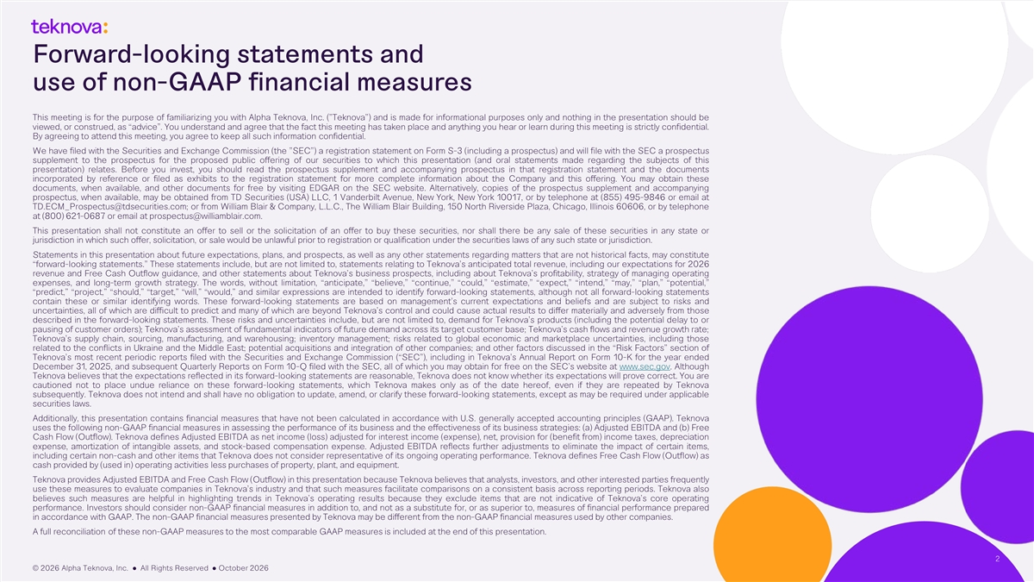
Forward-looking statements and use of non-GAAP financial measures This meeting is for the purpose of familiarizing you with Alpha Teknova, Inc. ( Teknova ) and is made for informational purposes only and nothing in the presentation should be viewed, or construed, as “advice”. You understand and agree that the fact this meeting has taken place and anything you hear or learn during this meeting is strictly confidential. By agreeing to attend this meeting, you agree to keep all such information confidential. We have filed with the Securities and Exchange Commission (the SEC ) a registration statement on Form S-3 (including a prospectus) and will file with the SEC a prospectus supplement to the prospectus for the proposed public offering of our securities to which this presentation (and oral statements made regarding the subjects of this presentation) relates. Before you invest, you should read the prospectus supplement and accompanying prospectus in that registration statement and the documents incorporated by reference or filed as exhibits to the registration statement for more complete information about the Company and this offering. You may obtain these documents, when available, and other documents for free by visiting EDGAR on the SEC website. Alternatively, copies of the prospectus supplement and accompanying prospectus, when available, may be obtained from TD Securities (USA) LLC, 1 Vanderbilt Avenue, New York, New York 10017, or by telephone at (855) 495-9846 or email at TD.ECM_Prospectus@tdsecurities.com; or from William Blair & Company, L.L.C., The William Blair Building, 150 North Riverside Plaza, Chicago, Illinois 60606, or by telephone at (800) 621-0687 or email at prospectus@williamblair.com. This presentation shall not constitute an offer to sell or the solicitation of an offer to buy these securities, nor shall there be any sale of these securities in any state or jurisdiction in which such offer, solicitation, or sale would be unlawful prior to registration or qualification under the securities laws of any such state or jurisdiction. Statements in this presentation about future expectations, plans, and prospects, as well as any other statements regarding matters that are not historical facts, may constitute “forward-looking statements.” These statements include, but are not limited to, statements relating to Teknova’s anticipated total revenue, including our expectations for 2026 revenue and Free Cash Outflow guidance, and other statements about Teknova’s business prospects, including about Teknova’s profitability, strategy of managing operating expenses, and long-term growth strategy. The words, without limitation, “anticipate,” “believe,” “continue,” “could,” “estimate,” “expect,” “intend,” “may,” “plan,” “potential,” “predict,” “project,” “should,” “target,” “will,” “would,” and similar expressions are intended to identify forward-looking statements, although not all forward-looking statements contain these or similar identifying words. These forward-looking statements are based on management’s current expectations and beliefs and are subject to risks and uncertainties, all of which are difficult to predict and many of which are beyond Teknova’s control and could cause actual results to differ materially and adversely from those described in the forward-looking statements. These risks and uncertainties include, but are not limited to, demand for Teknova’s products (including the potential delay to or pausing of customer orders); Teknova’s assessment of fundamental indicators of future demand across its target customer base; Teknova’s cash flows and revenue growth rate; Teknova’s supply chain, sourcing, manufacturing, and warehousing; inventory management; risks related to global economic and marketplace uncertainties, including those related to the conflicts in Ukraine and the Middle East; potential acquisitions and integration of other companies; and other factors discussed in the “Risk Factors” section of Teknova’s most recent periodic reports filed with the Securities and Exchange Commission (“SEC”), including in Teknova’s Annual Report on Form 10-K for the year ended December 31, 2025, and subsequent Quarterly Reports on Form 10-Q filed with the SEC, all of which you may obtain for free on the SEC’s website at www.sec.gov. Although Teknova believes that the expectations reflected in its forward-looking statements are reasonable, Teknova does not know whether its expectations will prove correct. You are cautioned not to place undue reliance on these forward-looking statements, which Teknova makes only as of the date hereof, even if they are repeated by Teknova subsequently. Teknova does not intend and shall have no obligation to update, amend, or clarify these forward-looking statements, except as may be required under applicable securities laws. Additionally, this presentation contains financial measures that have not been calculated in accordance with U.S. generally accepted accounting principles (GAAP). Teknova uses the following non-GAAP financial measures in assessing the performance of its business and the effectiveness of its business strategies: (a) Adjusted EBITDA and (b) Free Cash Flow (Outflow). Teknova defines Adjusted EBITDA as net income (loss) adjusted for interest income (expense), net, provision for (benefit from) income taxes, depreciation expense, amortization of intangible assets, and stock-based compensation expense. Adjusted EBITDA reflects further adjustments to eliminate the impact of certain items, including certain non-cash and other items that Teknova does not consider representative of its ongoing operating performance. Teknova defines Free Cash Flow (Outflow) as cash provided by (used in) operating activities less purchases of property, plant, and equipment. Teknova provides Adjusted EBITDA and Free Cash Flow (Outflow) in this presentation because Teknova believes that analysts, investors, and other interested parties frequently use these measures to evaluate companies in Teknova’s industry and that such measures facilitate comparisons on a consistent basis across reporting periods. Teknova also believes such measures are helpful in highlighting trends in Teknova’s operating results because they exclude items that are not indicative of Teknova’s core operating performance. Investors should consider non-GAAP financial measures in addition to, and not as a substitute for, or as superior to, measures of financial performance prepared in accordance with GAAP. The non-GAAP financial measures presented by Teknova may be different from the non-GAAP financial measures used by other companies. A full reconciliation of these non-GAAP measures to the most comparable GAAP measures is included at the end of this presentation. 2 © 2026 Alpha Teknova, Inc. ● All Rights Reserved ● October 2026

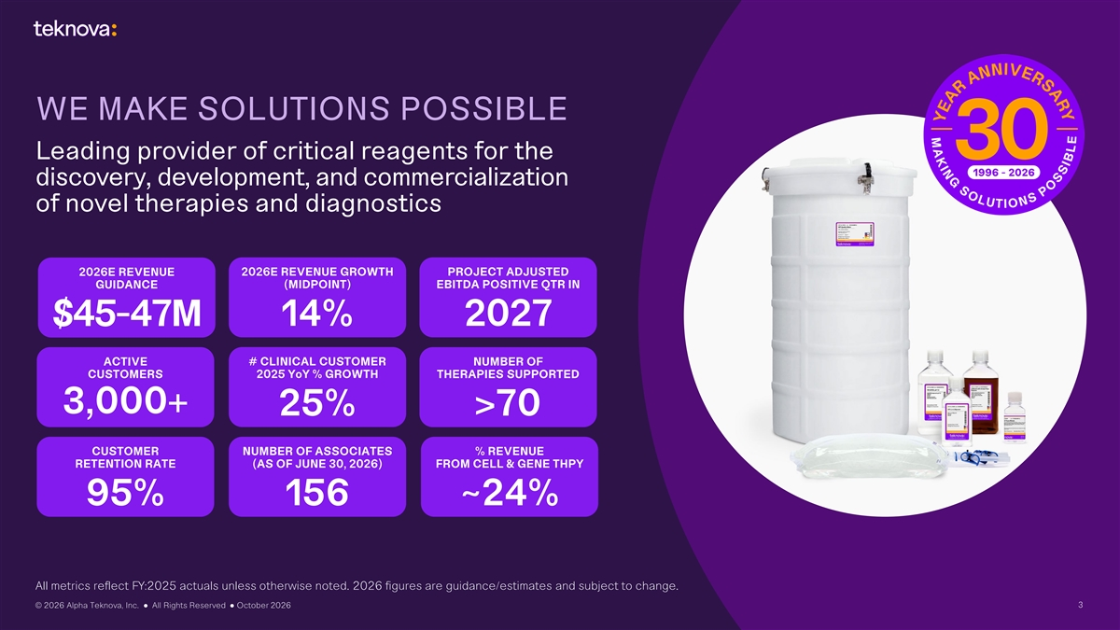
WE MAKE SOLUTIONS POSSIBLE Leading provider of critical reagents for the discovery, development, and commercialization of novel therapies and diagnostics 2026E REVENUE GROWTH PROJECT ADJUSTED 2026E REVENUE GUIDANCE (MIDPOINT) EBITDA POSITIVE QTR IN 14% 2027 $45-47M ACTIVE # CLINICAL CUSTOMER NUMBER OF CUSTOMERS 2025 YoY % GROWTH THERAPIES SUPPORTED 3,000+ 25% >70 CUSTOMER NUMBER OF ASSOCIATES % REVENUE RETENTION RATE (AS OF JUNE 30, 2026) FROM CELL & GENE THPY 95% 156 ~24% All metrics reflect FY:2025 actuals unless otherwise noted. 2026 figures are guidance/estimates and subject to change. © 2026 Alpha Teknova, Inc. ● All Rights Reserved ● October 2026 3

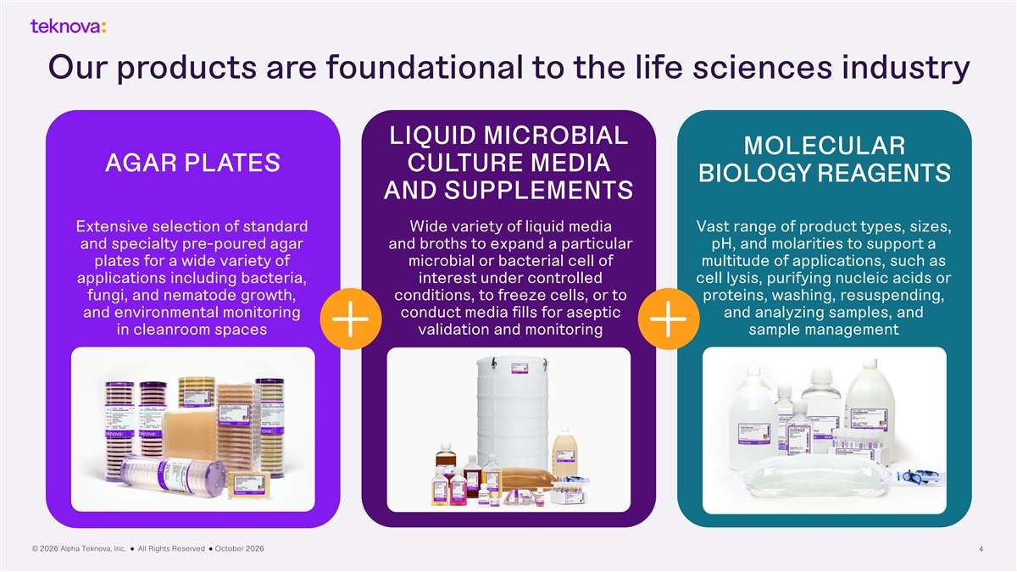
Our products are foundational to the life sciences industry LIQUID MICROBIAL MOLECULAR AGAR PLATES CULTURE MEDIA BIOLOGY REAGENTS AND SUPPLEMENTS Extensive selection of standard Wide variety of liquid media Vast range of product types, sizes, and specialty pre-poured agar and broths to expand a particular pH, and molarities to support a plates for a wide variety of microbial or bacterial cell of multitude of applications, such as applications including bacteria, interest under controlled cell lysis, purifying nucleic acids or fungi, and nematode growth, conditions, to freeze cells, or to proteins, washing, resuspending, and environmental monitoring conduct media fills for aseptic and analyzing samples, and in cleanroom spaces validation and monitoring sample management © 2026 Alpha Teknova, Inc. ● All Rights Reserved ● October 2026 4

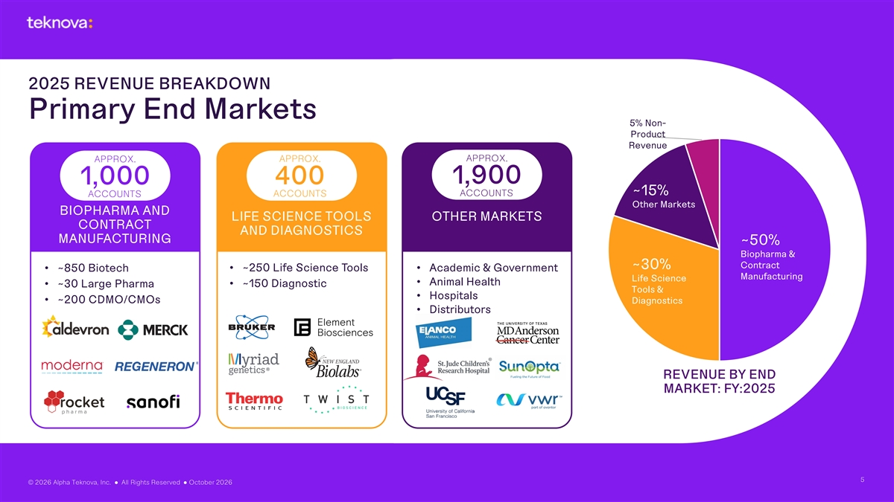
2025 REVENUE BREAKDOWN Primary End Markets 5% Non- Product Revenue APPROX. APPROX. APPROX. 400 1,900 1,000 ~15% ACCOUNTS ACCOUNTS ACCOUNTS Other Markets BIOPHARMA AND LIFE SCIENCE TOOLS OTHER MARKETS CONTRACT AND DIAGNOSTICS MANUFACTURING ~50% Biopharma & Contract ~30% • ~850 Biotech • ~250 Life Science Tools • Academic & Government Manufacturing Life Science • Animal Health • ~30 Large Pharma • ~150 Diagnostic Tools & • Hospitals • ~200 CDMO/CMOs Diagnostics • Distributors REVENUE BY END MARKET: FY:2025 5 © 2026 Alpha Teknova, Inc. ● All Rights Reserved ● October 2026

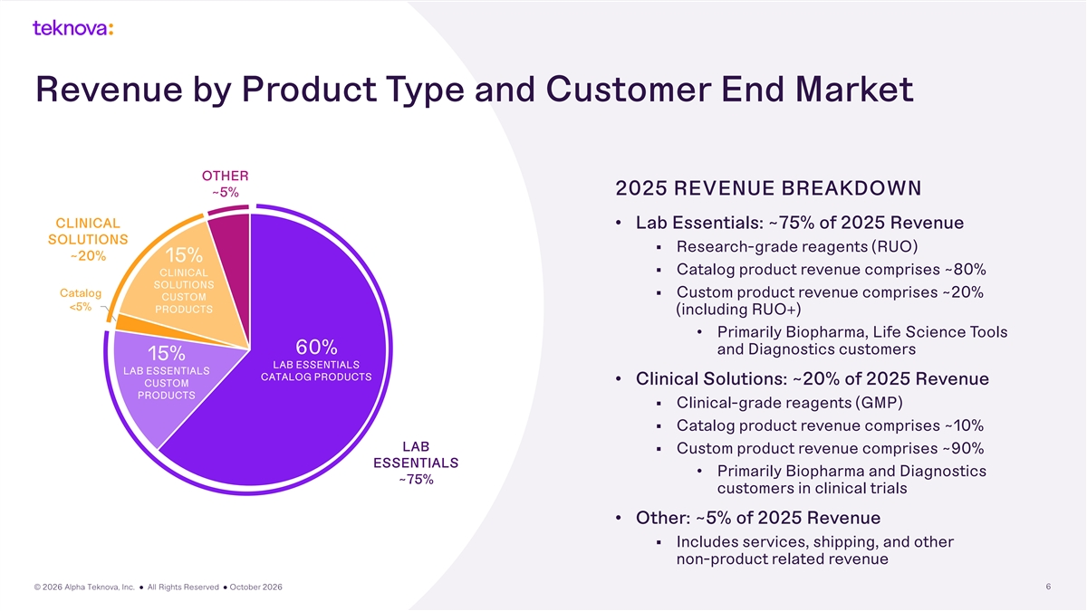
Revenue by Product Type and Customer End Market Total 2024 Revenue by OTHER Product Type and End Market 2025 REVENUE BREAKDOWN ~5% CLINICAL • Lab Essentials: ~75% of 2025 Revenue SOLUTIONS § Research-grade reagents (RUO) ~20% 15% § Catalog product revenue comprises ~80% CLINICAL SOLUTIONS Catalog § Custom product revenue comprises ~20% CUSTOM <5% PRODUCTS (including RUO+) • Primarily Biopharma, Life Science Tools 60% and Diagnostics customers 15% LAB ESSENTIALS LAB ESSENTIALS CATALOG PRODUCTS • Clinical Solutions: ~20% of 2025 Revenue CUSTOM PRODUCTS § Clinical-grade reagents (GMP) § Catalog product revenue comprises ~10% LAB § Custom product revenue comprises ~90% ESSENTIALS • Primarily Biopharma and Diagnostics ~75% customers in clinical trials • Other: ~5% of 2025 Revenue § Includes services, shipping, and other non-product related revenue © 2026 Alpha Teknova, Inc. ● All Rights Reserved ● October 2026 6

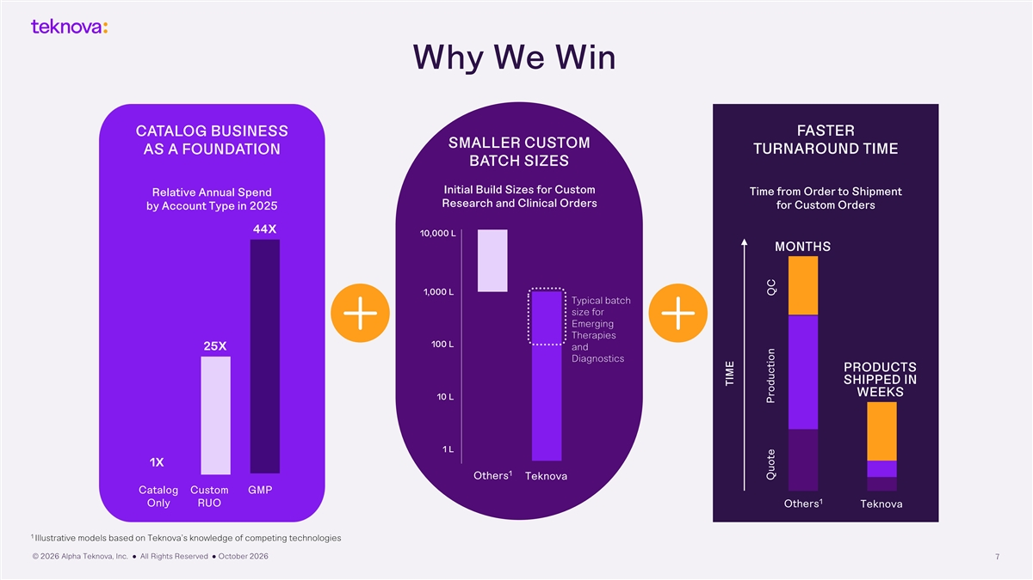
Why We Win FASTER CATALOG BUSINESS SMALLER CUSTOM TURNAROUND TIME AS A FOUNDATION BATCH SIZES Initial Build Sizes for Custom Time from Order to Shipment Relative Annual Spend Research and Clinical Orders by Account Type in 2025 for Custom Orders 44X 10,000 L MONTHS 1,000 L Typical batch size for Emerging Therapies 100 L 25X and Diagnostics PRODUCTS SHIPPED IN WEEKS 10 L 1 L 1X 1 Others Teknova Catalog Custom GMP 1 Only RUO Others Teknova 1 Illustrative models based on Teknova’s knowledge of competing technologies © 2026 Alpha Teknova, Inc. ● All Rights Reserved ● October 2026 7 TIME Quote Production QC

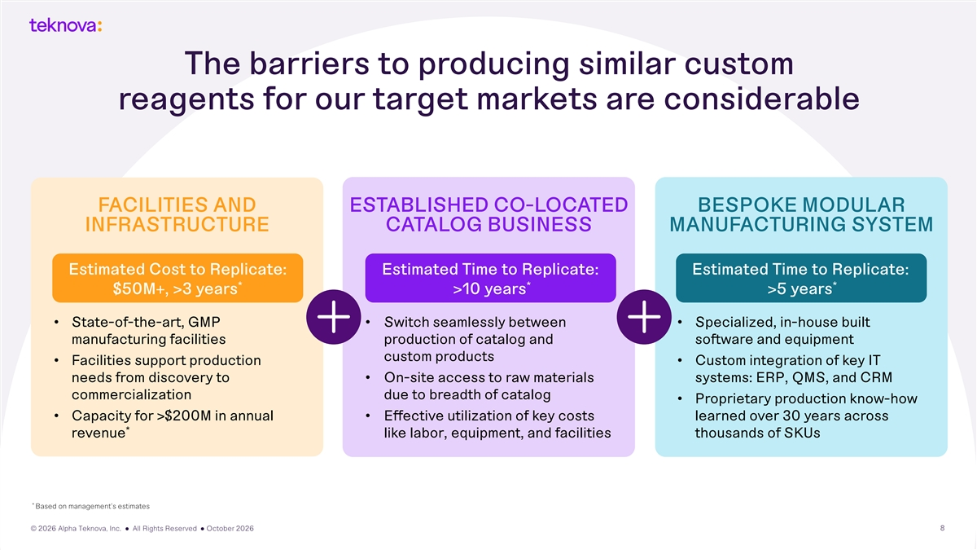
The barriers to producing similar custom reagents for our target markets are considerable FACILITIES AND ESTABLISHED CO-LOCATED BESPOKE MODULAR INFRASTRUCTURE CATALOG BUSINESS MANUFACTURING SYSTEM Estimated Cost to Replicate: Estimated Time to Replicate: Estimated Time to Replicate: * * * $50M+, >3 years >10 years >5 years • State-of-the-art, GMP • Switch seamlessly between • Specialized, in-house built manufacturing facilities production of catalog and software and equipment custom products • Facilities support production • Custom integration of key IT needs from discovery to • On-site access to raw materials systems: ERP, QMS, and CRM commercialization due to breadth of catalog • Proprietary production know-how • Capacity for >$200M in annual • Effective utilization of key costs learned over 30 years across * revenue like labor, equipment, and facilities thousands of SKUs * Based on management’s estimates © 2026 Alpha Teknova, Inc. ● All Rights Reserved ● October 2026 8

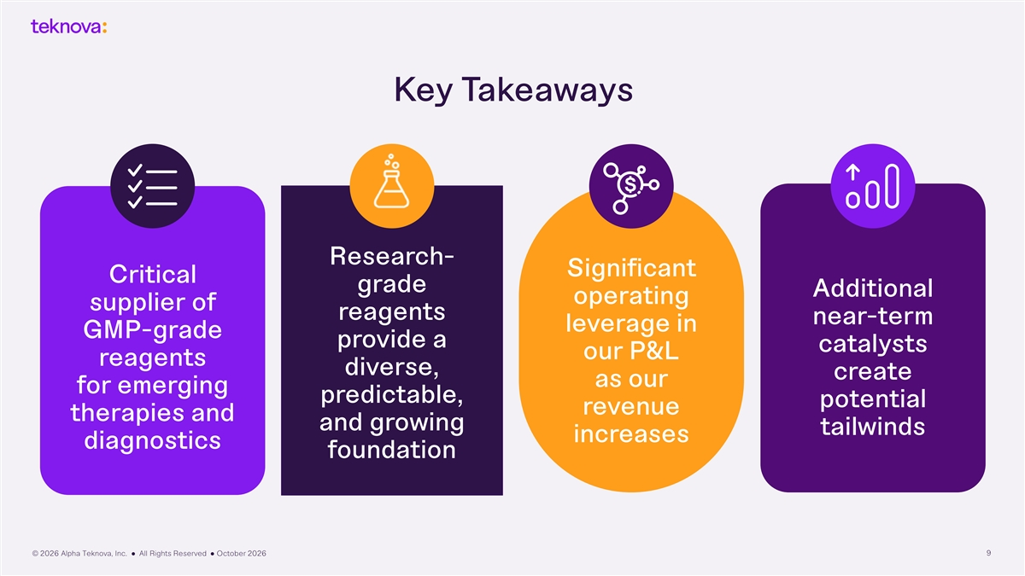
Key Takeaways Research- Significant Critical grade Additional operating supplier of reagents near-term leverage in GMP-grade provide a catalysts our P&L reagents diverse, create as our for emerging predictable, potential revenue therapies and and growing tailwinds increases diagnostics foundation © 2026 Alpha Teknova, Inc. ● All Rights Reserved ● October 2026 9


Continued success in attracting clinical customers 1 NUMBER OF CLINICAL SOLUTIONS CUSTOMERS 60 10 48 6 35 7 26 23 50 4 42 6 13 36% 28 2 22 17 2020-2025 11 CAGR 2020 2021 2022 2023 2024 2025 Biopharma Tools/Dx/Other Total 1 Customer is defined as any customer purchasing within the fiscal year. There is a $5,000 minimum threshold for Clinical Solutions customers. © 2026 Alpha Teknova, Inc. ● All Rights Reserved ● October 2026 10

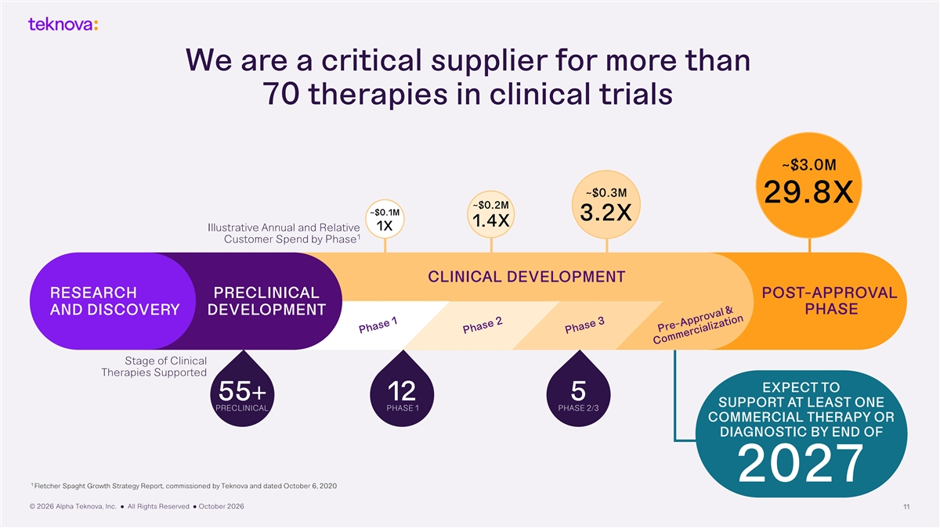
We are a critical supplier for more than 70 therapies in clinical trials ~$3.0M ~$0.3M 29.8X ~$0.2M ~$0.1M 3.2X 1.4X 1X Illustrative Annual and Relative 1 Customer Spend by Phase CLINICAL DEVELOPMENT RESEARCH PRECLINICAL POST-APPROVAL AND DISCOVERY DEVELOPMENT PHASE Stage of Clinical Therapies Supported EXPECT TO 55+ 12 5 SUPPORT AT LEAST ONE PRECLINICAL PHASE 1 PHASE 2/3 COMMERCIAL THERAPY OR DIAGNOSTIC BY END OF 2027 1 Fletcher Spaght Growth Strategy Report, commissioned by Teknova and dated October 6, 2020 © 2026 Alpha Teknova, Inc. ● All Rights Reserved ● October 2026 11

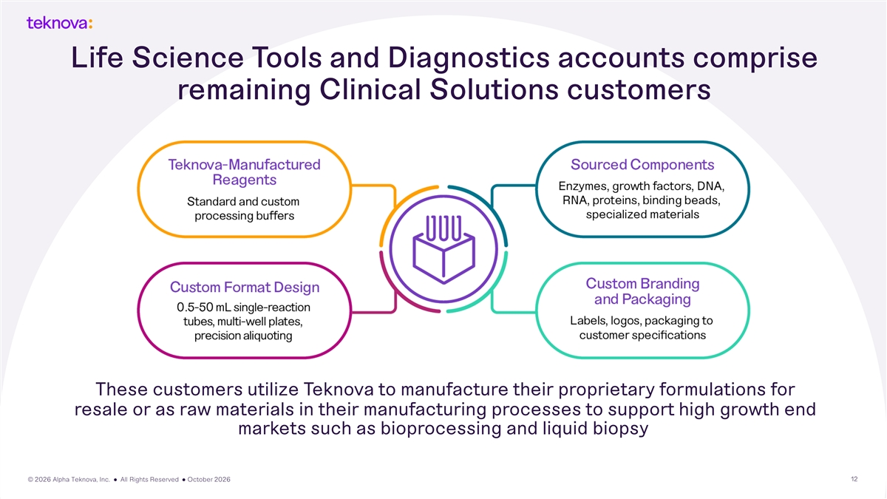
Life Science Tools and Diagnostics accounts comprise remaining Clinical Solutions customers These customers utilize Teknova to manufacture their proprietary formulations for resale or as raw materials in their manufacturing processes to support high growth end markets such as bioprocessing and liquid biopsy © 2026 Alpha Teknova, Inc. ● All Rights Reserved ● October 2026 12

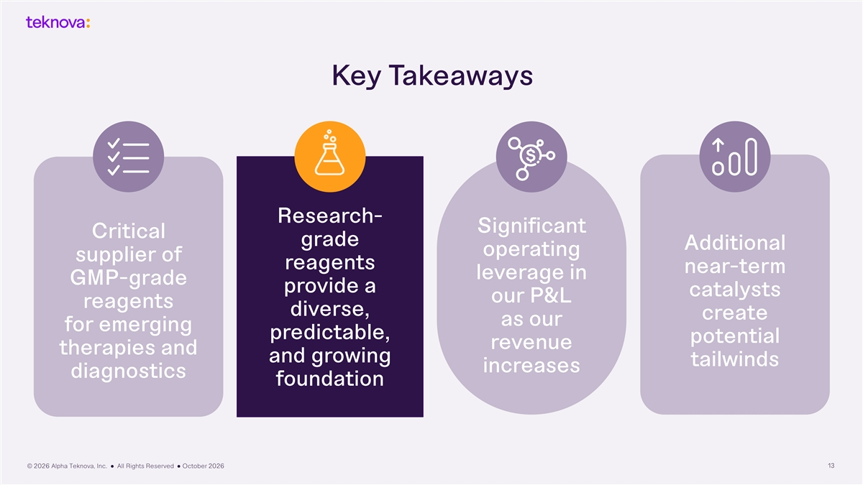
Key Takeaways Research- Significant Critical grade Additional operating supplier of reagents near-term leverage in GMP-grade provide a catalysts our P&L reagents diverse, create as our for emerging predictable, potential revenue therapies and and growing tailwinds increases diagnostics foundation © 2026 Alpha Teknova, Inc. ● All Rights Reserved ● October 2026 13

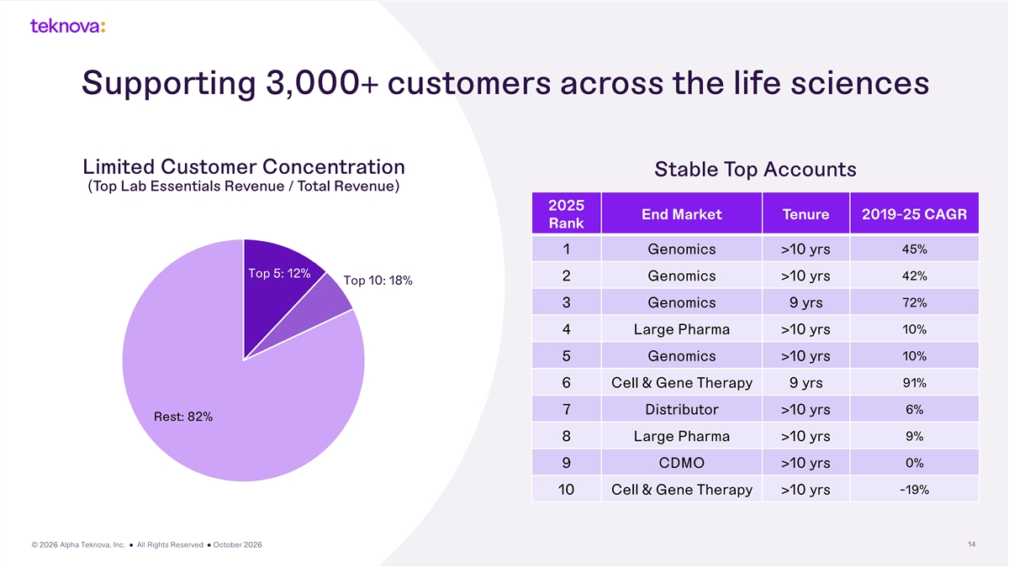
Supporting 3,000+ customers across the life sciences Limited Customer Concentration Stable Top Accounts (Top Lab Essentials Revenue / Total Revenue) 2025 End Market Tenure 2019-25 CAGR Rank 1 Genomics >10 yrs 45% Top 5: 12% 42% 2 Genomics >10 yrs Top 10: 18% 72% 3 Genomics 9 yrs 4 Large Pharma >10 yrs 10% 10% 5 Genomics >10 yrs 6 Cell & Gene Therapy 9 yrs 91% 6% 7 Distributor >10 yrs Rest: 82% 8 Large Pharma >10 yrs 9% 0% 9 CDMO >10 yrs 10 Cell & Gene Therapy >10 yrs -19% © 2026 Alpha Teknova, Inc. ● All Rights Reserved ● October 2026 14

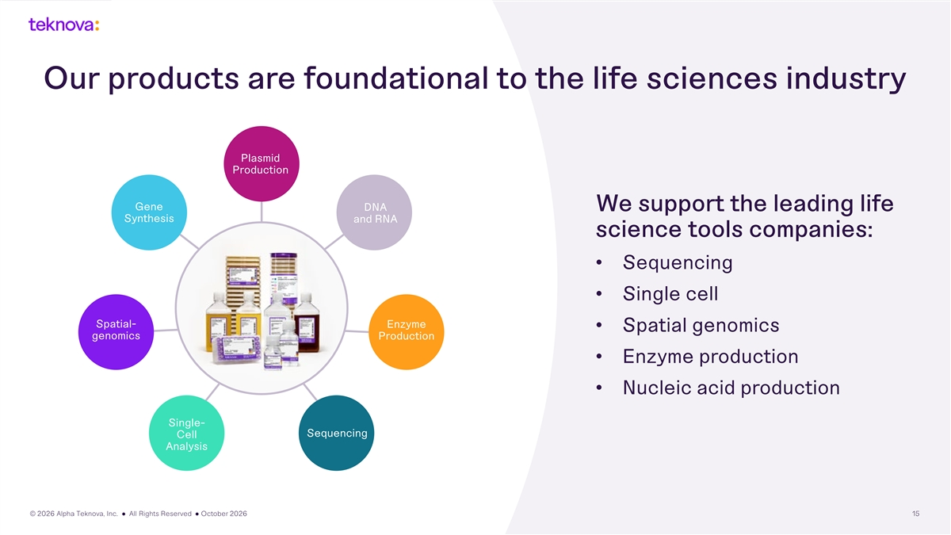
Our products are foundational to the life sciences industry Plasmid Production Gene DNA We support the leading life Synthesis and RNA science tools companies: • Sequencing • Single cell Spatial- Enzyme • Spatial genomics genomics Production • Enzyme production • Nucleic acid production Single- Sequencing Cell Analysis © 2026 Alpha Teknova, Inc. ● All Rights Reserved ● October 2026 15

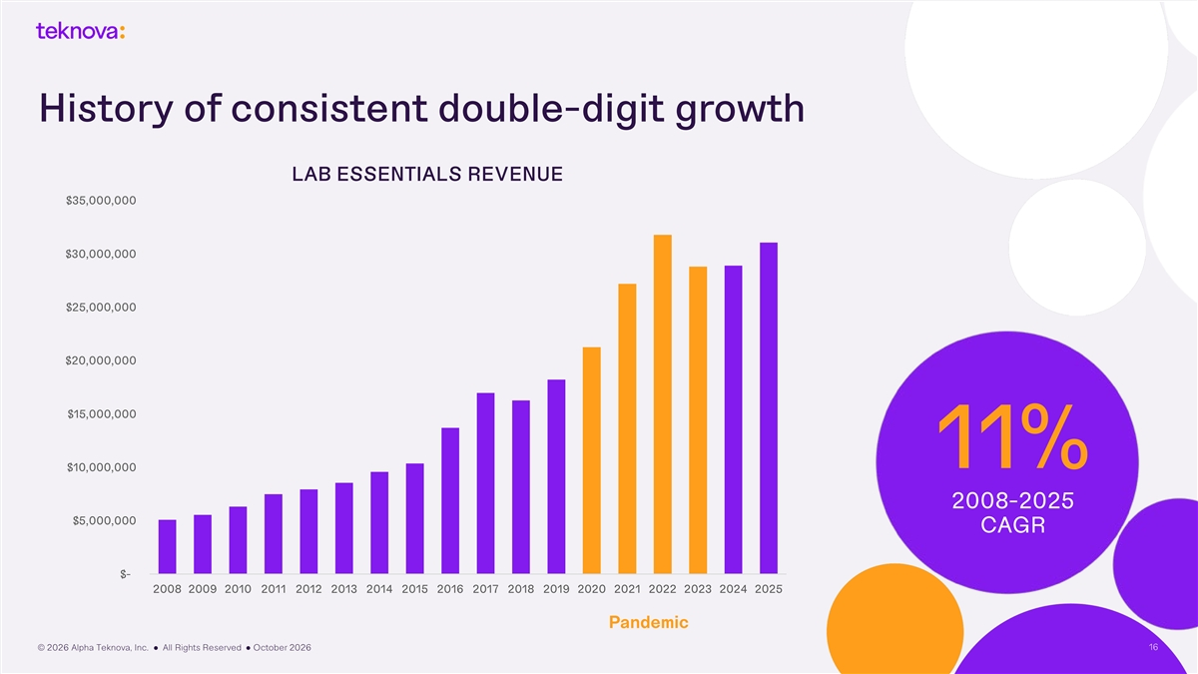
History of consistent double-digit growth LAB ESSENTIALS REVENUE $35,000,000 $30,000,000 $25,000,000 $20,000,000 $15,000,000 11% $10,000,000 2008-2025 $5,000,000 CAGR $- 2008 2009 2010 2011 2012 2013 2014 2015 2016 2017 2018 2019 2020 2021 2022 2023 2024 2025 Pandemic © 2026 Alpha Teknova, Inc. ● All Rights Reserved ● October 2026 16

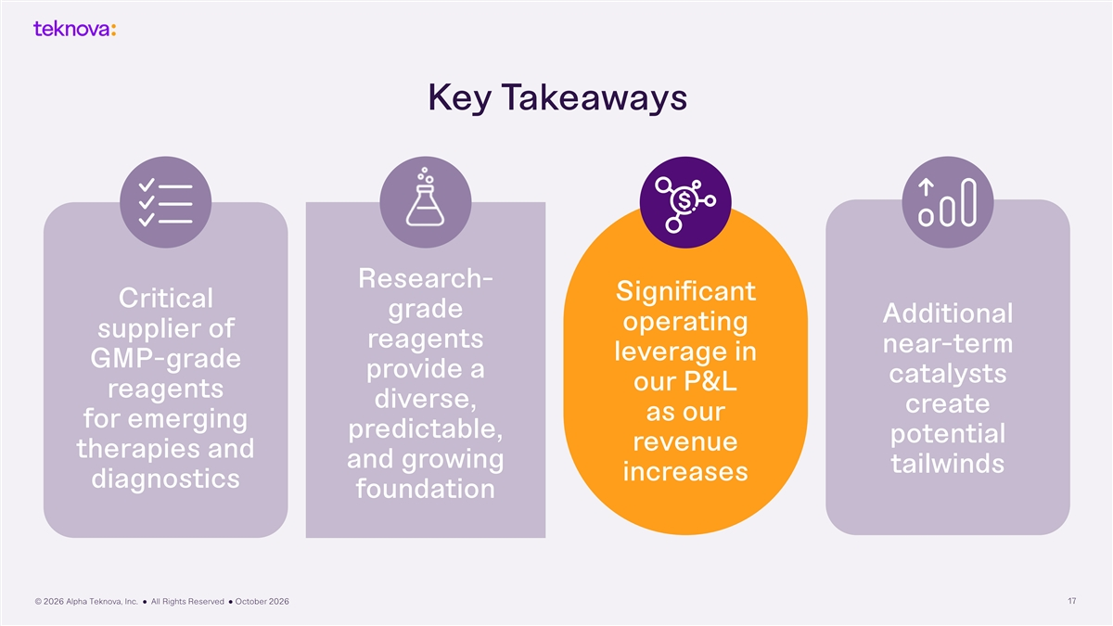
Key Takeaways Research- Significant Critical grade Additional operating supplier of reagents near-term leverage in GMP-grade provide a catalysts our P&L reagents diverse, create as our for emerging predictable, potential revenue therapies and and growing tailwinds increases diagnostics foundation © 2026 Alpha Teknova, Inc. ● All Rights Reserved ● October 2026 17

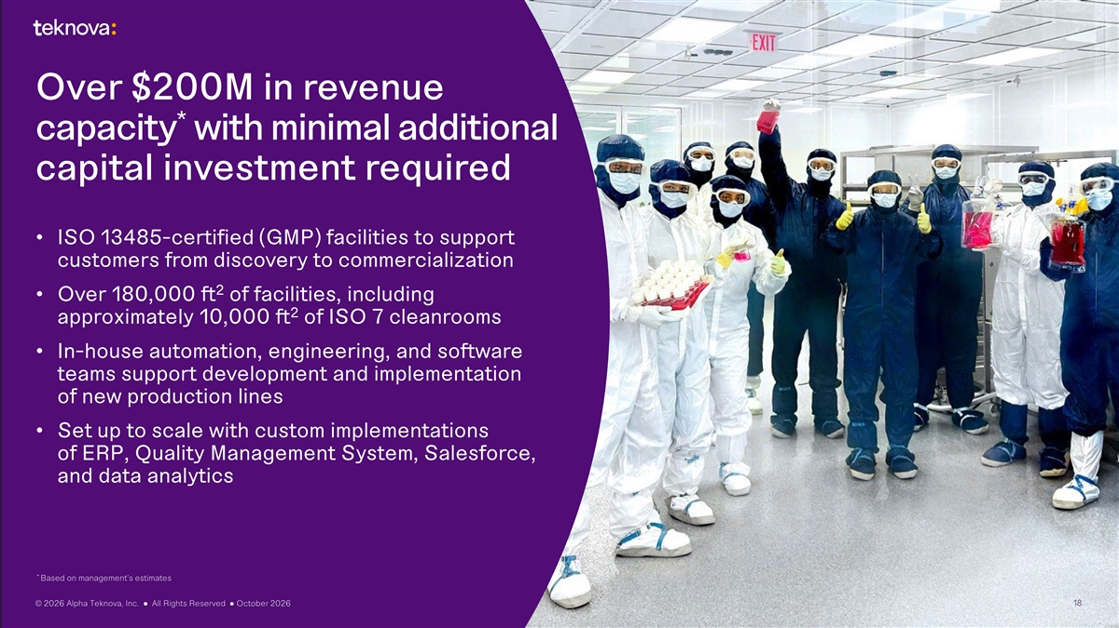
Over $200M in revenue * capacity with minimal additional capital investment required • ISO 13485-certified (GMP) facilities to support customers from discovery to commercialization 2 • Over 180,000 ft of facilities, including 2 approximately 10,000 ft of ISO 7 cleanrooms • In-house automation, engineering, and software teams support development and implementation of new production lines • Set up to scale with custom implementations of ERP, Quality Management System, Salesforce, and data analytics * Based on management’s estimates © 2026 Alpha Teknova, Inc. ● All Rights Reserved ● October 2026 18

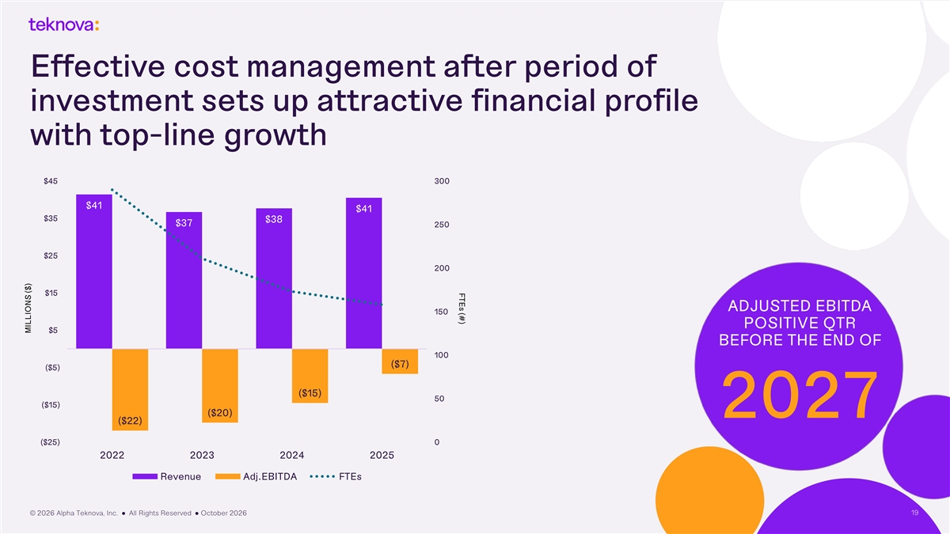
FTEs (#) Effective cost management after period of investment sets up attractive financial profile with top-line growth $45 300 $41 $41 $35 $38 $37 250 $25 200 $15 ADJUSTED EBITDA 150 POSITIVE QTR $5 BEFORE THE END OF 100 ($7) ($5) ($15) 50 ($15) ($20) 2027 ($22) ($25) 0 2022 2023 2024 2025 Revenue Adj.EBITDA FTEs © 2026 Alpha Teknova, Inc. ● All Rights Reserved ● October 2026 19 MILLIONS ($)

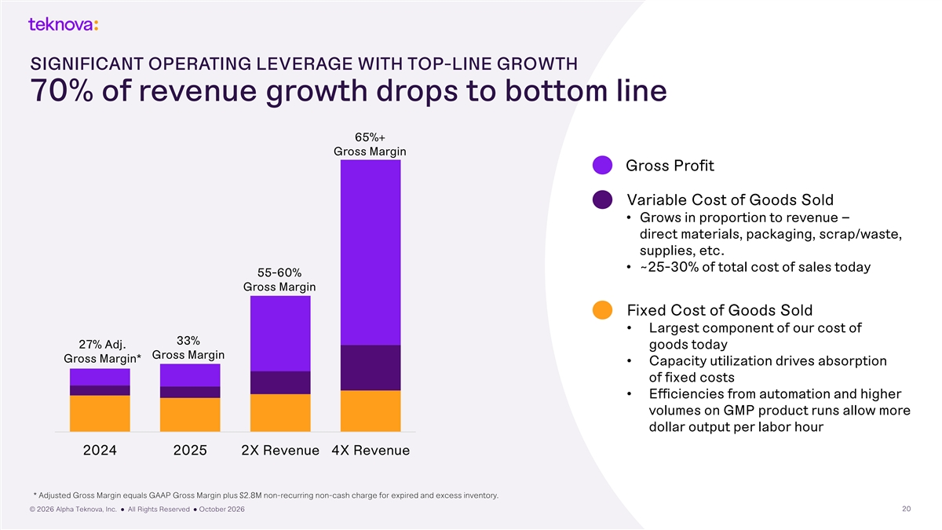
SIGNIFICANT OPERATING LEVERAGE WITH TOP-LINE GROWTH 70% of revenue growth drops to bottom line 65%+ Gross Margin Gross Profit Variable Cost of Goods Sold • Grows in proportion to revenue – direct materials, packaging, scrap/waste, supplies, etc. • ~25-30% of total cost of sales today 55-60% Gross Margin Fixed Cost of Goods Sold • Largest component of our cost of 33% 27% Adj. goods today Gross Margin Gross Margin* • Capacity utilization drives absorption of fixed costs • Efficiencies from automation and higher volumes on GMP product runs allow more dollar output per labor hour 2024 2025 2X Revenue 4X Revenue * Adjusted Gross Margin equals GAAP Gross Margin plus $2.8M non-recurring non-cash charge for expired and excess inventory. © 2026 Alpha Teknova, Inc. ● All Rights Reserved ● October 2026 20

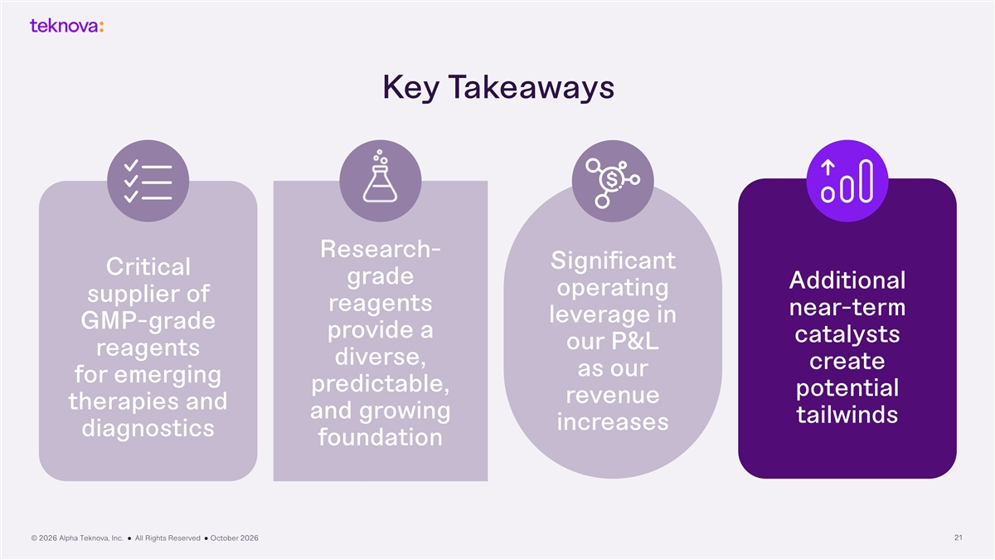
Key Takeaways Research- Significant Critical grade Additional operating supplier of reagents near-term leverage in GMP-grade provide a catalysts our P&L reagents diverse, create as our for emerging predictable, potential revenue therapies and and growing tailwinds increases diagnostics foundation © 2026 Alpha Teknova, Inc. ● All Rights Reserved ● October 2026 21

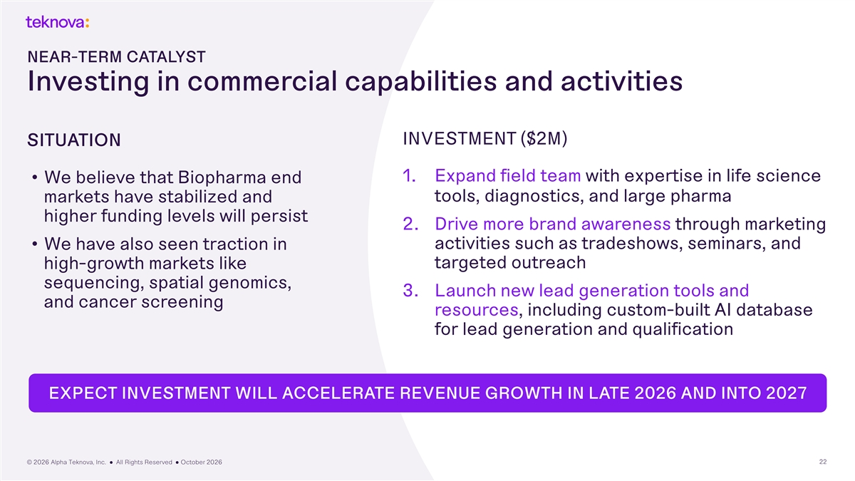
NEAR-TERM CATALYST Investing in commercial capabilities and activities INVESTMENT ($2M) SITUATION 1. Expand field team with expertise in life science • We believe that Biopharma end markets have stabilized and tools, diagnostics, and large pharma higher funding levels will persist 2. Drive more brand awareness through marketing activities such as tradeshows, seminars, and • We have also seen traction in targeted outreach high-growth markets like sequencing, spatial genomics, 3. Launch new lead generation tools and and cancer screening resources, including custom-built AI database for lead generation and qualification EXPECT INVESTMENT WILL ACCELERATE REVENUE GROWTH IN LATE 2026 AND INTO 2027 © 2026 Alpha Teknova, Inc. ● All Rights Reserved ● October 2026 22

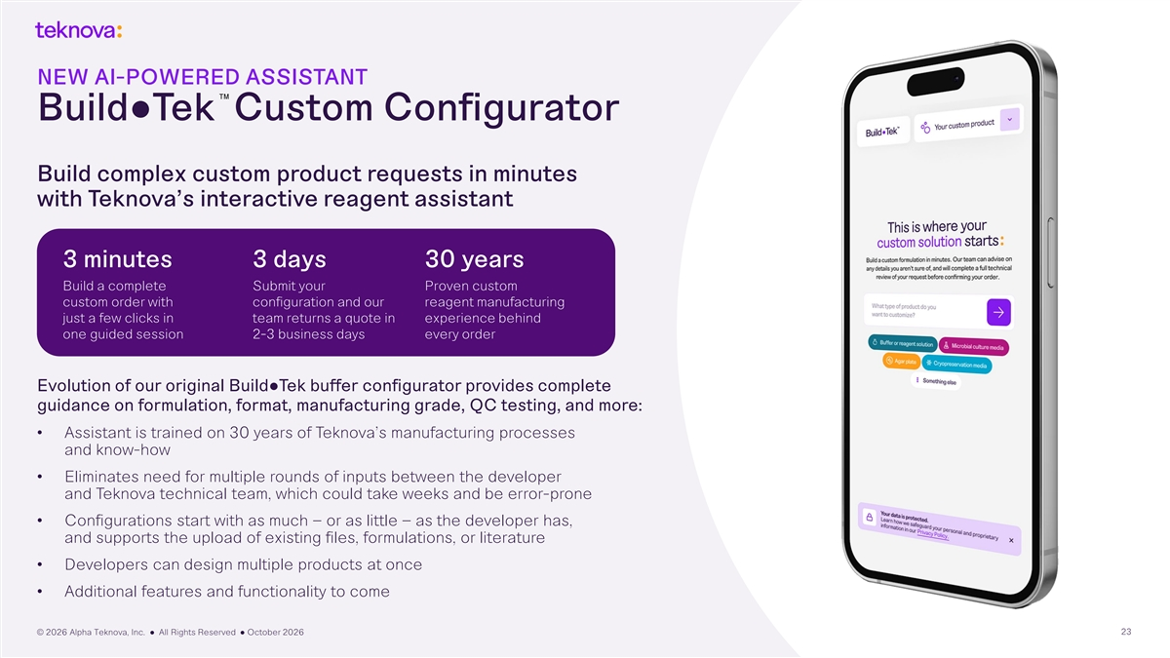
NEW AI-POWERED ASSISTANT TM Build●Tek Custom Configurator Build complex custom product requests in minutes with Teknova’s interactive reagent assistant 3 minutes 3 days 30 years Build a complete Submit your Proven custom custom order with configuration and our reagent manufacturing just a few clicks in team returns a quote in experience behind one guided session 2-3 business days every order Evolution of our original Build●Tek buffer configurator provides complete guidance on formulation, format, manufacturing grade, QC testing, and more: • Assistant is trained on 30 years of Teknova’s manufacturing processes and know-how • Eliminates need for multiple rounds of inputs between the developer and Teknova technical team, which could take weeks and be error-prone • Configurations start with as much – or as little – as the developer has, and supports the upload of existing files, formulations, or literature • Developers can design multiple products at once • Additional features and functionality to come © 2026 Alpha Teknova, Inc. ● All Rights Reserved ● October 2026 23

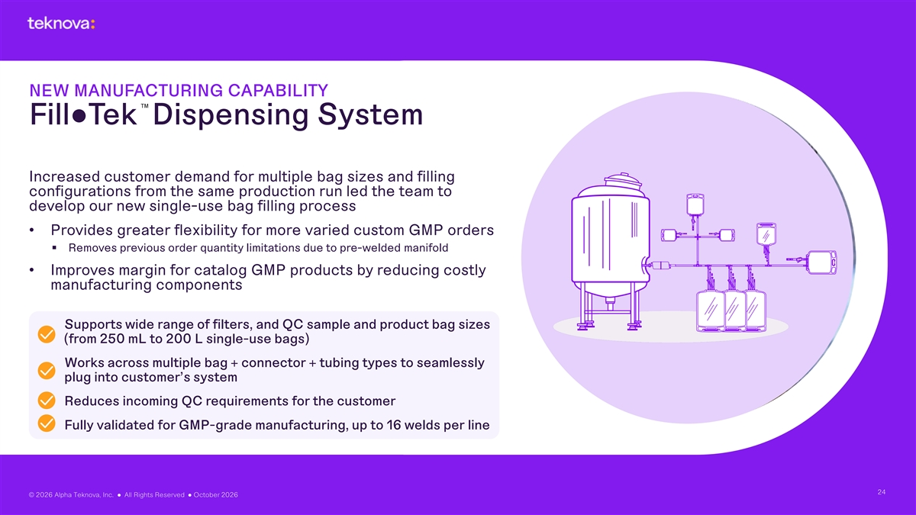
NEW MANUFACTURING CAPABILITY TM Fill●Tek Dispensing System Increased customer demand for multiple bag sizes and filling configurations from the same production run led the team to develop our new single-use bag filling process • Provides greater flexibility for more varied custom GMP orders § Removes previous order quantity limitations due to pre-welded manifold • Improves margin for catalog GMP products by reducing costly manufacturing components Supports wide range of filters, and QC sample and product bag sizes (from 250 mL to 200 L single-use bags) Works across multiple bag + connector + tubing types to seamlessly plug into customer’s system Reduces incoming QC requirements for the customer Fully validated for GMP-grade manufacturing, up to 16 welds per line 24 © 2026 Alpha Teknova, Inc. ● All Rights Reserved ● October 2026

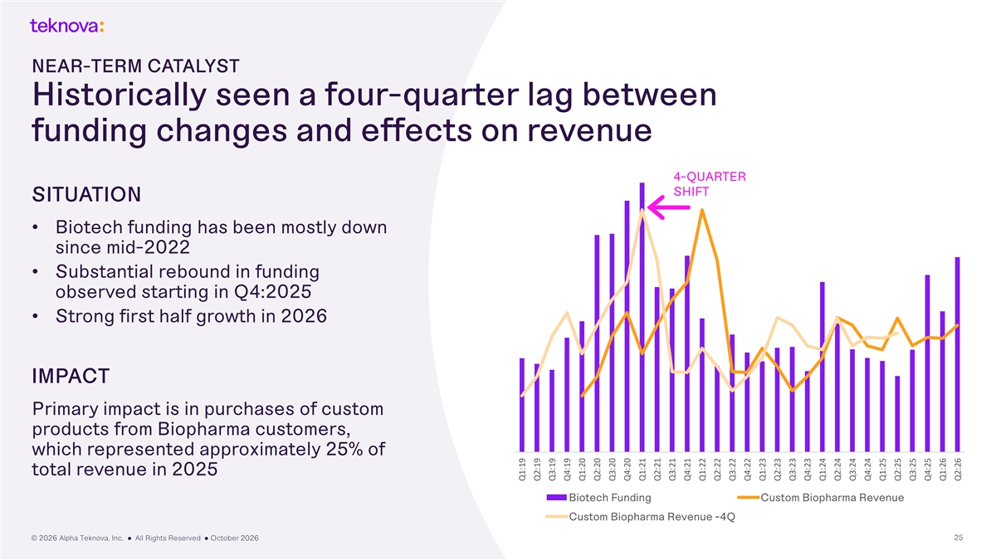
NEAR-TERM CATALYST Historically seen a four-quarter lag between funding changes and effects on revenue 45 6 4-QUARTER 40 SHIFT SITUATION 5 35 • Biotech funding has been mostly down since mid-2022 30 4 • Substantial rebound in funding 25 observed starting in Q4:2025 3 • Strong first half growth in 2026 20 15 2 IMPACT 10 1 Primary impact is in purchases of custom 5 products from Biopharma customers, which represented approximately 25% of - 0 total revenue in 2025 Biotech Funding Custom Biopharma Revenue Custom Biopharma Revenue -4Q © 2026 Alpha Teknova, Inc. ● All Rights Reserved ● October 2026 25 Q1:19 Q2:19 Q3:19 Q4:19 Q1:20 Q2:20 Q3:20 Q4:20 Q1:21 Q2:21 Q3:21 Q4:21 Q1:22 Q2:22 Q3:22 Q4:22 Q1:23 Q2:23 Q3:23 Q4:23 Q1:24 Q2:24 Q3:24 Q4:24 Q1:25 Q2:25 Q3:25 Q4:25 Q1:26 Q2:26


NEAR-TERM CATALYST Opportunity to expand through tuck-in M&A Specific areas of interest: • Cell culture media and supplements • Transfection reagents • Cytokines, growth factors, enzymes, antibodies and other proteins • Geographic expansion © 2026 Alpha Teknova, Inc. ● All Rights Reserved ● October 2026 26

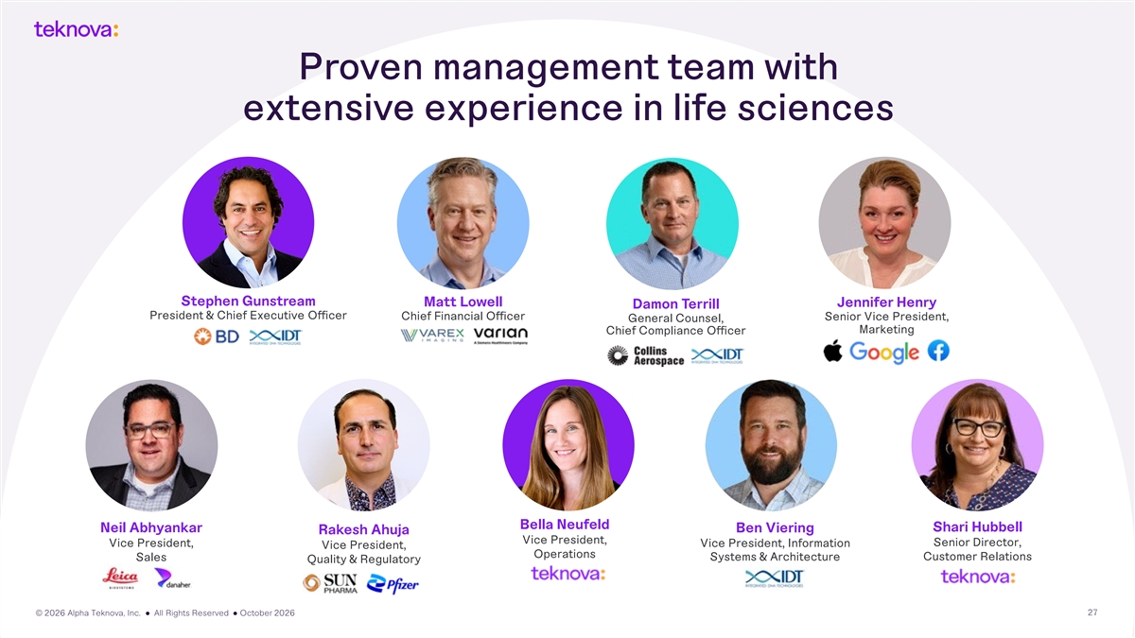
Proven management team with extensive experience in life sciences Stephen Gunstream Matt Lowell Jennifer Henry Damon Terrill President & Chief Executive Officer Chief Financial Officer Senior Vice President, General Counsel, Marketing Chief Compliance Officer Bella Neufeld Shari Hubbell Neil Abhyankar Ben Viering Rakesh Ahuja Vice President, Senior Director, Vice President, Vice President, Information Vice President, Operations Customer Relations Sales Systems & Architecture Quality & Regulatory © 2026 Alpha Teknova, Inc. ● All Rights Reserved ● October 2026 27

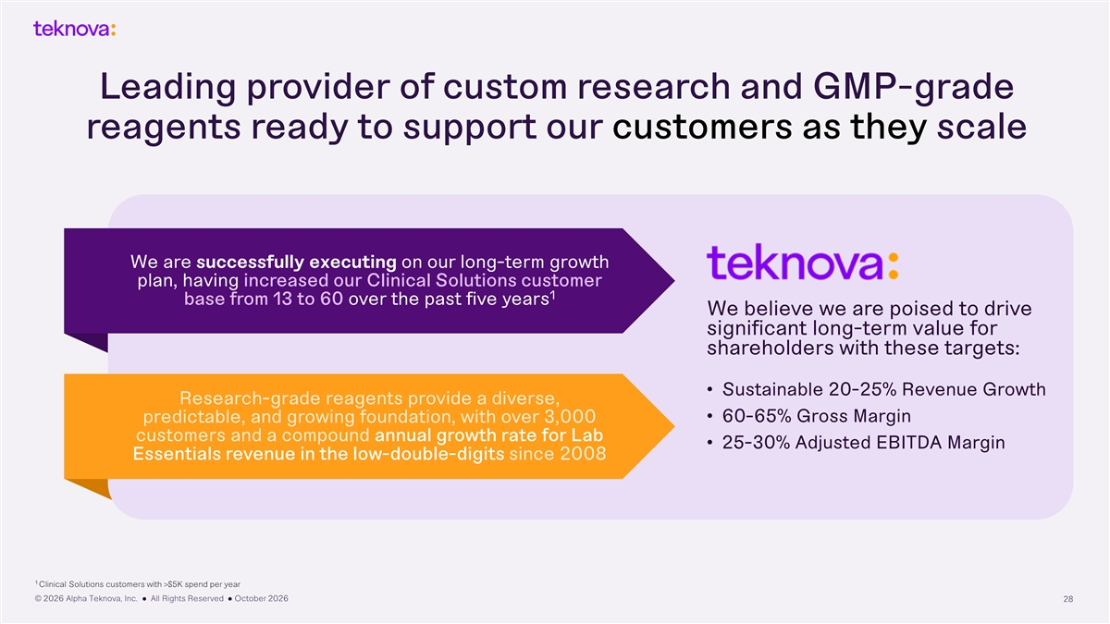
Leading provider of custom research and GMP-grade reagents ready to support our customers as they scale We are successfully executing on our long-term growth plan, having increased our Clinical Solutions customer 1 base from 13 to 60 over the past five years We believe we are poised to drive significant long-term value for shareholders with these targets: • Sustainable 20-25% Revenue Growth Research-grade reagents provide a diverse, • 60-65% Gross Margin predictable, and growing foundation, with over 3,000 customers and a compound annual growth rate for Lab • 25-30% Adjusted EBITDA Margin Essentials revenue in the low-double-digits since 2008 1 Clinical Solutions customers with >$5K spend per year © 2026 Alpha Teknova, Inc. ● All Rights Reserved ● October 2026 28


Q2:26 Financials

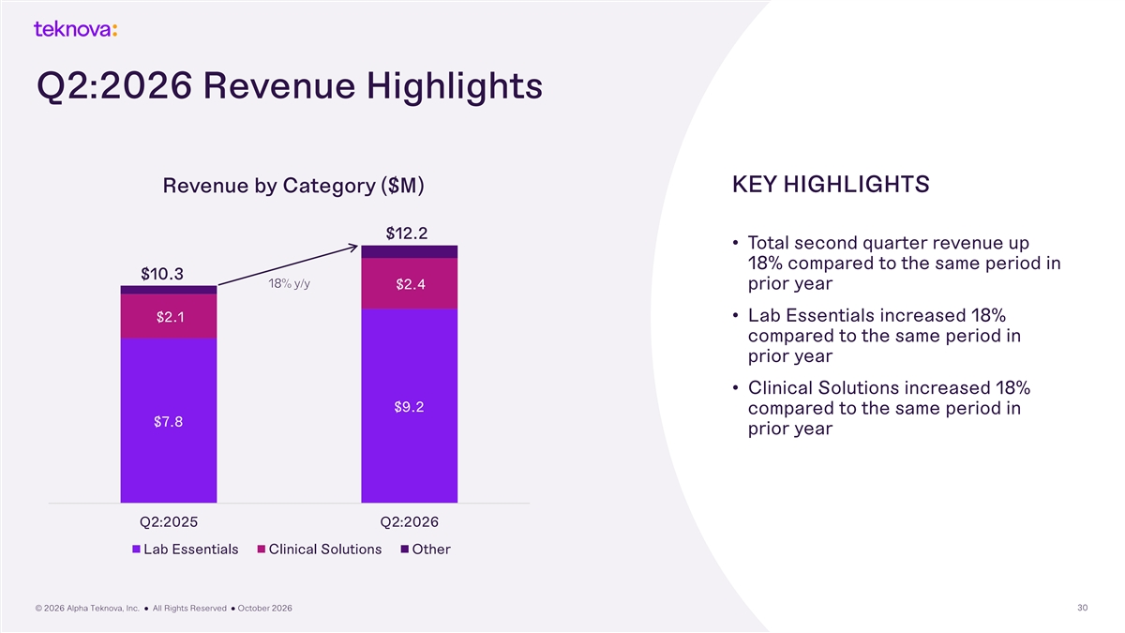
Q2:2026 Revenue Highlights Revenue by Category ($M) KEY HIGHLIGHTS $12.2 • Total second quarter revenue up 18% compared to the same period in $10.3 18% y/y $2.4 prior year • Lab Essentials increased 18% $2.1 compared to the same period in prior year • Clinical Solutions increased 18% $9.2 compared to the same period in $7.8 prior year Q2:2025 Q2:2026 Lab Essentials Clinical Solutions Other © 2026 Alpha Teknova, Inc. ● All Rights Reserved ● October 2026 30

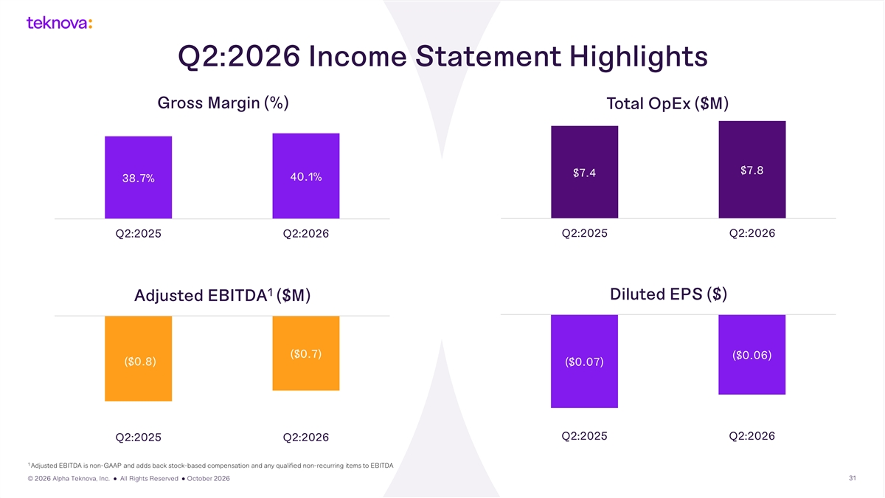
Q2:2026 Income Statement Highlights Gross Margin (%) Total OpEx ($M) $7.8 $7.4 40.1% 38.7% Q2:2025 Q2:2026 Q2:2025 Q2:2026 1 Diluted EPS ($) Adjusted EBITDA ($M) ($0.7) ($0.06) ($0.8) ($0.07) Q2:2025 Q2:2026 Q2:2025 Q2:2026 1 Adjusted EBITDA is non-GAAP and adds back stock-based compensation and any qualified non-recurring items to EBITDA © 2026 Alpha Teknova, Inc. ● All Rights Reserved ● October 2026 31

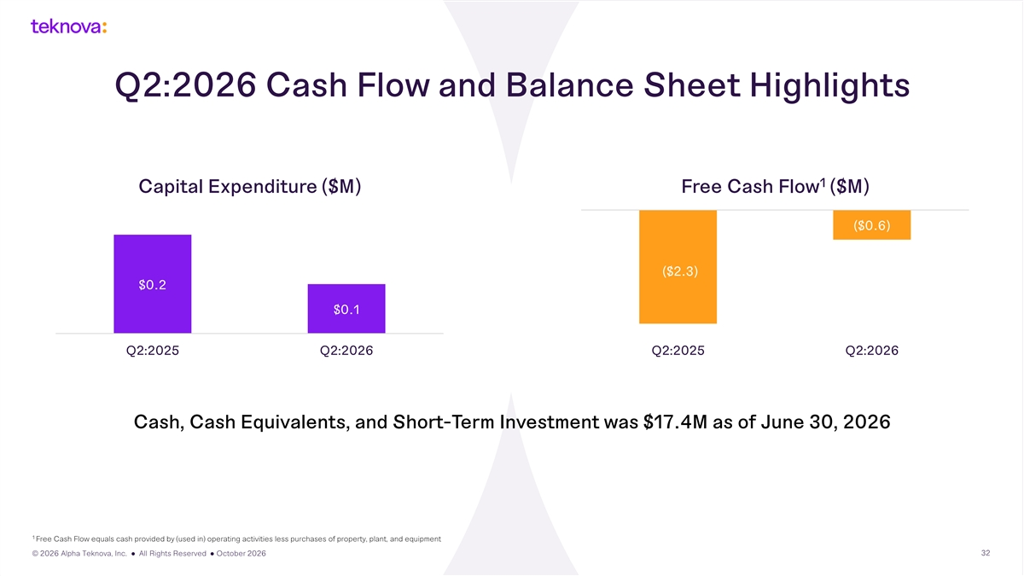
Q2:2026 Cash Flow and Balance Sheet Highlights 1 Capital Expenditure ($M) Free Cash Flow ($M) ($0.6) ($2.3) $0.2 $0.1 Q2:2025 Q2:2026 Q2:2025 Q2:2026 Cash, Cash Equivalents, and Short-Term Investment was $17.4M as of June 30, 2026 1 Free Cash Flow equals cash provided by (used in) operating activities less purchases of property, plant, and equipment © 2026 Alpha Teknova, Inc. ● All Rights Reserved ● October 2026 32

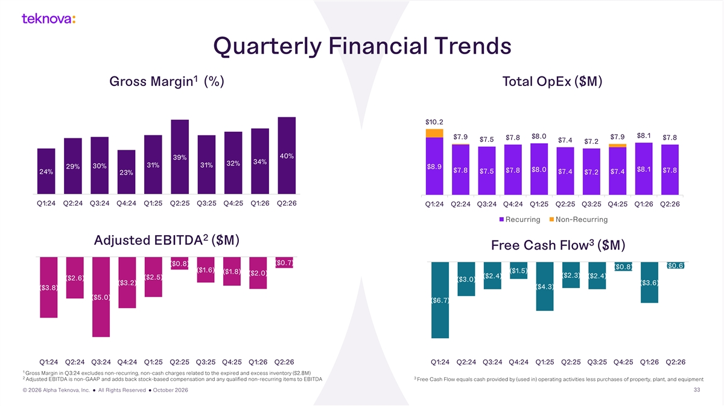
Quarterly Financial Trends 1 Gross Margin (%) Total OpEx ($M) $10.2 $8.0 $8.1 $7.9 $7.9 $7.8 $7.8 $7.5 $7.4 $7.2 40% 39% 34% 32% 31% 31% 30% 29% $8.9 $8.1 $8.0 $7.8 $7.8 $7.8 $7.5 $7.4 $7.4 24% $7.2 23% Q1:24 Q2:24 Q3:24 Q4:24 Q1:25 Q2:25 Q3:25 Q4:25 Q1:26 Q2:26 Q1:24 Q2:24 Q3:24 Q4:24 Q1:25 Q2:25 Q3:25 Q4:25 Q1:26 Q2:26 Recurring Non-Recurring 2 Adjusted EBITDA ($M) 3 Free Cash Flow ($M) ($0.7) ($0.8) ($0.6) ($0.8) ($1.6) ($1.5) ($1.8) ($2.0) ($2.4) ($2.3) ($2.4) ($2.5) ($2.6) ($3.0) ($3.6) ($3.2) ($4.3) ($3.8) ($5.0) ($6.7) Q1:24 Q2:24 Q3:24 Q4:24 Q1:25 Q2:25 Q3:25 Q4:25 Q1:26 Q2:26 Q1:24 Q2:24 Q3:24 Q4:24 Q1:25 Q2:25 Q3:25 Q4:25 Q1:26 Q2:26 1 Gross Margin in Q3:24 excludes non-recurring, non-cash charges related to the expired and excess inventory ($2.8M) 2 3 Adjusted EBITDA is non-GAAP and adds back stock-based compensation and any qualified non-recurring items to EBITDA Free Cash Flow equals cash provided by (used in) operating activities less purchases of property, plant, and equipment © 2026 Alpha Teknova, Inc. ● All Rights Reserved ● October 2026 33

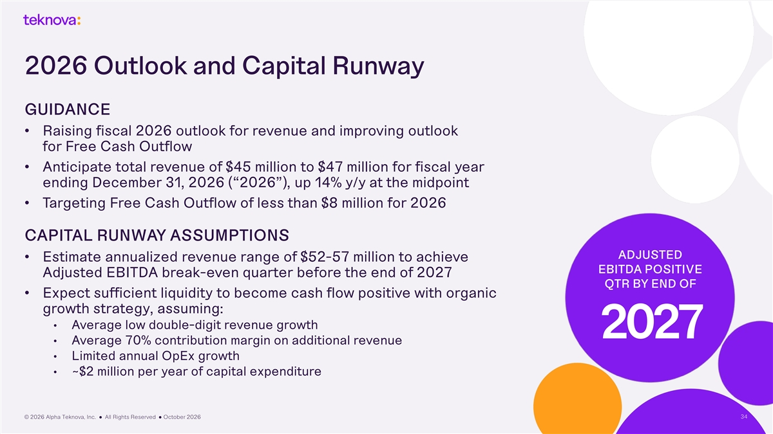
2026 Outlook and Capital Runway GUIDANCE • Raising fiscal 2026 outlook for revenue and improving outlook for Free Cash Outflow • Anticipate total revenue of $45 million to $47 million for fiscal year ending December 31, 2026 (“2026”), up 14% y/y at the midpoint • Targeting Free Cash Outflow of less than $8 million for 2026 CAPITAL RUNWAY ASSUMPTIONS ADJUSTED • Estimate annualized revenue range of $52-57 million to achieve EBITDA POSITIVE Adjusted EBITDA break-even quarter before the end of 2027 QTR BY END OF • Expect sufficient liquidity to become cash flow positive with organic growth strategy, assuming: • Average low double-digit revenue growth 2027 • Average 70% contribution margin on additional revenue • Limited annual OpEx growth • ~$2 million per year of capital expenditure © 2026 Alpha Teknova, Inc. ● All Rights Reserved ● October 2026 34


Preliminary Q3:26 Financials

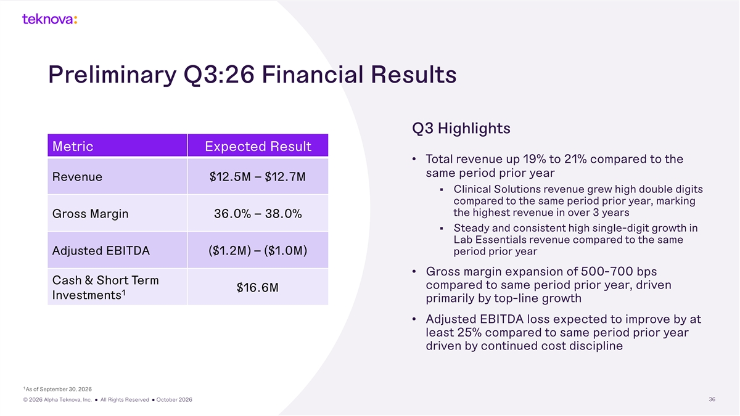
Preliminary Q3:26 Financial Results Q3 Highlights Metric Expected Result • Total revenue up 19% to 21% compared to the same period prior year Revenue $12.5M – $12.7M § Clinical Solutions revenue grew high double digits compared to the same period prior year, marking the highest revenue in over 3 years Gross Margin 36.0% – 38.0% § Steady and consistent high single-digit growth in Lab Essentials revenue compared to the same Adjusted EBITDA ($1.2M) – ($1.0M) period prior year • Gross margin expansion of 500-700 bps Cash & Short Term compared to same period prior year, driven $16.6M 1 Investments primarily by top-line growth • Adjusted EBITDA loss expected to improve by at least 25% compared to same period prior year driven by continued cost discipline 1 As of September 30, 2026 © 2026 Alpha Teknova, Inc. ● All Rights Reserved ● October 2026 36


Supplemental Non-GAAP Reconciliations

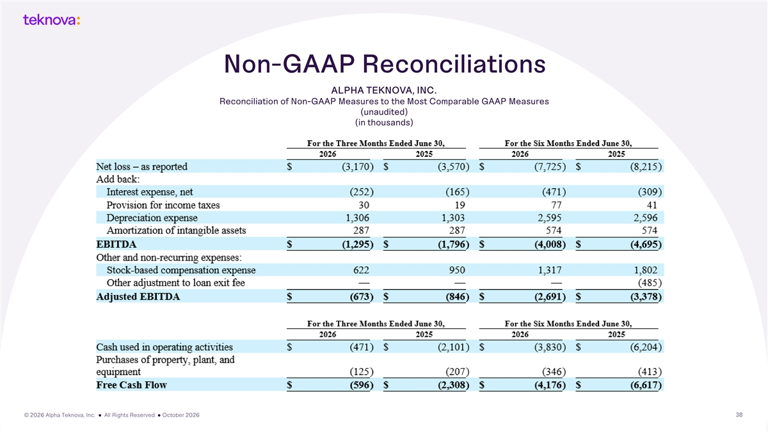
Non-GAAP Reconciliations ALPHA TEKNOVA, INC. Reconciliation of Non-GAAP Measures to the Most Comparable GAAP Measures (unaudited) (in thousands) © 2026 Alpha Teknova, Inc. ● All Rights Reserved ● October 2026 38



