UNITED STATES
SECURITIES AND EXCHANGE COMMISSION
Washington, D.C. 20549
SCHEDULE 14A INFORMATION
Proxy Statement Pursuant to Section 14(a) of
the Securities Exchange Act of 1934 (Amendment No.)
Filed by the Registrant ☒
Filed by a Party other than the Registrant ☐
Check the appropriate box:
☐ Preliminary Proxy Statement
☐ Confidential, for Use of the Commission Only (as permitted by Rule 14a-6(e)(2))
☐ Definitive Proxy Statement
☒ Definitive Additional Materials
☐ Soliciting Material under §240.14a-12
ALPHA TEKNOVA, INC.
(Name of Registrant as Specified In Its Charter)
N/A
(Name of Person(s) Filing Proxy Statement, if other than the Registrant)
Payment of Filing Fee (Check the appropriate box):
☒ No fee required.
☐ Fee paid previously with preliminary materials.
☐ Fee computed on table in exhibit required by Item 25(b) per Exchange Act Rules 14a-6(i)(1) and 0-11.

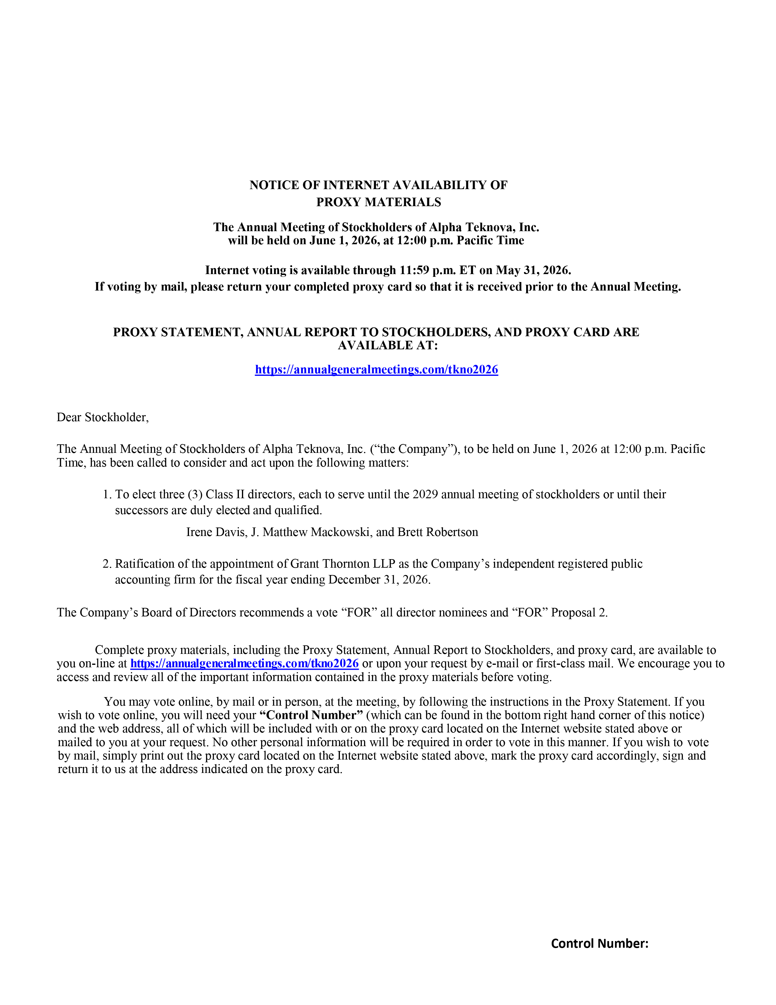
NOTICE OF INTERNET AVAILABILITY OF PROXY MATERIALS The Annual Meeting of Stockholders of Alpha Teknova, Inc. will be held on June 1, 2026, at 12:00 p.m. Pacific Time Internet voting is available through 11:59 p.m. ET on May 31, 2026. If voting by mail, please return your completed proxy card so that it is received prior to the Annual Meeting. PROXY STATEMENT, ANNUAL REPORT TO STOCKHOLDERS, AND PROXY CARD ARE AVAILABLE AT: https://annualgeneralmeetings.com/tkno2026 Dear Stockholder, The Annual Meeting of Stockholders of Alpha Teknova, Inc. (“the Company”), to be held on June 1, 2026 at 12:00 p.m. Pacific Time, has been called to consider and act upon the following matters: 1. To elect three (3) Class II directors, each to serve until the 2029 annual meeting of stockholders or until their successors are duly elected and qualified. Irene Davis, J. Matthew Mackowski, and Brett Robertson 2. Ratification of the appointment of Grant Thornton LLP as the Company’s independent registered public accounting firm for the fiscal year ending December 31, 2026. The Company’s Board of Directors recommends a vote “FOR” all director nominees and “FOR” Proposal 2. Complete proxy materials, including the Proxy Statement, Annual Report to Stockholders, and proxy card, are available to you on-line at https://annualgeneralmeetings.com/tkno2026 or upon your request by e-mail or first-class mail. We encourage you to access and review all of the important information contained in the proxy materials before voting. You may vote online, by mail or in person, at the meeting, by following the instructions in the Proxy Statement. If you wish to vote online, you will need your “Control Number” (which can be found in the bottom right hand corner of this notice) and the web address, all of which will be included with or on the proxy card located on the Internet website stated above or mailed to you at your request. No other personal information will be required in order to vote in this manner. If you wish to vote by mail, simply print out the proxy card located on the Internet website stated above, mark the proxy card accordingly, sign and return it to us at the address indicated on the proxy card. Control Number:

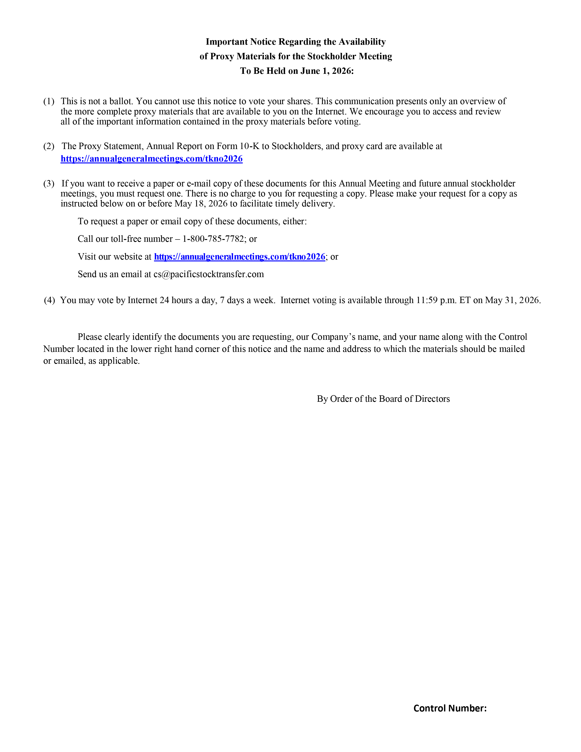
Important Notice Regarding the Availability of Proxy Materials for the Stockholder Meeting To Be Held on June 1, 2026: (1) This is not a ballot. You cannot use this notice to vote your shares. This communication presents only an overview of the more complete proxy materials that are available to you on the Internet. We encourage you to access and review all of the important information contained in the proxy materials before voting. (2) The Proxy Statement, Annual Report on Form 10-K to Stockholders, and proxy card are available at https://annualgeneralmeetings.com/tkno2026 (3) If you want to receive a paper or e-mail copy of these documents for this Annual Meeting and future annual stockholder meetings, you must request one. There is no charge to you for requesting a copy. Please make your request for a copy as instructed below on or before May 18, 2026 to facilitate timely delivery. To request a paper or email copy of these documents, either: Call our toll-free number – 1-800-785-7782; or Visit our website at https://annualgeneralmeetings.com/tkno2026; or Send us an email at cs@pacificstocktransfer.com (4) You may vote by Internet 24 hours a day, 7 days a week. Internet voting is available through 11:59 p.m. ET on May 31, 2026. Please clearly identify the documents you are requesting, our Company’s name, and your name along with the Control Number located in the lower right hand corner of this notice and the name and address to which the materials should be mailed or emailed, as applicable. By Order of the Board of Directors Control Number:

